IDT Participation: MDS Process and Workflow

MDSC
  - Responsible for the Coordination and the accuracy of all data in the MDS
  - Maintain the MDS schedule, create the MDS, maintain care plan schedule
  - Trigger all the needed IDT assessments needed to complete MDS by utilizing the MDS-UDA

MDS Assessors/Nursing, Dietary, Recreation, Social Services
  - Collaborate with MDSC to complete MDS assessments and required documentation timely,
  - Participate in care planning and review process.

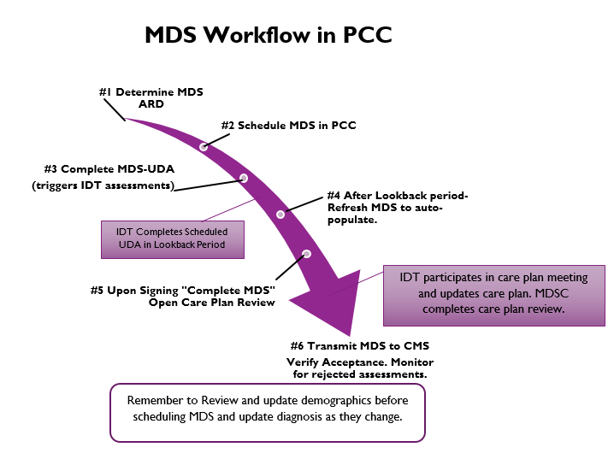

Disciplines Responsible for MDS Sections and CAA Areas
Discipline | MDS Section(s) | CAA
Dietary | K | 12, 13, 14
Recreation | F, A (A1005 & A1010)  B (0700 & 0800) C and D, A (PASSR), Q, S (0160, 0171a, 0171b, S6500) | 7, 10
Social Services | B (0700& 0800) C and D, A (PASSR), Q, S (0160, 0171a, 0171b, S6500) | CAA – 2, 7 (if needed), 8, 20
Therapy | O (auto-populated) MDS Verifies and Signs | None
MDS | All Remaining Sections and Questions | 1, 3, 4, 5, 6, 9, 11, 14, 16, 17, 18, 19

UDA's: Triggered UDAs
On Admission the following assessment schedules are triggered (version #s will change). These assessments have items that populate the MDS or are needed for assessment of the resident.
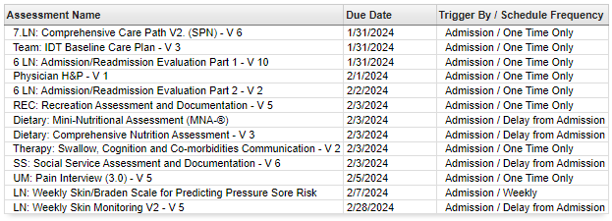
After the Initial Admission / Readmission assessments are triggered then the MDS: UDA is completed by the MDSC or designee and assessment schedules will be triggered to correspond with the MDS.
MDS UDA triggers
- Comprehensive:
  - UM: Quarterly Evaluation
  - Dietary: Comprehensive Nutrition Assessment
  - Dietary: Mini Nutritional Assessment (MNA)
  - SS: Social Services Assessment and Documentation
  - REC: Recreation Assessment and Documentation
  - Substance Abuse Evaluation (If applicable to your facility)
  - 7. LN: Comprehensive Care path Daily x 7 days
  - MDS/IDT: GG Summary

- Non-comprehensive (Quarterly)
  - UM: Quarterly Evaluation
  - Dietary: Nutritional Quarterly/IPA Assessment
  - SS: Social Services Assessment and Documentation
  - REC: Recreation Assessment and Documentation
  - Substance Abuse Evaluation (If applicable to your facility)
  - MDS/IDT: GG Summary
- IPA
  - Dietary: Nutritional Quarterly/IPA Assessment
  - REC: MDS - Ethnicity/Race Interview
  - MDS/IDT: GG Summary

- 5day
  - UM: Pain Interview
  - SS: Social Service Assessment and Documentation (Reminder – SS does an assessment that includes the BIMs/PHQ9 that automatically triggers to be due 3 days after admission)
  - Dietary: Nutritional Quarterly/IPA Assessment
  - MDS/IDT: GG Summary
  - REC: MDS - Ethnicity/Race Interview

Please Note that:
- PPS/Planned Discharge (MDS UDA does not trigger anything, the following are processes related to PPS/ Planned Discharge)
  - UM Pain Interview (Built into Discharge Summary therefore does not trigger)
  - RD: (completed in Discharge Summary)
  - MDS/IDT: GG Summary (Manually Triggered by MDS)

Link to most current Triggered UDAs document

UDA's: UDA Portal
Navigate to Clinical>UDA
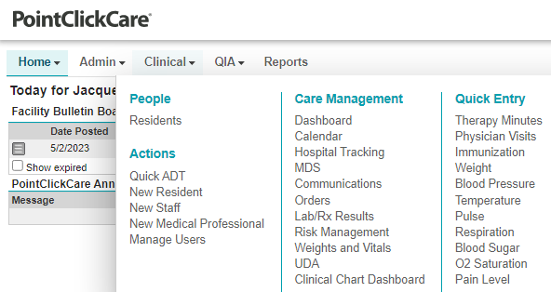
UDA List Window
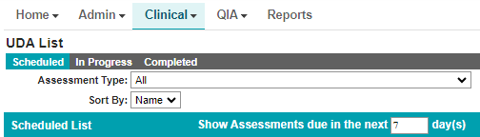
Scheduled – lists all scheduled assessments.
The schedule window will display the assessment name, schedule description, assessment type, due date. Anything displayed in red is overdue.
In Progress – lists all assessments that were opened and saved but not locked.
Completed – list all assessment that are locked.
This symbol indicates that there are additional items available for the resident. This icon appears throughout PCC. Click on the + to expand selection.
An assessment that is not needed can be cleared from the portal or by going to the resident’s chart.
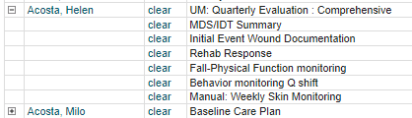
By clicking on the assessment name, you are presented a “Reason for Assessment” window that allows you to choose the date and time that the assessment was completed (note the assessment cannot be scheduled in the future). When the assessment is created the assessment will open “In Progress” for completion. It will not clear the schedule until the assessment has been saved, signed, and locked.
Note: If the assessment has MDS responses then assure that the Assessment Date is within the lookback period of the MDS (typically 7-days).
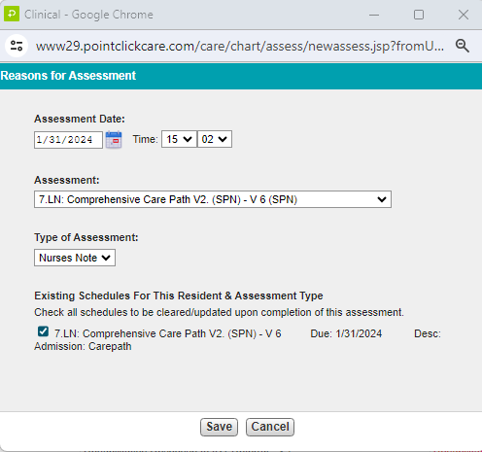
By clicking on the resident’s name, you will go into the resident Assessment tab.
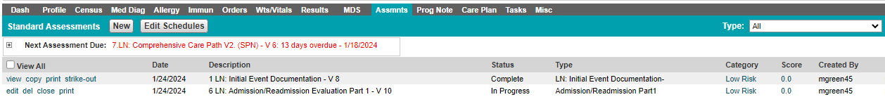
To narrow down the list of assessments, click on the down arrow to choose the assessment type.

In Progress
List all assessments that have not been signed and locked. From this window you can edit, print, or copy.
Any assessment listed with a (SPN) means that when the assessment is signed and locked that a Progress Note will be created that goes to the Progress note chart. Once an SPN is created the assessment cannot be unlocked and edited (it will need to be struck out).
Clicking on the edit takes you into the assessment for data entry
Some Assessments have sections. All sections must be signed and in green to complete the assessment by locking it. Sections in Red indicate errors usually related to missing responses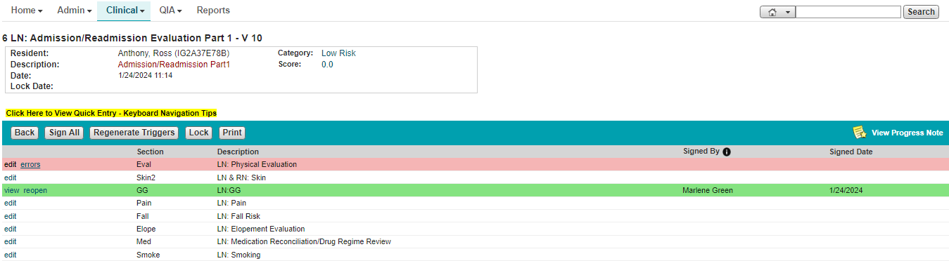
Function buttons:
Back – will bring you back to the resident assessment tab
Sign All – will sign all completed sections
Regenerate Triggers – will trigger all care plans, assessments, and tasks associated with the assessment once completed.
Lock – will complete the assessment once all signatures have been completed.
Print – will display a printable version of the assessment form
Click edit next to the section to begin filling it out on the assessment data entry screen.
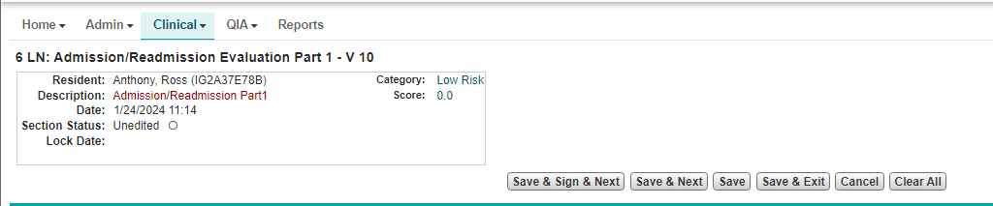
Function buttons:
Save and Sign and Next – will save the current section, sign it, and let you proceed to the next section if applicable.
Save and Next – will save the questions answered and proceed to the next section without signing.
Save – will save and keep you in the assessment.
Save and Exit – will save the answered questions and exit the assessment.
Save & Sign & Lock & Exit – will complete the assessment. If there are any errors they will be identified. Correct the errors and then you will be able to proceed.
Cancel – all work will be lost since the last save.
Clear All – will clear all responses.

Completed
Lists all the assessments that have been completed.
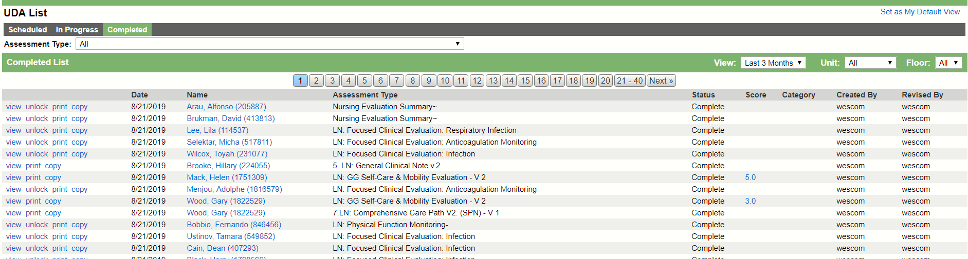
Score
Several assessments have scores built into them. The scores are displayed in blue indicating that there is a hyperlink, click on the default score to display the scoring window. Note: PCC only displays one score in the window so remember to click on the score to display additional scores, example below.
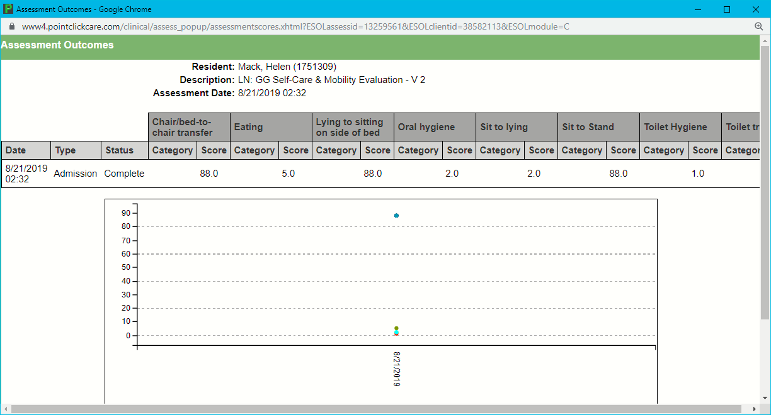
MDS Portal
Navigate to Clinical>MDS
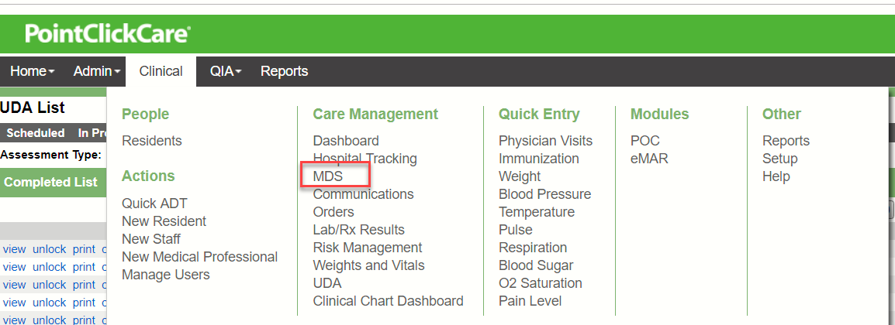

Tabs
In Progress
This tab will indicate what section is still in need of data entry, acknowledgement, or to be signed off. The window lists the MDS by date newest to oldest. Review this tab to find sections that have not been signed.
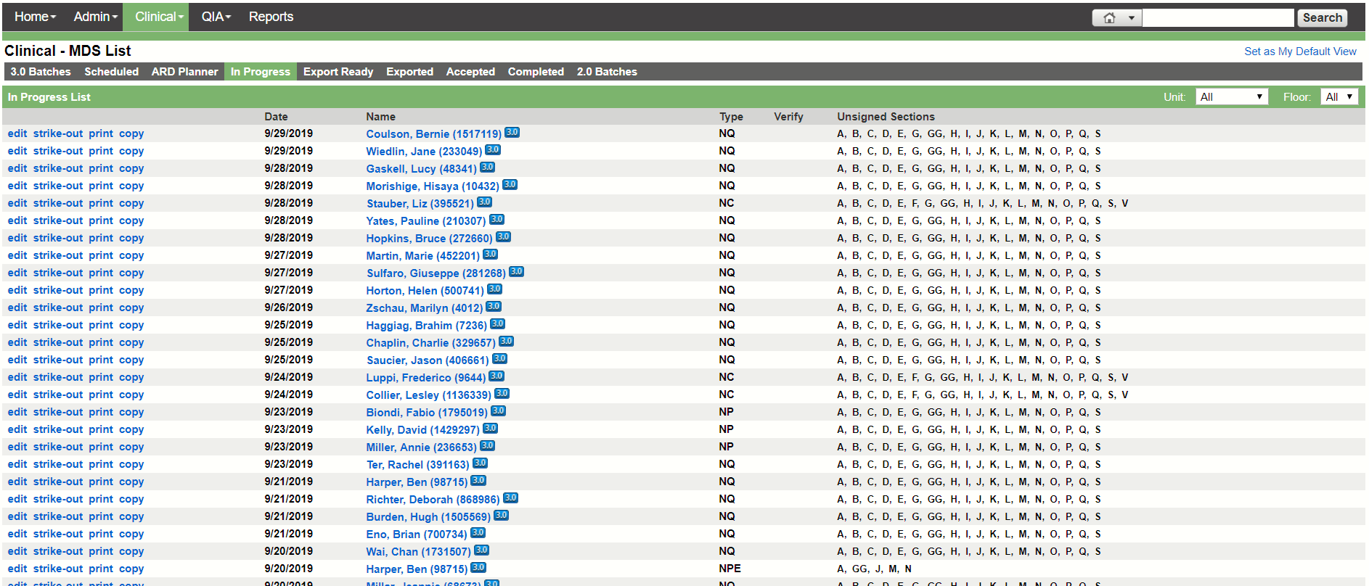
Click on edit to go into the assessment and work on the MDS. (the strikeout, etc. will be dependent on Security)
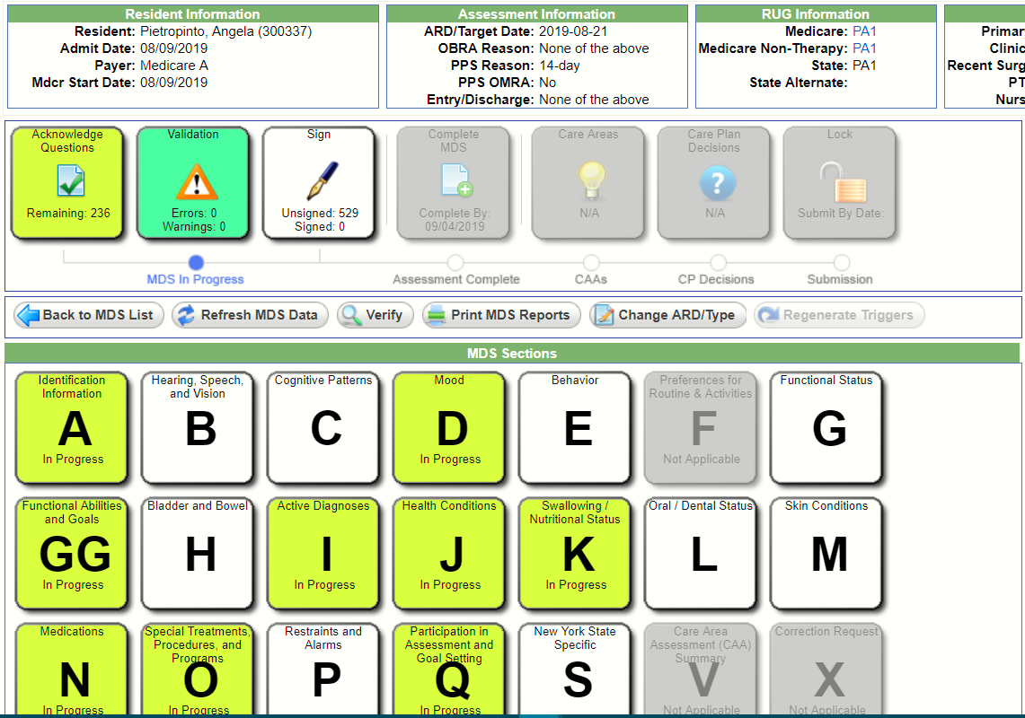
MDS Workflow
Acknowledge Questions – will list the questions by section that have been populated upon creation of the MDS. This includes responses from the assessments, profile, weight and vitals, POC, Net Health, questions disabled based on the assessment type, etc. The MDSC may have to Refresh MDS Data so the MDS is brought up to date with everything that has been entered since the MDS was created. Please check with the MDSC if you have questions.
Click on the button and select your section and acknowledge the questions.
Note: If you click on All and acknowledge you will have assigned all the questions to your name for signature.
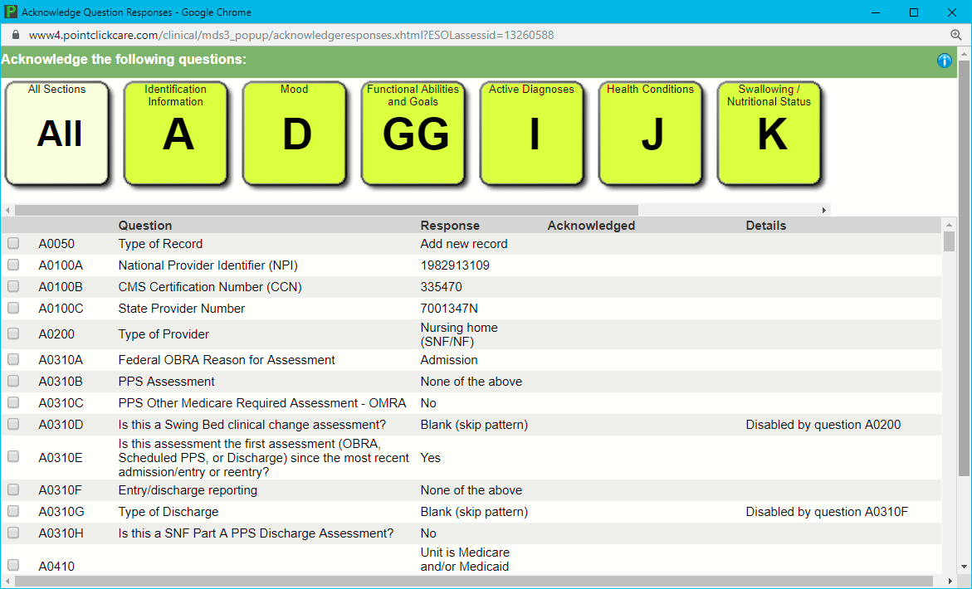
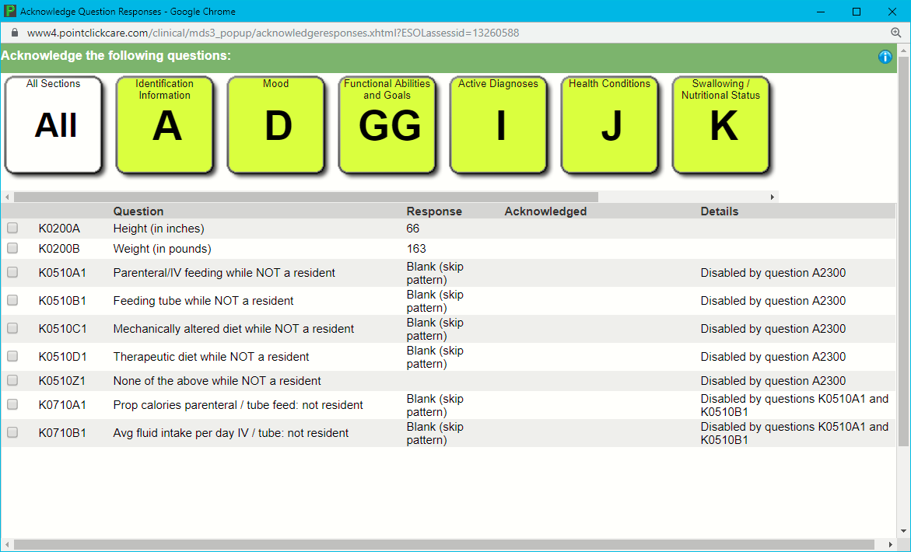
Select the questions you need to acknowledge (All if you are responsible for the entire section) and click Acknowledge.
Section
Click on your Section and finish responding to the questions.
***NOTE**** for interview sections to be dimmed when there is an unplanned discharge or a comatose resident question B0100 must be answered and saved.***
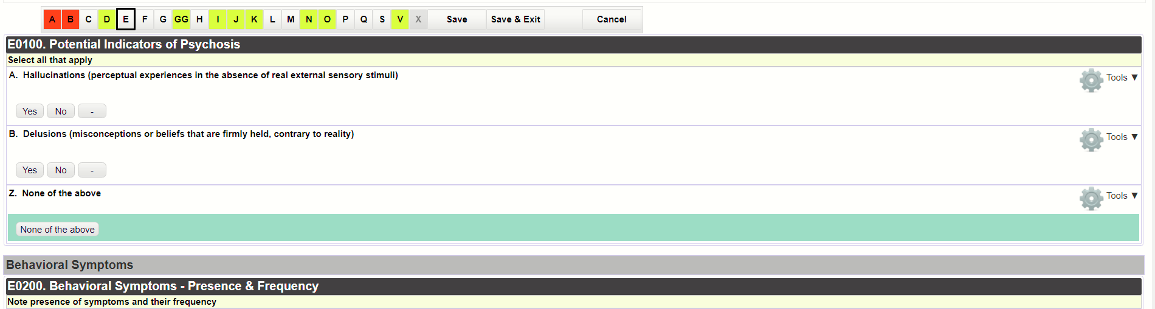
To save from within the section click on the letter for the section, Save, or Save and Exit. Cancel will not save.
Color Coding –
- Red – questions still need answered or there is an error.
- Yellow – data is entered but the section has not been signed off.
- Green – questions have been answered and the section is signed.
Validation – will list any errors or warnings. You should review for your sections. Ask the MDSC for assistance if needed.
Sign – Any questions that you have acknowledged or answered will be assigned to you for signature.
- My Questions – will list the questions the system has assign to you.
- Waiting to be Signed by Others – certain positions (based on security) can sign for all users.
PCC Care Plan Reviews
Care Plan Reviews
- Care Plan Review Cycle are scheduled by the MDSC in accordance with the RAI Manual.
  - The care plan completion date (item V0200C2) must be no later than 7 calendar days after the CAA(s) completion date (item V0200B2) (CAA(s) completion date + 7 calendar days).
  - A care plan should be placed in review 7 days before the review is due and all members of the IDT should review their items and sign. On the due date the review should be marked as completed by the MDSC.
  - Care Plan Review should be done with comprehensives, sig changes, and quarterlies.
- The Care Plan meeting should be scheduled to occur within the time frame that the care plan is being reviewed so that resident and resident representative can be included in the care planning process
  - The care plan meeting should be documented by completing and summarizing in the Team IDT: Meetings and Evaluations UDA.

