MDS Management: PCC
- Management of MDS Schedule for the IDT Team
  - Review the MDS schedule that are needed in the next 12-30 days.
  - Open up the MDS Books, setting the ARD
  - Open, complete, sign and lock the MDS-UDA to schedule the IDT assessments
- Diagnosis
  - Maintain accurate diagnosis on each chart
  - Resolve Diagnosis Notifications
- Demographics
  - Maintain demographic information that populates for MDS, if needed.
- MDS
  - Refresh MDS to pull in the IDT team, POC, and other modules the day after the ARD
    - You may be requested to refresh by the departments, as needed.
  - Work on completing the MDS that are due.
    - This will include the IDT Team.
  - Sign off MDS(s)
  - Once the MDS is locked submit
- CP – Review Cycles
  - In conjunction with the Completing the MDS, Locking, and submitting of the MDS. Schedule Care Plan Reviews, when all teams have reviewed: Mark the Review as Completed.
    - Comprehensives
    - Quarterly
    - Sig Changes

- For New MDS Assessments and to support the IDT Process.
  - Set the ARD Date and open the MDS.
  - Create and Lock the MDS UDA to schedule the assessment for the IDT Team. See below for more detail.
    - Remember that the IDT assessments trigger with the Census Lines for the Admission and Discharges so the MDS-UDA is not required for admissions and discharges.
  - The MDS UDA can be done and locked for a time frame of 30 days.
    - Remember for the triggers the assessment needs to be locked.
    - Remember that the IDT Team UDA’s have to be dated during the lookback period of the MDS to pull into the MDS
    - Remind the IDT Team, if needed, that the reference date in the assessment has to be in the 7 day look back period to pull into MDS.
  - For MDS(s) created more than 30 days in the future create a manual schedule (tickler) that will prompt you when to complete and lock the MDS UDA. Or monitor your scheduled In Progress MDS and utilize the UDA portal to look for MDS UDAs that have not been completed.
  - When the ARD Lookback period is completed remember to refresh the MDS to pull in all data within the lookback period.
    - Demographics
    - Assessments
    - Diagnosis
    - POC
    - Optima/Net Health
    - ETC.
PCC Care Plan Management
Care Plan Reviews
- Care Plan Review Cycle are scheduled by the MDSC in accordance with the RAI Manual.
  - The care plan completion date (item V0200C2) must be no later than 7 calendar days after the CAA(s) completion date (item V0200B2) (CAA(s) completion date + 7 calendar days).
  - A care plan should be placed in review 7 days before the review is due and all members of the IDT should review their items and sign. On the due date the review should be marked as completed by the MDSC.
  - Care Plan Review should be done with comprehensives, sig changes, and quarterlies.
- The Care Plan meeting should be scheduled to occur within the time frame that the care plan is being reviewed so that resident and resident representative can be included in the care planning process
  - The care plan meeting should be documented by completing and summarizing in the Team IDT: Meetings and Evaluations UDA.

Setting the Care Plan Review in PCC
- Clinical > Resident > Care Plan.
- During the transition period and if a review has to be adjusted. To manually edit the Care Plan review dates, click the Next Review Date link.
  - If the initial (New) button is shown RN (including MDS RN) opens blank Care Plan in order to set review.

Note
When a comprehensive MDS is completed, the Care Plan next review date is updated.
- When signing completion of an MDS, if the next review date is more than 7 days from the completion date, you are asked if you want to update the next Care Plan review date. If you click OK, the next Care Plan review date is set 7 days from the completion date.

- If a review is scheduled in the next 7 days or if a review is already in progress, the Care Plan review date remains unchanged.

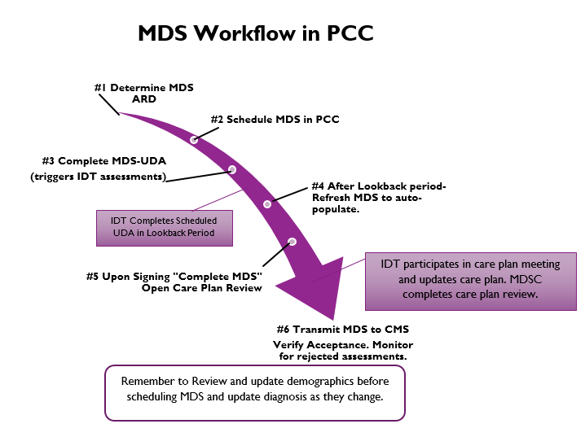

Disciplines Responsible for MDS Sections and CAA Areas | Discipline MDS Section(s) CAA  Dietary K 12, 13, 14  Recreation F, A (A1005 & A1010) 7, 10  Social Services B (0700 & 0800) C and D, A (PASSR), Q, S (0160, 0171a, 0171b, S6500) CAA – 2, 7 (if needed), 8, 20  Therapy O (auto-populated) MDS Verifies and Signs None  MDS All Remaining Sections and Questions 1, 3, 4, 5, 6, 9, 11, 14, 16, 17, 18, 19

MDS UDA Instruction Summary
Instructions for the MDSC: Please, see this link for full instruction guide. https://cfc.freshdesk.com/a/solutions/articles/4000007336
- Type Of MDS
  - Selecting the MDS Type will help determine which UDA's will be scheduled
  - Admission/Readmission MDS's do not require the MDS-UDA to be completed
  - 5-day PPS MDS's do not require the MDS-UDA to be completed unless the 5 day MDS was not combined with the Admission/Readmission MDS.
- ARD Date this is the ARD Date of the MDS.
- Choose the type of assessment.
  - Type Of MDS
    - Comprehensive (May Be Combined With PPS)
    - Quarterly/Non-Comprehensive (May Be Combined With PPS)
    - IPA
    - 5 Day PPS
- Selected the number of days the IDT Team has to complete the supporting assessment for the MDS
  - ARD – 6 = # of days
- The MDS UDA can schedule up to 30 days in advance.
- If you create the MDS more than thirty days in advance then create a manual schedule (tickler) for yourself on the MDS UDA that will prompt you to do the MDS UDA.
  - Check daily what MDS UDA(s) you must complete and lock.
  - If you change the MDS ARD and the IDT assessments that were scheduled when you did the MDS UDA
    - you will have to update the schedules of the IDT assessments so that they fall within the lookback period
      - Go to resident chart and deactivate current schedules
        - Then you may either complete MDS-UDA if ARD is 3 to 30 days in the future
        - Or manually schedule each assessment from the resident assessment scheduler

MDS UDA Triggers:
Comprehensive:
  - UM: Quarterly Evaluation
  - Dietary: Comprehensive Nutrition Assessment
  - Dietary: Mini Nutritional Assessment (MNA)
  - SS: Social Services Assessment and Documentation
  - REC: Recreation Assessment and Documentation
  - Substance Abuse Evaluation (If applicable to your facility)
  - 7. LN: Comprehensive Care path Daily x 7 days
  - MDS/IDT: GG Summary
Non-comprehensive (Quarterly)
- UM: Quarterly Evaluation
- Dietary: Nutritional Quarterly/IPA Assessment
- SS: Social Services Assessment and Documentation
- REC: Recreation Assessment and Documentation
- Substance Abuse Evaluation (If applicable to your facility)
- MDS/IDT: GG Summary

IPA
- Dietary: Nutritional Quarterly/IPA Assessment
- REC: MDS - Ethnicity/Race Interview
- MDS/IDT: GG Summary

5day
- UM: Pain Interview
- SS: Social Service Assessment and Documentation (Reminder – SS does an assessment that includes the BIMs/PHQ9 that automatically triggers to be due 3 days after admission)
- Dietary: Nutritional Quarterly/IPA Assessment
- MDS/IDT: GG Summary
- REC: MDS - Ethnicity/Race Interview

Please Note that:
PPS/Planned Discharge (MDS UDA does not trigger anything, the following are processes related to PPS/ Planned Discharge)
- UM Pain Interview (Built into Discharge Summary therefore does not trigger)
- RD: (completed in Discharge Summary)
- MDS/IDT: GG Summary (Manually Triggered by MDS)

