PCC Reset / Assign Passwords
The Administrator, Assistant Administrator, HR, DON, ADON, Unit Manager, Nursing Supervisor, MDS, Facility Super Users, or Therapy DOR can reset or assign passwords.
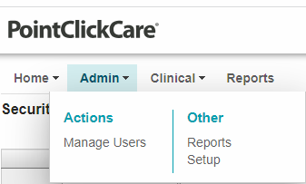
Instructions:
- Hover over "Admin" tab then
- Click on Manage Users

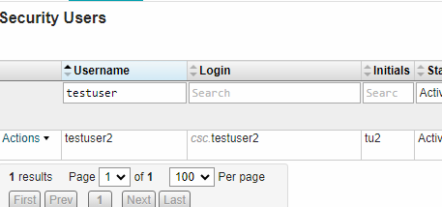
- Search for name in search box: You will only be able to reset the passwords of users that have access to one facility (single facility users) If they use one login for multiple facilities you will not be able to reset their password. You will have to reach out to EHR Support or After-Hours Support.

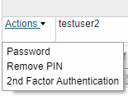
- Click "Actions" to the left of the name
- Click “Password” to change password

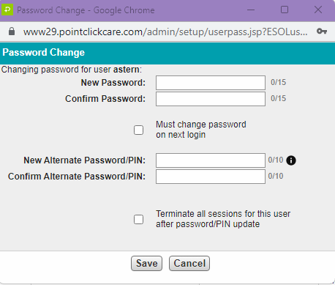

- Change the password with the following considerations:
  - New Password is for everyone except CNA's: Minimum of 8 digits. Max of 15. Must use Capital letter, Lowercase letter, and a number. Example: Hello123
  - New Alternate Password/PIN is for CNA's only: Minimum of 4 numeric digits. Max of 15. May use letters if preferred. Example 1234
- Make sure you check the box for “change password/alternate password/pin on next login”
- Give the password you put in to the user.

