CHC Quick Reference Guide to Resident Chart Reports/Generate Clinical Chart

Reports

Resident Chart | Report(s)
Admission/Transfer Records | Admission Record, Transfer/Discharge Report, NJ Universal Transfer Form
Medical Diagnosis | Diagnosis Report *New*
Allergies | Allergy Report
Immunizations | Immunization Report
Orders | Administration Record (eMar/eTar), Order Listing Report *New*
Weights and Vitals | Weights and Vitals Summary
Results (ONLY if PCC Integrated) | Lab Results Report, Radiology Results Report
Assessments | Assessment Report (Includes MDS 3.0)
Progress Notes | Progress Notes *NEW*
Care Plan | Care Plan Report
Tasks (POC) | Documentation Survey Report V2
Therapy | Therapy Minutes *NEW*
Misc. | Online Documentation Storage Report

Generate/View Clinical Chart

Clinical > Reports > Generate/View ​​Clinical Chart.

- Use the magnifying glass to select resident by name, or resident ID number.
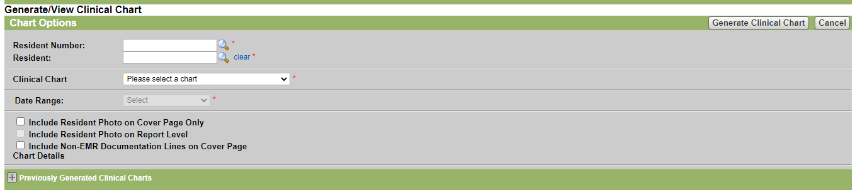
- Select which part of the clinical chart you would like to generate.
Admission/ Transfer | Medical Diagnosis/Allergies
Assessments 1 | Misc.
Assessments 2 | Orders
Care Plans | Progress Notes
Clinical Chart- does not include assessments | Tasks
Immunizations | Therapy
MDS - Accepted | Weights & Vitals
** To generate the entire chart, select Clinical Chart- Does NOT include Assessments, Assessments 1, and Assessments 2. **
- Generate/Clinical Chart
- Files will upload to the misc. tab
** Note: Clinical charts cannot be generated for periods greater than 1 year. When generating a clinical chart for multiple years, it is recommended to do so by calendar year. **

** Depending on the complexity of the clinical chart being generated, PointClickCare determines whether it is run on demand in real time or if it is queued to be scheduled to run overnight. **

