Physician Visit Tracking:
Purpose: The purpose of Physician visit Tracking is to make sure that residents are seen by providers to meet regulatory requirements. Recording the Last Physician Visit allows you to monitor when each resident is next due to be visited.

Schedule:
- Current PCC configuration matches federal requirements for visits
- The date will automatically update based on the following schedule once a visit is recorded.
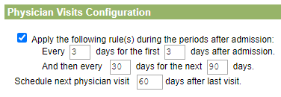
* Please, note that if an NP/PA visit meets the regulatory requirements and sees the resident for one of these visits defined above you can track that they were seen but not which provider saw the resident using this tracking method.
Managing Physician Visits:
Physician visits can be recorded in one of three places Resident Detail page of the resident's chart, Quick Entry or Physician Visits Clinical Dashboard pane. Here are the instructions for each.

Method 1: Resident Detail page of the resident’s chart:
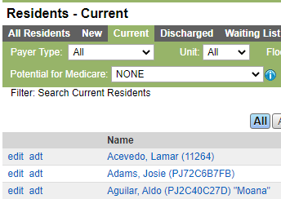
- Clinical > Resident List > next to the resident, click edit.
- In Last Physician Visit, type the date of the last visit.
- Click Save.
Method 2: Quick Entry:
Quick Entry
- Clinical > Quick Entry > Physician Visits.
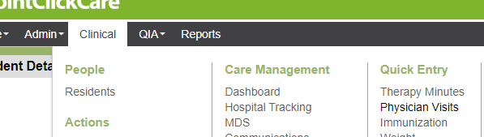
- Select the filters as required.
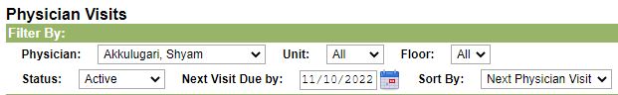
- Select the name of the resident(s) visited.
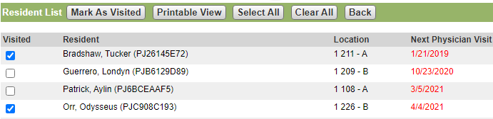
- Click Mark as Visited. (a new window will open)
- Type the last physician visit date.
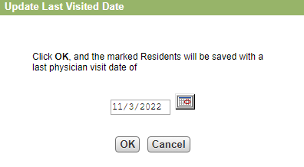
- Click OK to Save.
Method 3: Physician Visits Clinical Dashboard
- Clinical > Dashboard > Physician Visits.
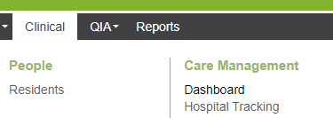
- Select the filters as required.
General Dashboard filters allow for narrowing down by Unit/Floor/Primary Physician. Physician Visit Widget allows for narrowing down visits due in 0 to 14 days
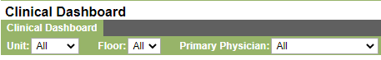
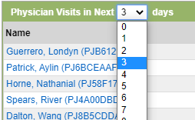
- Click Update Physician Visits. This will take you to the Quick Entry Physician Visits screen
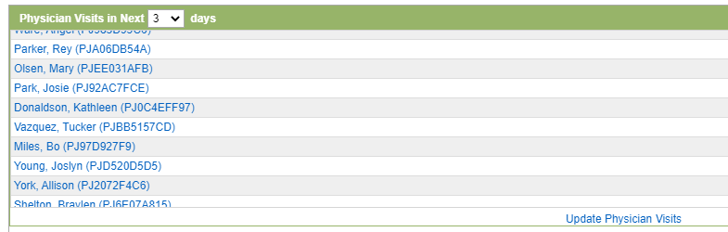
- Verify filters are correct and then Select the name of the resident(s) visited.
- Click Mark as Visited. (a new window will open)
- Type the last physician visit date.
- Click OK to Save.

