Purpose:
The EHR (Electronic Health Record) is an everyday part of a center’s routine and with that in mind a more formal process and definition of support needs to be communicated. This guideline will serve to establish some basic guidelines for both the center’s and for the EHR Team.
Who to Call:
Computer Equipment / Network Issues / Software Installation / etc. - should be reported to HOCS. The number for HOCS is 718-377-0922 and the email is support@hocsinc.com.
Software Issues/ Functionality / Questions / Security – should be reported to the EHR team.
Hours of Operation: We are aware that our centers are operating 24/7 and we are ever evaluating support needs. Currently the EHR Team monitors tickets and the hotline from 9:00 a.m. (EST) to 5:00 p.m. (EST) Monday through Friday. After hours support for security and new admits (if no one is in the building) are handled by calling 866-294-0768.
Expectations:
User Access Request – When the proper EMR release form is included in the ticket the typical turn around for granting access is 2 hours during normal business hours. Requests should include the start date of the employee, the name of the employee (legible), system being requested, center, and the EMR Form.
Software Questions / Issues – An EHR team member will typically call you within 4 hours of the ticket being generated during normal support hours. The EHR team member will attempt to answer the question or provide resolution to a software issue during the initial phone call or within 12 hours of the initial contact.
Software Issues – Reportable to Vendor – If a software issue is reportable to the software vendor the EHR team will attempt to establish a work around and then report the issue to the software vendor. Please be aware that issues reported to the vendor will take time to get resolution and some even may be deemed as enhancement by the vendor. We will update the ticket with vendor updates as they are received or on a monthly basis. If the issue is deemed an enhancement by the vendor the ticket will be closed and added to an enhancement tracking spreadsheet and period follow-up with the vendor will occur.
Process:
All requests should be reported through the ticketing system and NO email should be sent directly to an EHR team member unless additional information is requested for a particular ticket. This will alleviate response delays if the contact person is unavailable.
There are several ways to open a ticket they include from within PCC, from within SigmaCare, and via email. Also, if the matter is urgent the support hotline can be called.
To open a ticket in PCC – Hover on the “Home” tab and select “View all Links” and choose CHC Support and click on New Support Ticket.
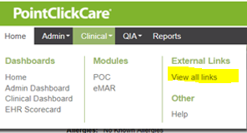
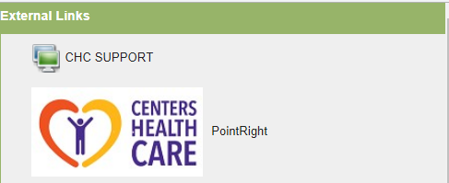
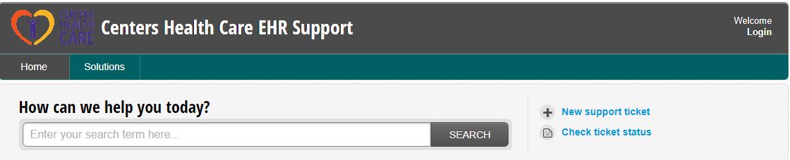
Fill out the following Submit a Ticket request form with as much information as possible and click on Submit. If you have documentation such as the EMR form or documentation on the issue please attach the file to the ticket prior to clicking on the Submit button. You will receive confirmation that a ticket has been opened. This confirmation email can be replied to if you need to update the ticket. Once a ticket is closed you will receive an email or a phone call with the resolution. NOTE: For resident information use only the resident number.
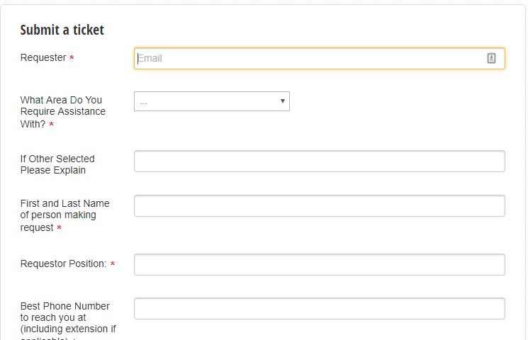
To Open a ticket in Sigma Care
Click on External Links and choose CHC Support. The
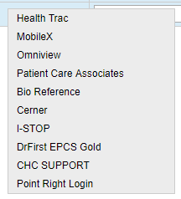
The Submit A Ticket window will open. Fill out the Submit a Ticket request form with as much information as possible and click on Submit. If you have documentation such as the EMR form or documentation on the issue please attach the file to the ticket prior to clicking on the Submit button. You will receive confirmation that a ticket has been opened. This confirmation email can be replied to if you need to update the ticket. Once a ticket is closed you will receive an email or a phone call with the resolution. NOTE: For resident information use only the resident number.
To open a ticket via email - EHRsupport@centershealthcare.org (this method is not preferred)
You can also submit a non-encrypted email to EHRsupport@centershealthcare.org with all the information / attachments concerning your request.
Hotline:
The EHR team hotline is 917-633-4854 and is set-up to ring the EHR team M- F 9-5. This number should only be used in an emergency. When an EHR team member picks up they will require your name, center name, email address, telephone number, and detail of your issue. The EHR team member may request you open a ticket (as described above) to better gather information on what is needed.
The EHR team FAX Number is (917) 983-2802 and should only be used when asked to provide additional information that cannot be scanned and attached to the ticket or an email.

