Documents from numerous sources such as outside providers, such as consult notes, H&P, and Physician Visit Notes may be added into the resident record in Point Click Care. The process is simple, but does require additional equipment. A scanner is required to add the documents to the PCC chart. Follow the directions below to complete this process.
- Scan the document to the computer you are using PCC on into a known location. Many users create a document folder on their desktop to scan these documents into. Within that folder they create two additional folder, one for scanned to the computer, and one for scanned into PCC.
- If the document was emailed to you, download the document to the computer you are using to a known location as above.
- Login to your PCC account.
- Go to the desired resident record.
- Go to the “Misc” Tab in the resident record:
- While in the misc tab, select the “New Document” tab
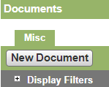

- When the “New Document” item is clicked, a popup will open as below:
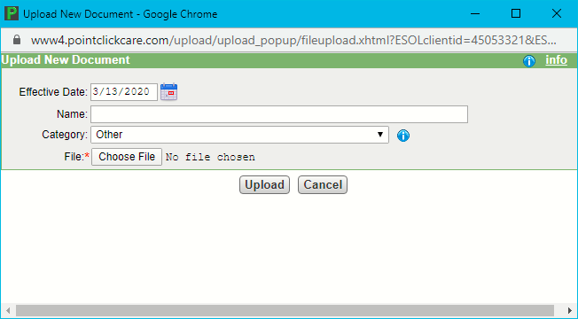
- Name the document by type and enter the date of the document at the end of the name. For example: Dental Visit Dr Smith 8-1-17, select the category appropriate for the document, choose the document to be uploaded and click upload.
NOTE: Be specific as to the document name and consistent with the Category Chosen.

- An edited version of how the field will display is seen below- (names and specifics redacted.)

System Guidelines
FILE TYPE that can be uploaded are:
BMP, CSV, DOC, DOCX, GIF, HTM, HTML, JPEG, JPG, PDF, PJPEG, PNG, PPT, RTF, TXT, WPS, XLS, XLSX, XML, ZIP
FILE SIZE that can be uploaded:
Max 15 MB

Display Filter. To quickly locate a document on a resident chart use the display filters.
To get a listing of all documents uploaded utilize the Documentation Storage Report.

