Care Plan Closed Automatically if Return Not Anticipated

Care Plans will be closed automatically on discharge: Return Not Anticipated MDS (or after completion of a death). However, if the resident returns with no significant change their Care Plan can be reactivated (with proper security roles). Screen shot examples illustrating steps shown below.
NOTE: If the resident does return with significant changes a New Care Plan must be created for the resident by clicking on the New Button. If a new Care Plan is established you cannot reactivate the former Care Plan.
- To reactivate a Closed Care Plan, click on the reactivate link

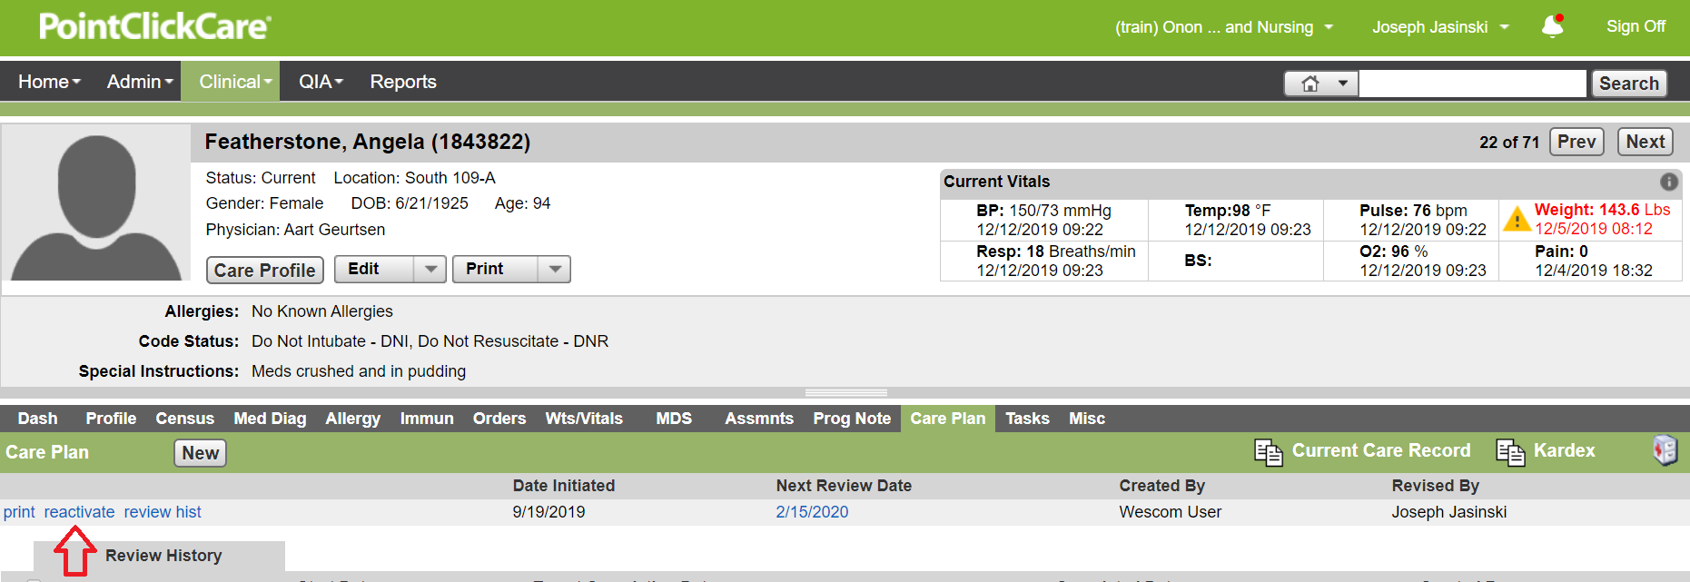

- Reactivation popup window is displayed until process completed.

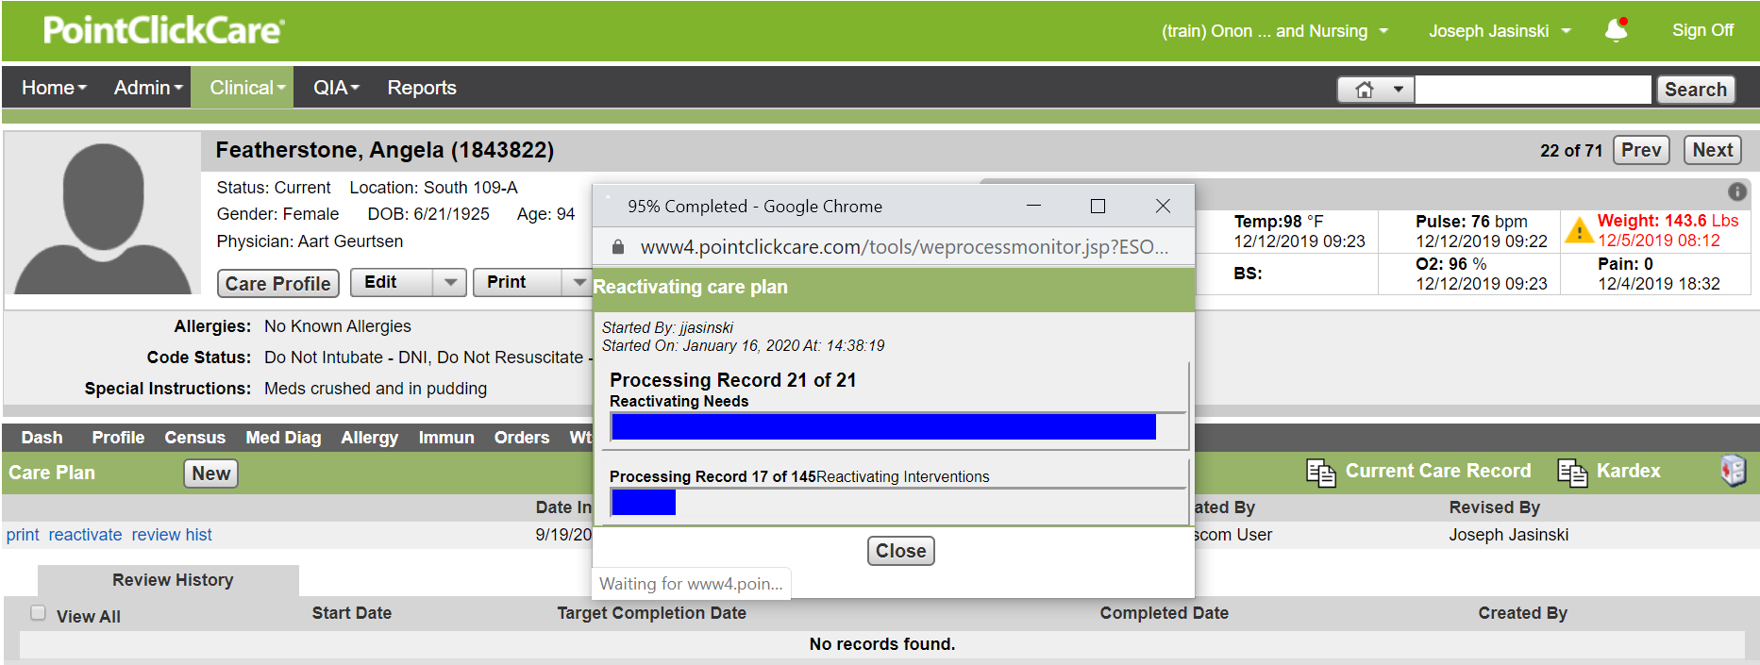

- Resident’s Care Plan reactivated.

