Quick ADT: How to enter resident census status changes.
From anywhere in the system
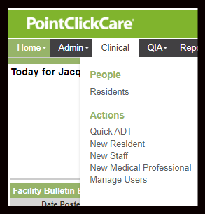
- Click on Clinical > Actions “Quick ADT”

- Enter Resident Demographic information to find resident regardless of status, new, discharged, etc. and click on “Search”
  - If resident does not appear. Double check demographics information then if correct contact person(s) responsible for entering in new residents.
  - Pay close attention to residents with common names and double check entries to prevent duplicate charts or using the wrong similar name chart. Use as many identifiers as possible when searching for the correct chart including date of birth and ssn if known.

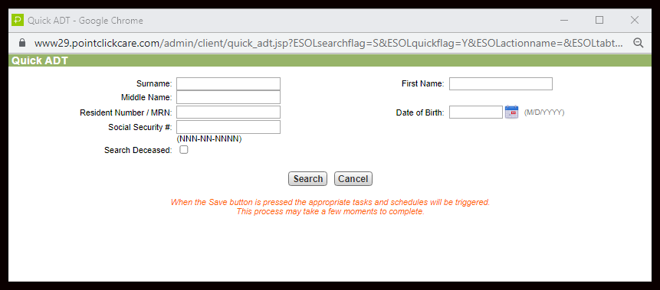
- Complete Required Fields and other information if known.
  - *Action Code: Admission, Readmission, Discharge, Transfer IN, Transfer Out, Room Change etc
  - *Effective Date and Time (actual arrival of resident into the facility)
  - *Estimated Payor: Insurance type during stay
  - *Location: Unit, Room and Bed. Click on Magnifying glass to see all available beds and their roommate if assigned to that room if applicable.
  - *To/From Type: What kind of facility did they come from or are they going to?
  - *To/From Location: What is the name of the facility they are going to or coming from.
    - If the facility location is not available on the drop-down list. Notify the EHR team with the details of the facility including:
      - Type of Facility
      - Name of Facility
      - Address including Street, City, State, and Zip Code
      - Phone Number
  - *Surname
  - *Resident MRN: is required but will already be entered based on autonumbering.
*Required fields are indicated with a red asterisk * in PCC.
*Many of these fields can be updated later if incorrect information was entered. Make sure that date and time are correct at time of Quick ADT to avoid more complicated procedures for updating this information.

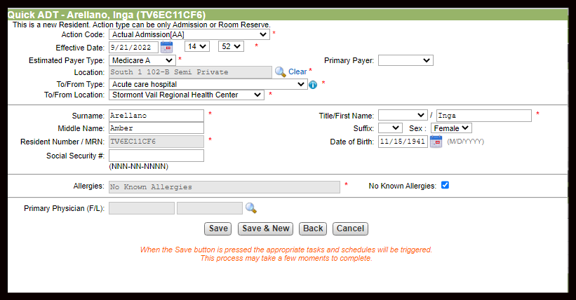
Quick ADT: How to enter resident census status changes.
From the resident's chart >
- Click on Clinical> Actions “Quick ADT”
- Complete Required Fields as described above

