**Order Entry: How to enter Laboratory and Radiology order(s)**

From the resident's chart > Orders tab, do one of the following:

* Click **New** and select **Laboratory or Diagnostic**.
  + Or use the search to Create an Order using an Order Template.

A new window will open once selection is made



* **Order Details:** Complete the fields as required. If you are using Order Templates, some fields are populated for you. Review the fields for accuracy.
  + Order Date: Ensure the date and time match the time the order was received
  + Communication Method
  + Ordered By: click the magnifying glass to find the provider if it was the last prescribed by click on the link to add the provider

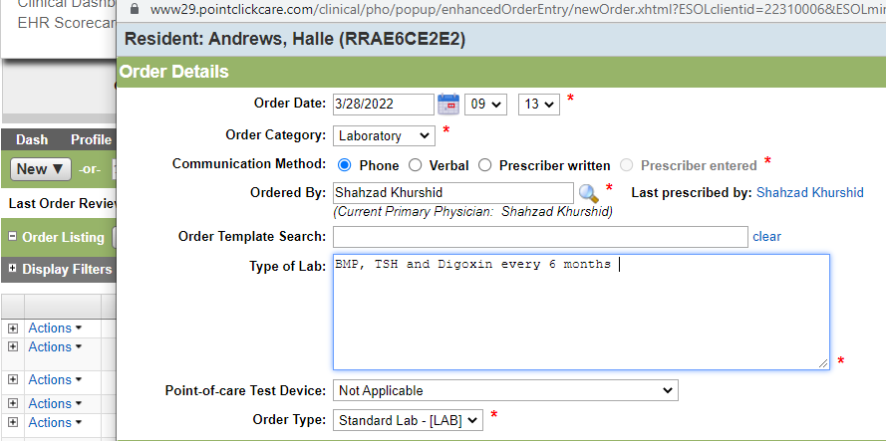

**Order Summary**: You can view the full order details as you are completing the fields. Click anywhere on the screen to update the Order Summary.

* Enter **Scheduling Details:** Complete the fields as required. If you are using an Order Template, some fields are populated for you, review the fields for accuracy.
* Add Schedule - Select 1 or multiple schedules.
* Click **Routine, Titration,** or PRN

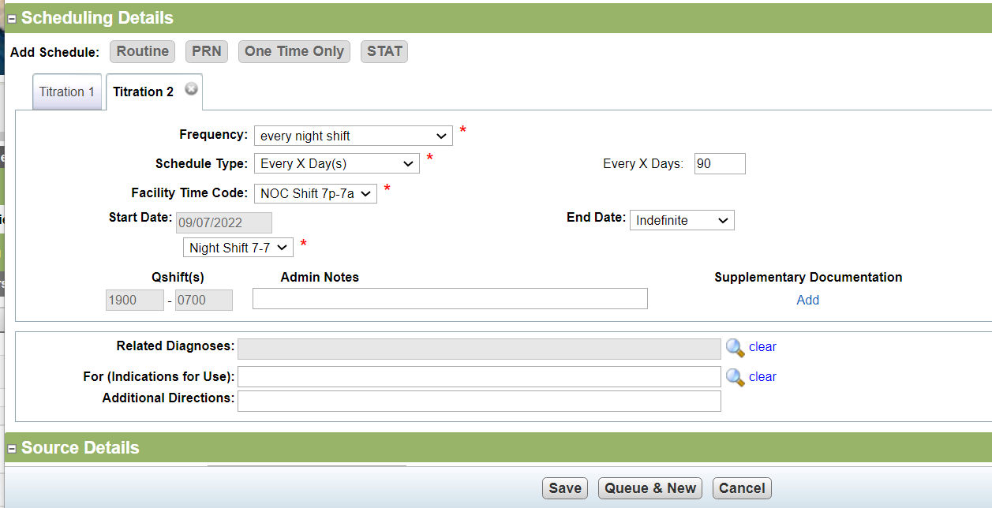

* Frequency: Select how many times a day the order is administered. For example, every day
* Schedule Type: Select how often the order is being administered.
* Facility Time Code: Select time from the list that the lab collects the samples from the residents every night shift
* Related Diagnosis: Select from a list of the resident's active diagnosis. You can also create a new diagnosis if needed
* For (Indications for Use)
* Additional Directions: Type any other information given as part of the order that is not included in the above fields
* Administered by: Select who is going to administer the order. This determines how the order is documented in eMAR and on your paper MAR. For example, Unsupervised Self-Administrations appear in eMAR, but they are automatically marked as given at the designated time.
* Start Date: Select the date and time of the first administration
* Pass Time(s) - This field populates based on what is selected for Facility Time Code. This can be changed depending on the selected Frequency.

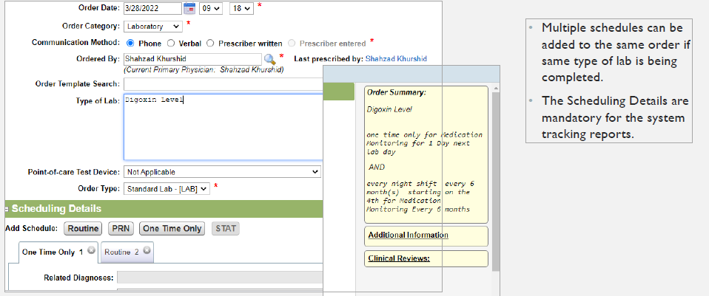

**Laboratory Management Daily Tracking:**

**Lab and Diagnostic Record**

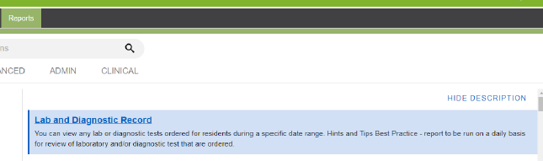

• This report to be run daily for a complete list of labs scheduled for that day.

• Recommended that Night Shift Nurse be responsible for tasks 1 & 2 below.

• Tasks 3 & 4 to be completed by resident’s assigned nurse and reviewed by nursing management

**Lab and Diagnostic Record Report Workflow Process**

1. Report should be printed and placed into Laboratory/Diagnostic binder on Unit

2. Check that each resident scheduled for lab work that day has their completed lab requisition form within the binder.

3. As lab results are received throughout the day then the nurse responsible for those results to initial paper report once reviewed and PCP notified. Any labs without initials should then be followed up on to determine why the sample was not collected or why they results are delayed.

4. There should be documentation of Nursing reviewing the results, notifying the provider, and the provider’s response to those lab results.

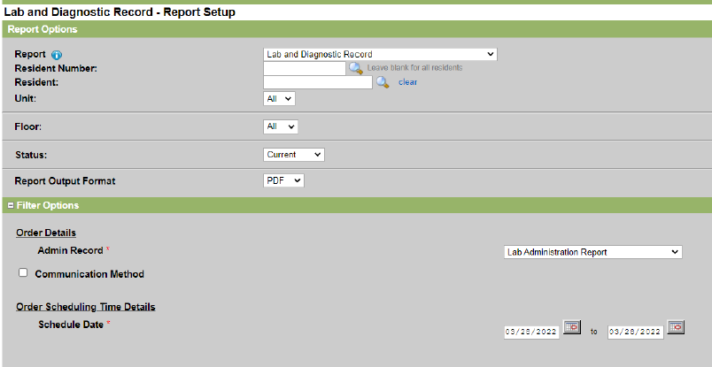

**Lab and Diagnostic Record Report Example**



**Lab and Diagnostic Order Review**

Review all new orders for Laboratory for accuracy

Verify correct order category, type, and a schedule(s) have been added.