Purpose:
You can modify an MDS record if errors are identified after the MDS is submitted to and accepted by CMS. You can also inactivate an MDS record that is submitted to and accepted by CMS in error.
Process and Steps:
Go to the residents chart - Clinical > Resident > MDS.
Next to the MDS, click correct.
Do one of the following:
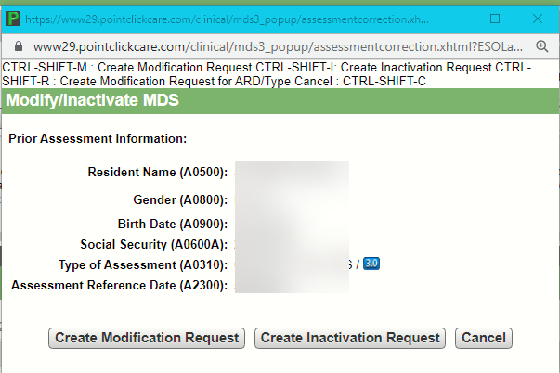
To correct the MDS, click Create Modification Request.
To inactivate the MDS, click Create Inactivation Request.
Note
You cannot modify or inactivate rejected MDS records. Only MDS records submitted to CMS with a status of Accepted can be modified or inactivated. To correct a rejected MDS, see Correcting MDS 3.0 Records.
Note
If you must modify the ARD or Type of MDS, create the modification request, then click Change ARD/Type. The Item Set Code (ISC) must match the original MDS to modify an ARD or Type of MDS. Refer to Chapter 2 or the RAI Manual for more information.
For Modification Requests only, correct the MDS item(s) as required.
Complete Section X - Correction Request as required.
Complete and lock the MDS.
Submit the MDS to CMS.
More information
After creating a Modification Request, the original MDS lists a status of Modified.
After creating an Inactivation Request, the original MDS lists a status of Inactivated.
If you create a Modification Request or Inactivation Request in error, strike-out the request. The original MDS reverts back to the previous status of Accepted.
When modifying a comprehensive MDS, if the changes made trigger a new Care Area, section X appears in red. You see a warning in the section and the Validation workflow button directing you to complete a Significant Correction in Prior Comprehensive Assessment. The CAA button in section V remains yellow in this Modification. Complete this newly triggered Care Area in the Significant Correction in Prior Comprehensive Assessment.
When modifying a comprehensive MDS, do NOT mark the Care Plan Decisions and Care Areas workflow buttons as incomplete unless you must modify the completion dates in section V or you must make changes to the Care Areas or Care Plan Decisions in the original assessment.
When submitting a Modification or Inactivation, if you are unable to locate the MDS when adding MDS records to the batch, change the Assessment Date After date to be at least one day before the ARD of the MDS.
If a Significant Correction of a Prior Quarterly assessment is required after a Modification, the Modification must be submitted and in a status of Accepted before you can create the significant correction.

