Signing In and Signing Out of PointClickCare:
To use PointClickCare, you must sign in using our secure login process. Use the most recent versions of supported browsers: Internet Explorer, Google Chrome, Mozilla-Firefox, or Apple Safari. Signing off ensures your PointClickCare session is securely closed.

Steps To sign in
- Open your internet browser. or Click on the link on the desktop if using Center’s Laptop
- Enter the web address login.pointclickcare.com
- Type your org code preﬁx, a period, and user name Center’s Health Care uses the org code of csc.
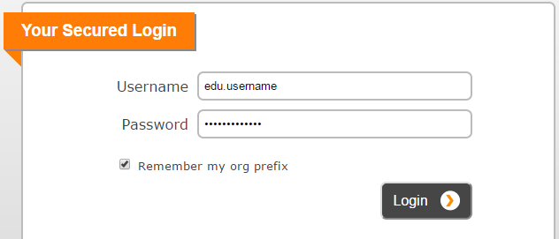

- Type your Password.
- Select Remember the org code preﬁx.
- Click Login. The PointClickCare home page appear

To sign off

From anywhere within PointClickCare, click Sign off.

More information

To read instructions on how to bookmark the page or save it to Favorites, click Bookmark this Login Page.

To read troubleshooting tips on login issues and error messages, click Login Trouble?.

After exceeding the maximum number of unsuccessful attempts conﬁgured, your login is disabled for security reasons and is reactivated in 5 minutes.

© 2021 PointClickCare. All rights reserved. PointClickCare is a registered trademark

Searching for Residents
Resident search is available on all tabs. Search using the:

First name.

Surname.

Medical Record Number (MRN).

Social Security Number (SSN).

Medicare Beneﬁciary Identiﬁer [glossary.html#UUID-c343cf2c-6be4-a5dd-c824-04cc0a3e03b6_glossentry- idm13101052713338] (MBI).

Health Insurance Claim Number (HICN).

 Note

Residents appear if there is a partial match on First name, Surname, or Medical Record Number (MRN) searches.

For a search using Social Security Number (SSN), MBI, or HICN, residents appear only if there is an exact match in Resident Identiﬁers or the resident ID. You must type the entire identiﬁer to ﬁnd matching residents.

Steps

- In the top right corner of the screen, click the house icon and select an option to search in This Facility or All Facilities.

- Type the information.

- Click Search.

© 2021 PointClickCare. All rights reserved. PointClickCare is a registered trademar

Using the Resident Listing
In PointClickCare, you select residents from an alphabetical list for your facility. The resident list also provides quick access to the resident records.

You can change the Resident List view by selecting ﬁlters. You can view the resident list by All Residents, New, Current, Discharged, Waiting List, and Outpatients. These ﬁlters narrow the list of possible selections. If you have diﬃculty ﬁnding a resident, try changing your view ﬁlter back to All Residents.

Steps

- Admin > Residents.

- You can ﬁlter the resident list as needed:

All Residents - All residents in the database, regardless of status.

New - The residents with demographic data entered and no admission date.

Current - All residents listed with an active census line.

Discharged - All discharged and deceased residents.

Waiting List - All residents on the waiting list from their demographics or CRM (if needed).

Outpatients - Add (if needed).

IRM Pending - All residents set to pending admission in IRM (if needed).

- You can sort the resident list as needed by Payer Type, Unit and Floor.

- Do one of the following:

Click the linked Resident Name to see the resident's record.

Click edit to edit the resident's detail information.

Click adt to enter an Quick ADT action for the resident

Navigating the Reports Tab Quick Reference Guide
This quick reference guide contains items required to navigate the Reports tab.

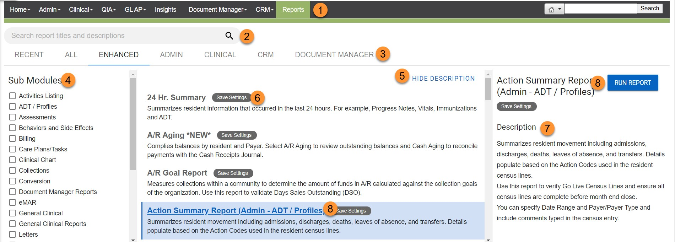

Item Number Item Name Description

  - Reports Opens the Reports tab.

  - Search
Locates reports by searching all report names, modules, sub modules, keywords, and report descriptions.

  - Module
Lists all reports available for a speciﬁc module. Click Recent
to open reports you ran in the last 60 days.

  - Sub Modules Filters the list of reports based on report type.

  - Description toggle
Hides or shows a short report description in the center pane of the reports page. Hide descriptions to see more reports in the list.

  - Report list
Shows an alphabetical list of reports based on search criteria. Includes a short description of the report.

  - Description
Provides a detailed explanation of the report including hints, tips, and deﬁnitions.

- Run Report

© 2021 PointClickCare. All rights reserved. PointClickCare is a registered trademark.
Click Run Report or click the report name to specify the options and parameters for the selected report

Look back Report (ADLs)
The Look Back Report shows documentation over a 3, 7, 14, or 16 day period, and tabulates data, for example, Intake and Output.
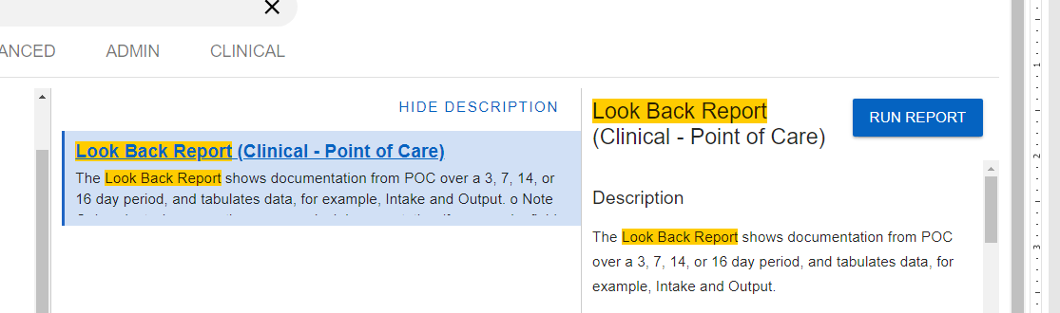
- Select either
  - ADL Late Loss Look Back Report OR Non-Late Loss ADL Look Back Report
  - Select the last day of Look Back Period 16th day of the month or 31st day of the month in order to view a max of 16 days. You may run the report as many times as you need moving the look back date to cover the entire time period you are looking for.
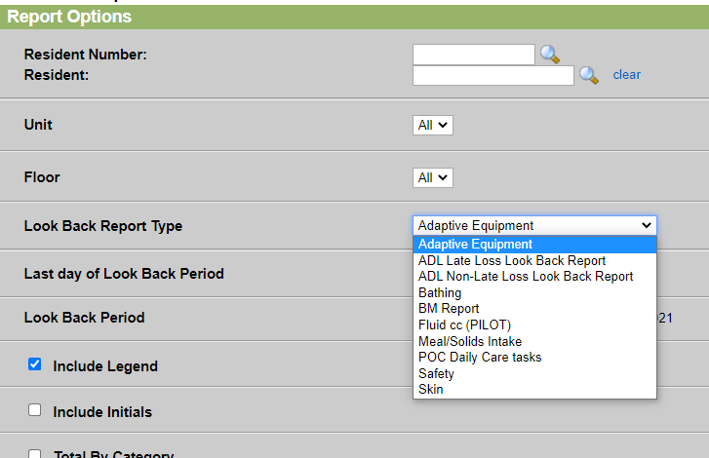

© 2021 PointClickCare. All rights reserved. PointClickCare is a registered trademark.

Administration Record Report
The Administration Record Report allows you to print an administration record to view the medication and treatment orders scheduled for the selected resident(s).

 Notes

When running the report, you can view open documentation boxes for the current month and 1 month in the future.

A blank version of this report is also available in the Reports area. You can print this empty report if you need to complete it manually.

Accessed via the Reports menu or Report Listing page.

You can use this report to print an administration record for the week or month based on the conﬁguration of the record.

When you select a speciﬁc resident and select either the Monthly Reports or Weekly Reports option, Print Blank Report appears to the left of Run Report. A blank report (does not contain any medication information) can be used as an administration record sheet.

Use Select Orders to run an Administration report containing only speciﬁc active orders.

If you access the Report Options page from the Orders module, the current resident's name and number appears in the appropriate ﬁelds.

Best Practice - report to be run monthly if using paper MAR and paper TAR, as needed to review documentation when using eMAR/eTAR.
© 2021 PointClickCare. All rights reserved. PointClickCare is a registered trademark.

