Order Entry: How to enter sliding scale insulin order(s)
From the resident's chart > Orders tab, do one of the following:
- Click New and select Pharmacy.
  - Or use the search to Create an Order using an Order Template.
A new window will open once selection is made
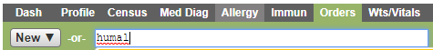

- Order Details: Complete the fields as required. If you are using Order Templates, some fields are populated for you. Review the fields for accuracy.
  - Order Date: Ensure the date and time match the time the order was received
  - Communication Method
  - Ordered By: click the magnifying glass to find the provider if it was the last prescribed by click on the link to add the provider
  - Medication Name
  - Dispense as Written (DAW) - Check only if the prescriber does not want alternative or generic medications dispensed.
  - Order Type will be selected by default
  - Route of Administration:
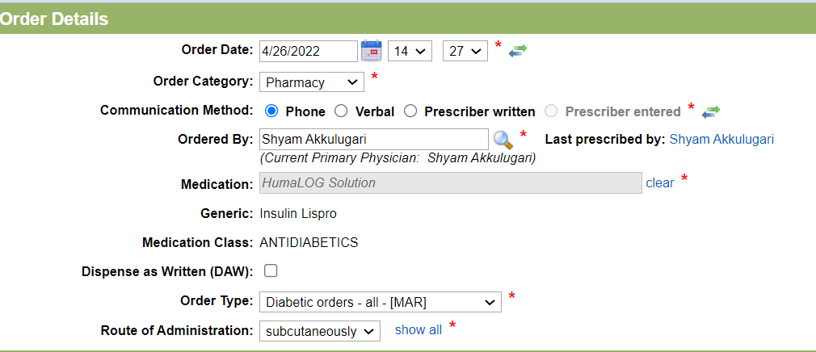
Order Summary: You can view the full order details as you are completing the fields. Click anywhere on the screen to update the Order Summary.
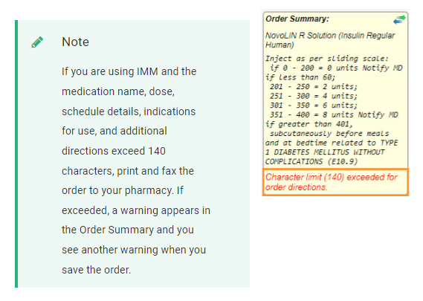
Additional Information: lists Drug Protocol alerts and Dose alerts. Click the alert to see more information.
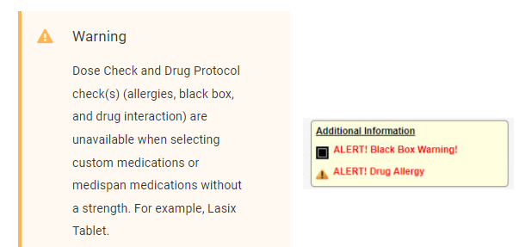

- Enter Scheduling Details: Complete the fields as required. If you are using an Order Template, some fields are populated for you, review the fields for accuracy.
  - Add Schedule - Select 1 or multiple schedules. Titration and STAT can't be combined with other schedules
- Click Routine for Sliding Scale insulin
- Enter ranges starting with 0. (make sure to include low and high parameters in the directions section)
- Click add another range until all ranges are entered
- Click Record a location upon administration
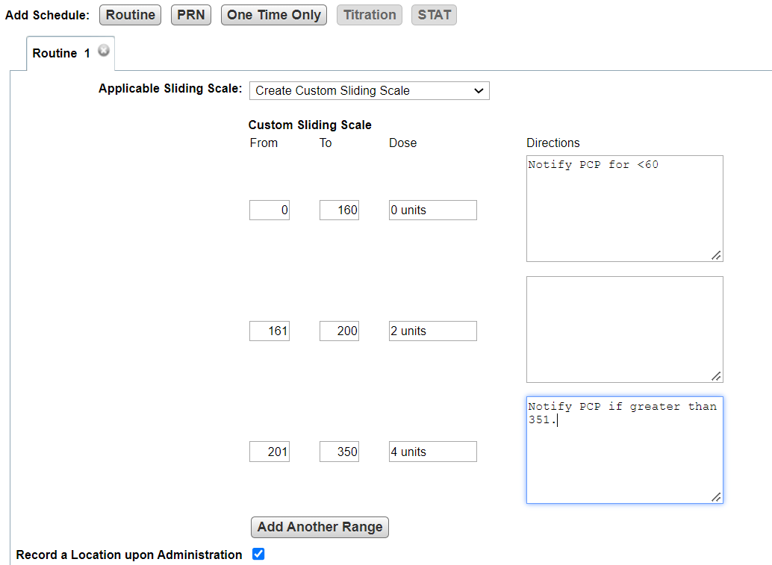
350

- Frequency: Select how many times a day the order is administered. For example, one time a day, every 12 hours, and so on
- Schedule Type: Select how often the order is being administered.
- Facility Time Code: Select from a list of configured options for the time(s) or range(s) the order is administered.
- Related Diagnosis: Select from a list of the resident's active diagnosis. You can also create a new diagnosis if needed
- For (Indications for Use)
- Additional Directions: Type any other information given as part of the order that is not included in the above fields
- Administered by: Select who is going to administer the order. This determines how the order is documented in eMAR and on your paper MAR. For example, Unsupervised Self-Administrations appear in eMAR, but they are automatically marked as given at the designated time.
- Start Date: Select the date and time of the first administration
- Pass Time(s) - This field populates based on what is selected for Facility Time Code. This can be changed depending on the selected Frequency.

