Purpose: ChartPic is a IOS application to be used on iPhone, and iPod Touch using iOS 7 or higher. This application connects to PCC and allow you to take pictures of the resident and place it on the chart without storing the picture on the device being used Note: ChartPic is not available for Android.
IOS Settings
The following setting need to be verified in the Setting and ChartPic
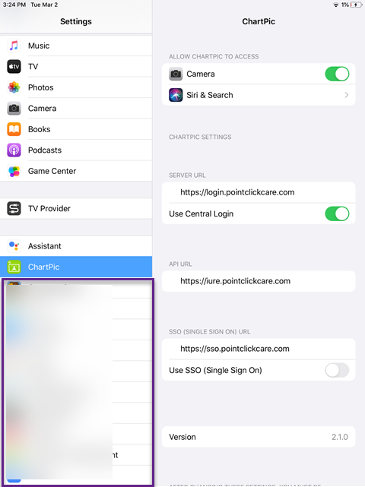

ChartPic Log in
To Log into ChartPic type you org code and userid. Example CSC.jdoe
Type your PCC password.
Click LOGIN.

Taking a Picture:
Select Resident by clicking on the name of the resident.
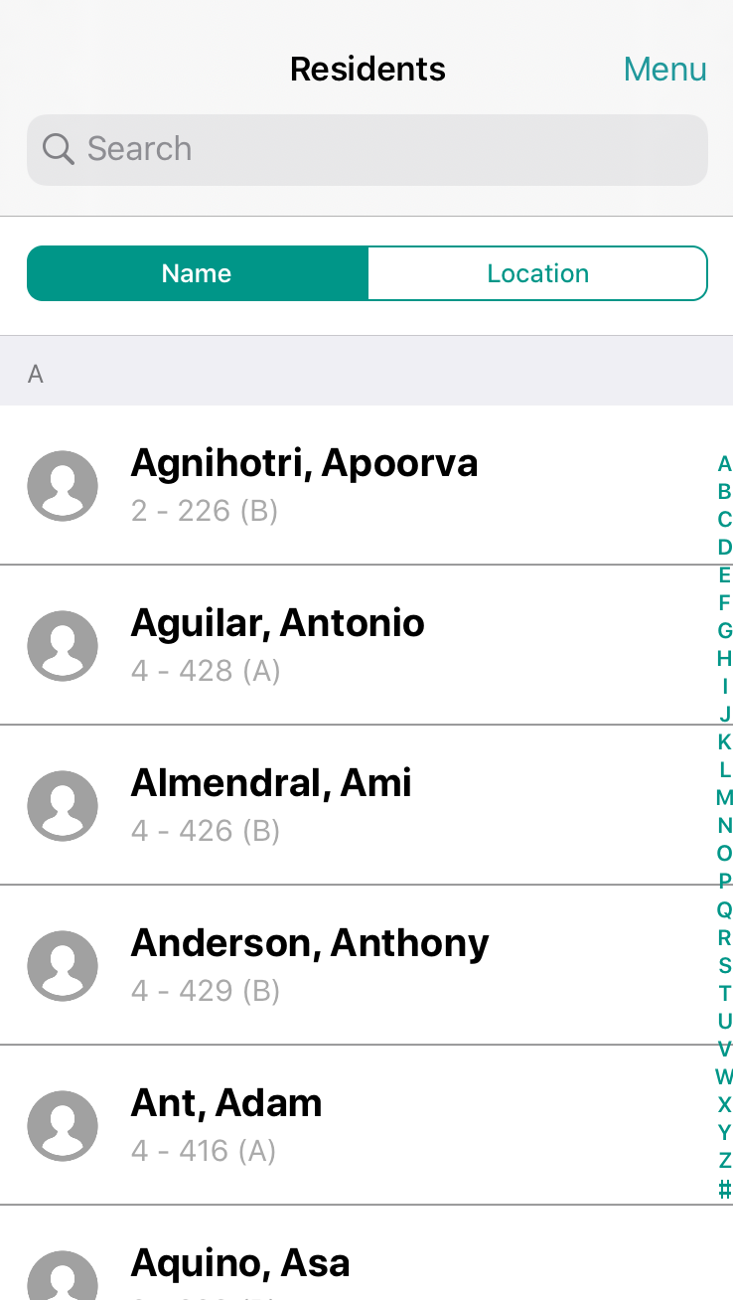

Click on Take Photo
Once photo is taken, click Use Photo.

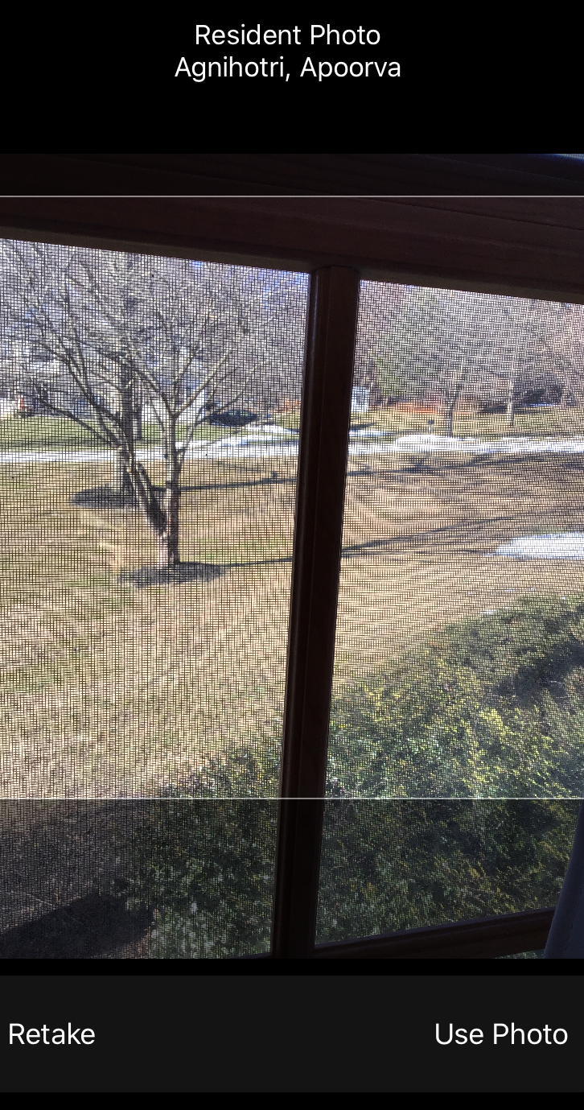

The photo is uploaded to the chart.

