1. **New User** 
   1. New Employees will sign the EMR Acknowledgement and the center designee will attach in e-mail, in the ticket portal or fax with cover sheet to: (917)633-4854.
   2. Open a support ticket - http://cfc.freshdesk.com/support/tickets/new or email EHRsupport@centershealthcare.org or call EHR Support Hotline Number - 917-633-4854
   3. In the body of the ticket or the fax cover sheet clearly state the center, employee name, position and credentials.
   4. After Hours Support for new user set-up, new admissions, and escalation of system issues. Hours - 5pm-9am and on weekends. -- After Hours Support Number - 1-866-294-07682 ways to request a new user:
   5. EHR Support will add new user (per Security Request Permissions Guide) and provide person making request with user name.
   6. Password
      1. During Normal Business Hours: Unit Manager, ADON, DON, or Administrator to assign a password and provide information to new user. Only request for a provider, corporate or regional staff should be supplied in the ticket response email.
      2. Outside of Normal Business Hours:
         1. EHR Support will request Shift Supervisor to initiate a remote session.
         2. EHR Support will watch remotely as Shift Supervisor logs in to PCC.
         3. Once EHR Support verifies that caller is Shift Supervisor they will provide supervisor with New User and Password.
2. **Password Reset /Assign Passwords**

The Administrator, HR, DON, ADON, Unit Manager, Supervisor or Therapy DOR can reset or assign passwords. Here are the instructions to do that. Let me know if you need help.

 Go to:

Admin tab

Setup

Security Users

Search for name in search box

Click “pwd” change password

Make sure you check the box for “change password on login”

Give the password you put in to the user.

 New Password is for everyone except C.N.A.( s)

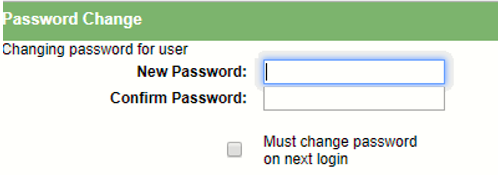

 New Alternate Password/ PIN is for C.N.A. (s) only.

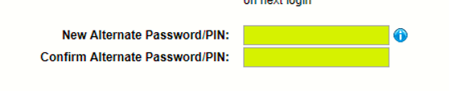

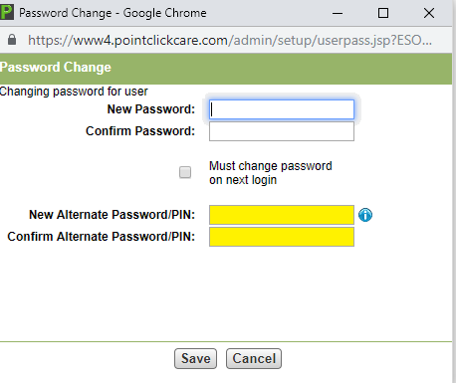

**Note: We are not able to disclose passwords in tickets. Please follow the password reset process as stated above. Password reset for a multi-center user that cannot be done by the center open a ticket with EHR Support.**

1. **Role/Position Changes**
   1. All Role/position changes must be requested by opening a support ticket.
   2. A user cannot request to have their own role changed; the request must come from their supervisor.
   3. EHR Support will make appropriate changes and reset the password (an email notification will be sent to requestor that the user has had role/position changed)
2. **Remote User**
   1. All request for non-standard position having remote must be approved by the Administrator or Regional Representative. Hourly employee should only be given remote access in an emergency because of labor laws.
3. **Re-enabling User**
   1. If a user has been in the center before, they can be re-enabled.
4. **Disabling a User**
   1. A Unit Manager, ADON, DON, DOR, or Administrator must then Submit a CFC Support Ticket to have user permanently disabled from all EHR System including Point Right.