On the Admin tab click on New Resident
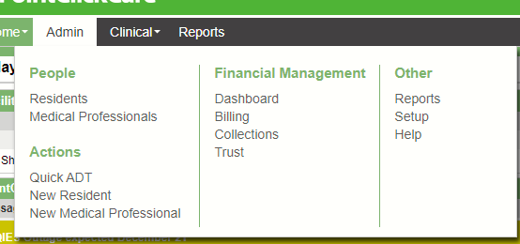
The following window will display:
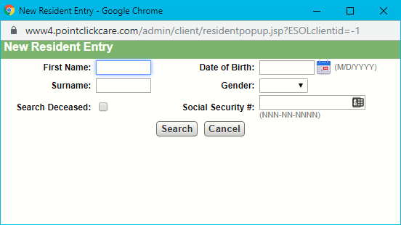
Complete a search using the name or another identifier. It is best practice to search on surname only or surname and an identifier.
NOTE: It is important that a duplicate resident is not created in the system. PCC cannot merge a duplicate resident.
If the resident is found in your search you can choose the resident by changing your selection it leaving the selection on none and clicking continue.
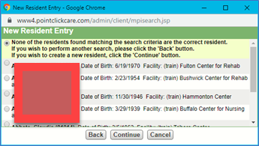

If you select to continue and add a brand-new resident the Resident Detail window will display. Complete the information. indicates that the information is required in order to save. Any item color coded in blue means that it populates into the MDS and should always be checked for accuracy.
Click Save when completed.
Choosing an existing resident will also bring you to the Resident Detail window for updating.
Deleting a Resident Profile
If a new resident is added in error the resident profile can be deleted as long as there is no information on the chart. There is some Clinical Information that can not be deleted once entered.
To delete a profile:
- Select a resident
- Edit the Profile
- Click on Delete (the system will indicate if the profile can be deleted or if information is found on the chart)
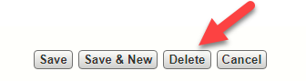
- Go to that area of the chart remove the information.
- Typically Orders added to the chart, Weights and Vitals, documented tasks and other areas of the Clinical Chart can not be deleted.

