Purpose: The MDS: UDA is used to schedule the IDT required assessments that cover the MDS Lookback. When the ARD of the MDS is set you MUST schedule or open the MDS:UDA. Upon locking the MDS:UDA the IDT assessment(s) will be scheduled. The MDS:UDA does not needs to be completed for Admission or Readmitted resident since the IDT assessments are set to trigger from census. Comprehensive, Quarterlies, IPA’s or 5day (standalone) must have the MDS:UDA completed and locked.
Reminder: The IDT assessments effective date MUST be within the 7-day lookback period of the MDS. An IDT assessment outside of the lookback period of the MDS will not pull information into the MDS. The MDS:UDA will allow you to schedule the IDT Assessments up to 30 days in future but the IDT team should be reminded on the 7-day lookback for the MDS.
Scheduling the MDS:UDA
When you do the first MDS:UDA for a resident you must schedule the MDS:UDA to activate a quarterly schedule once the initial MDS: UDA is locked. This will place a schedule reminder that you have an MDS: UDA due 90 days. The schedule will be based on when the initial MDS:UDA is locked.
This is to assist you in not missing a scheduled MDS that needs supporting documentation. When this is used, you will need to monitor the UDA Portal and the Scheduled tab on a daily basis for the MDS:UDA(s) that are due to be filled out.
NOTE: If you need to trigger the IDT assessments for an IPA or a 5 day that is outside of the schedule then you must manually open the MDS:UDA (see below).
To Schedule the MDS: UDA
Go to the Resident Chart
Click on the Assmnts tab.
Click on Edit Schedules
Click on the arrow and select the MDS:UDA
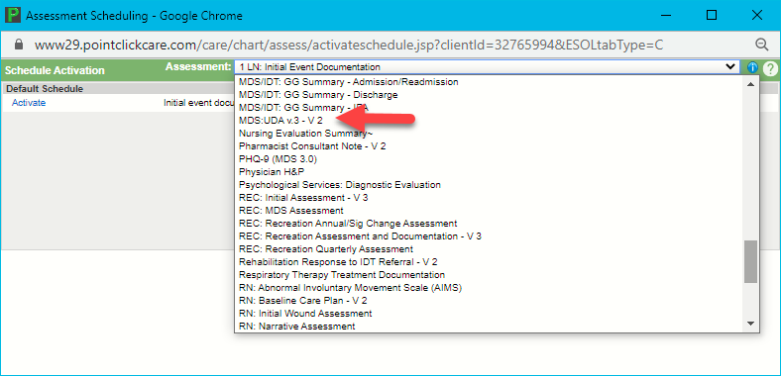
The following window will display:
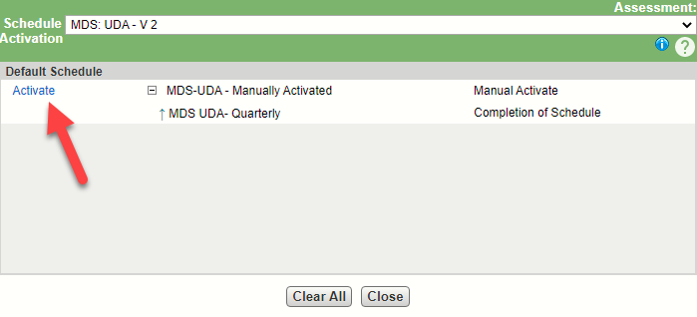
Click on the Activate link.
The following window will display:
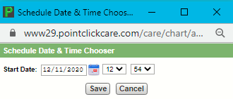
Set the date to when you will need to do the MDS:UDA to allow the IDT Assessments to be done within the ARD lookback.
Click on Save and then Ok the message to “Activate Schedule”.
If you wish to do the MDS:UDA immediately for the current MDS cycle, click on the + to the left of Next Assessment Due and click on the MDS:UDA to open, complete and lock. Upon lock this will schedule the next MDS:UDA for the resident 90 days from when you lock the MDS:UDA.
Example: If you schedule the MDS:UDA for the MDS office to do and the ARD of the MDS is 12/31/2020. The ARD lookback would begin 12/25/2020. You would schedule the MDS:UDA to be done on the 25th and select 7 days. The MDS:UDA can be set to schedule the IDT Assessments from 3-30 days.

To monitor what MDS:UDA(s) are scheduled you will go to the UDA Portal under Care Management.
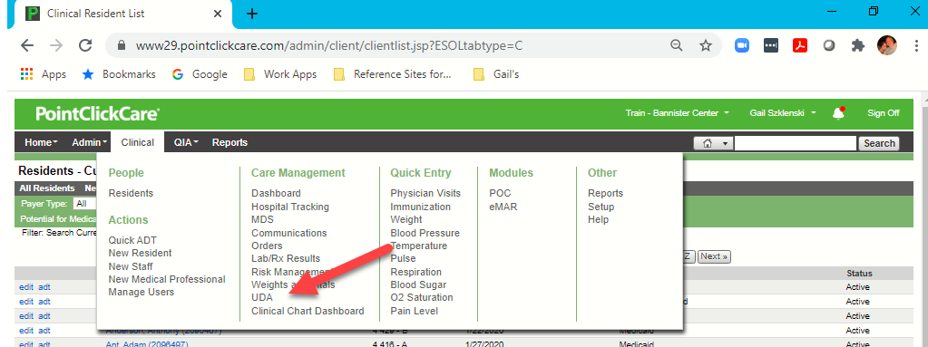
In the UDA Portal select the Scheduled tab.
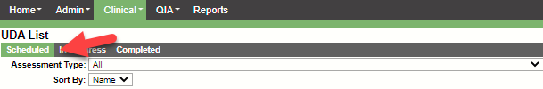
In “Assessment Type” select the MDS:UDA every morning to see what assessments you have to do. The “Show Assessment due in the next ____ days will default to 7.
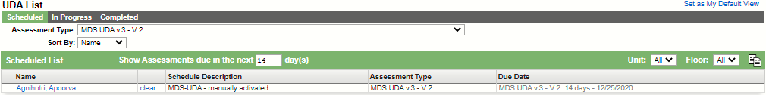
The Due Date will reflect when you scheduled the MDS:UDA to be completed, signed and locked.
Open the MDS:UDA by clicking on the name of the assessment under the Due Date Column. (Remember that the Assessment Date / Time cannot be set to the future).
The following window will display:
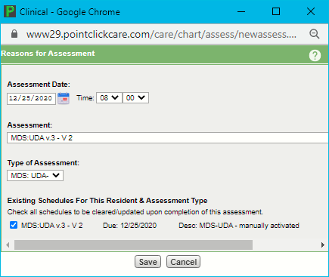
Make sure the Assessment Date and Time are correct and the check remains on the box to clear the schedule.
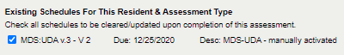
The MDS:UDA assessment will open, complete, sign and lock to trigger the schedule for the IDT assessments.
Remember if the MDS ARD changes you will need to clear the schedule and adjust when the MDS:UDA needs to be completed.
Opening the MDS:UDA
Note:
Navigate to the resident chart.
Click on the Assmnts tab
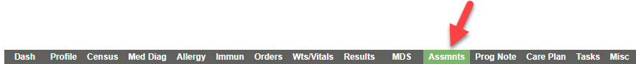
Click on the New button.
Select the MDS:UDAxxxxx
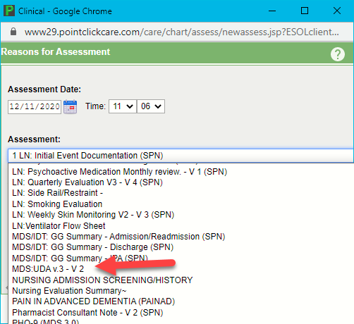

The following window will display:
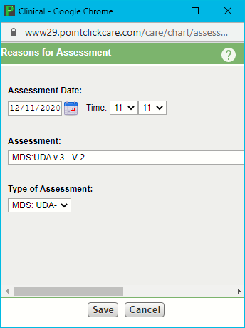
Verify the date / time (this cannot be in the future).
Click Save to open the assessment and complete data entry.
The following assessment entry window will display:
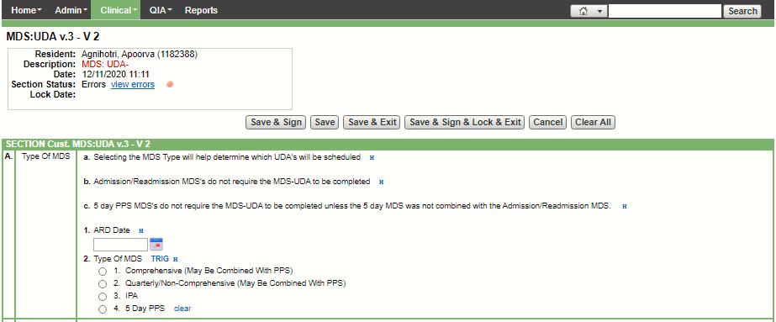
In Section A read all current instructions. Enter the ARD date of the MDS
Select the Type of MDS. Based on the selection section B, C, D, or E will be available for data entry.
Determine the numbers of days from todays date including the ARD date to select when the schedule due date will be set for the IDT assessment that are trigged. This can be 3 – 30 days from the ARD,
EXAMPLE: If the ARD is 12/16/2020 and today is 12/11/2020 then the number of days would be 6 days.
Choose the number of days. The choice in most cases will be from 3 days until 30 days.
Then Save Sign and Lock and Exit. (The MDS:UDA must always be locked in order for the IDT assessments to be triggered or scheduled).
Assessment Reference Date Changes
If the ARD changes the you will need to review the what IDT assessments have been scheduled and clear the schedule prior to opening another MDS:UDA to trigger / schedule the IDT assessments for the new ARD.
Clearing the UDA Schedule
Go to the resident chart.
Go to the Assmnts tab
Click on Edit Schedules. .
Click on the Clear All 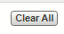
Change the “As of Date” to the a day after the IDT assessments are scheduled and click on Refresh List
The window will list all the Assessment that all schedule of the date selected.
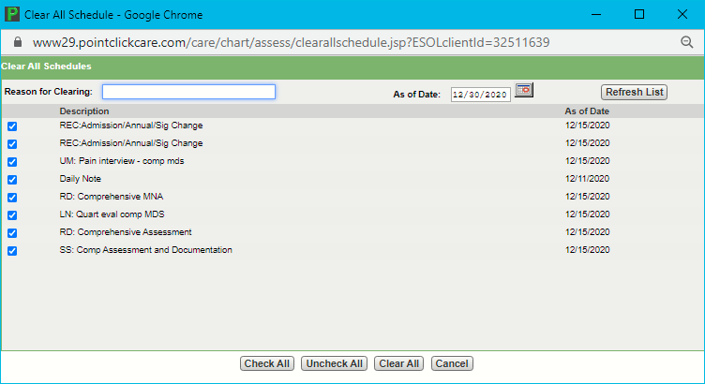
Check only the Assessments that you need to clear. NOTE: Once the schedule is cleared you cannot undo.
Type in the “Reason for Clearing”
Click on the Clear All button

