CHC Guide to Unlinking Orders in PCC

Orders – Resident Orders Tab
• Go to the resident orders tab
• Select the filter next to Actions on the medication that needs to be unlinked
• Click on the blue hyperlink beneath Supply/Medication
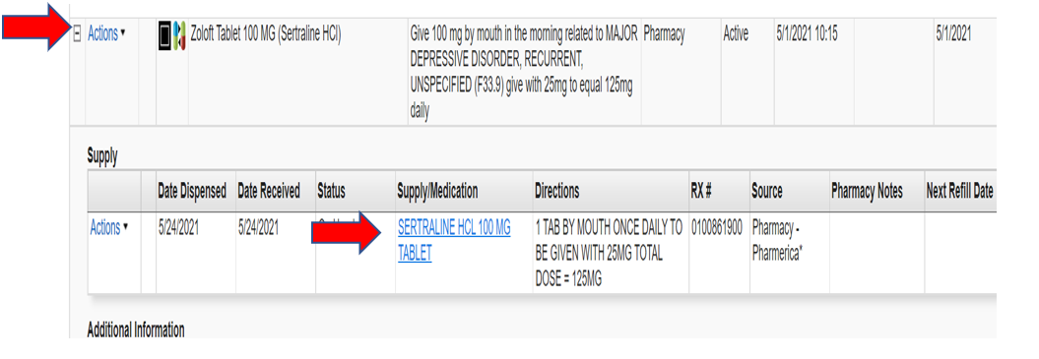
Unlinking – 3 Possible Scenarios
• Uncheck Box and update linked order(s)

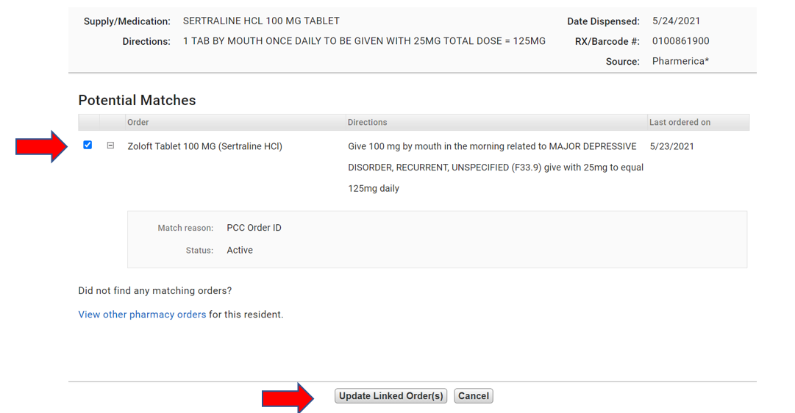
• Update Supply/Medication to read as Ordered (See below for details)
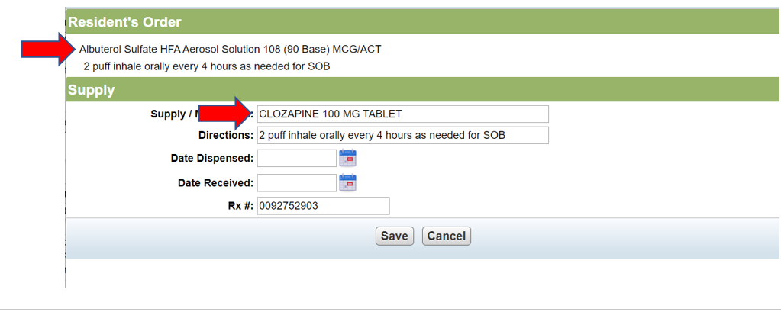
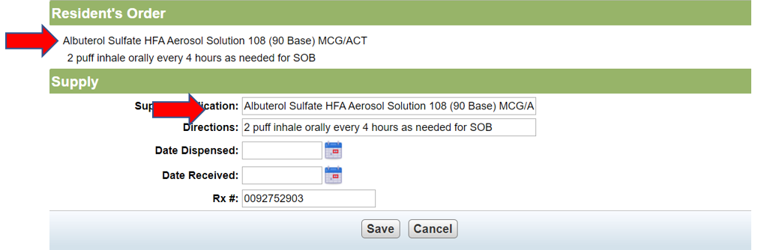

• Controlled Substances that have been linked incorrectly may require to discontinue the current order and create a new order

