Care Plans: Navigating the Care Plan Tab
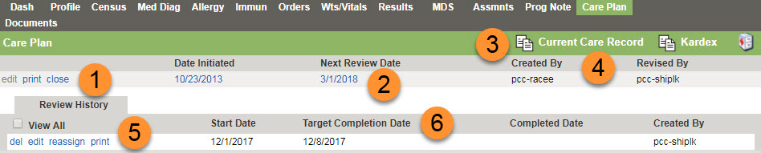
- Various links
  - edit - Click to edit the resident Care Plan.
  - print - Click to print the resident Care Plan.
  - close - Click to close the resident Care Plan.
- Date Initiated and Next Review Date
  - Date Initiated - Date the Care Plan was started.
  - Next Review Date - Date for next Care Plan review.
- Current Care Record and Kardex icons.
  - Click to view resident Care Record and Kardex.
- Created and Revised
  - Created By - Name of individual that created the resident Care Plan.
  - Revised By - Name of individual that revised the resident Care Plan.
- Various links for Care Plan review.
  - del - Click to delete the resident Care Plan review.
  - edit - Click to edit the resident Care Plan review.
  - reassign - Click to reassign the resident Care Plan review.
  - print - Click to select print options for the resident Care Plan review.
- Target Completion Date and Completion Date
  - Target Completion Date - Selected when Care Plan review is created.
  - Completed Date - Date Care Plan review is completed.
Care Plans: Navigating the Care Plan
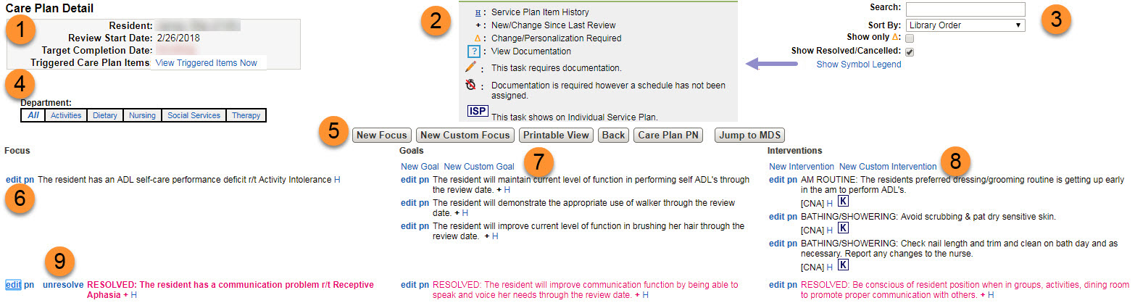
- Care Plan Header: Resident Name, Review start date, target completion date, and triggered care plan items.
  - Triggered Care Plan Items - Click to view triggered items.
- Care Plan Show Symbol Legend: Explains icons that appear in the care plan.
- Filters
  - Search - Type search item and click enter.
  - Sort By - Select option to sort by: Library Order, Revision Date or Intervention Date Initiated.
  - Show only - Select to show care plan items that require personalization.
  - Show Resolved/Cancelled - Select to show all resolved/cancelled care plan items.
  - Show Symbol Legend - Select to show symbol legend, see #2 above.
- Department and Care Plan Types: Click the department(s) to view the care plan types.
- Care Plan buttons:
  - New Focus - Click to create a new focus.
  - New Custom Focus - Click to create a new custom focus.
  - Printable View - Click to select Care Plan print options.
  - Back - Click to return to the resident chart.
  - Care Plan PN - Click to create a Care Plan progress note.
  - Jump to MDS - Click to open the resident MDS.
- Links
  - To edit the focus, goal(s), or intervention(s), click edit.
  - To create a progress note, click pn.
- New Goal/New Custom Goal
  - To create a new goal or new custom goals, click New Goal or New Custom Goal.
- New Intervention/New Custom Intervention
  - To create a new intervention or new custom intervention, click New Intervention or New Custom Intervention.
- Unresolve link:
  - Click the unresolve link to unresolve a previously resolved or cancelled focus.
Care Plans: Activating the Care Plan
New care Plan: If No Records found.

Clinical> Resident> Care Plan Tab on Resident Chart> Click on New
The care plan will initialize and immediately open to allow for editing.
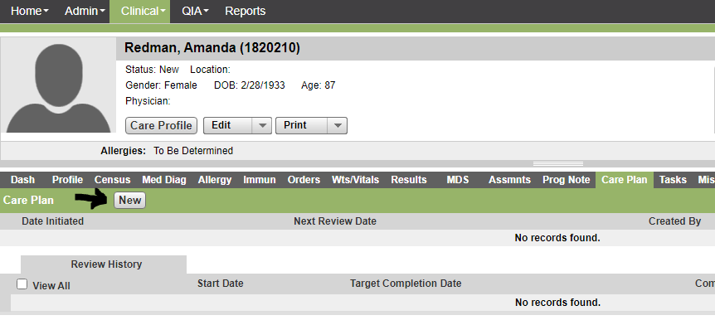
Triggered Items:
Triggered items are care plan focuses, goals, interventions and tasks that have been suggested based off the answers in certain assessments. These triggers are to be reviewed upon admission and with every care plan review. Not all triggers may apply. Select the items you do not wish to use and choose remove all. Select the items you do want to add to the care plan and then click on save.

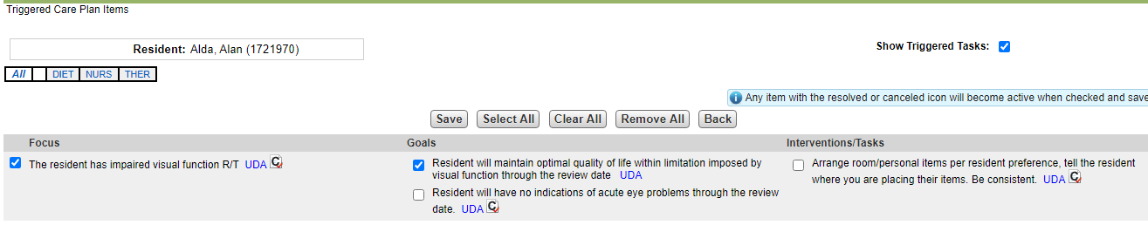

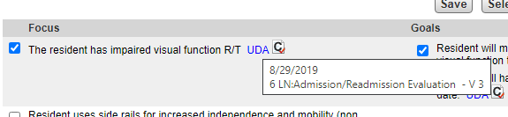
Tip: Hovering over the UDA link will show where the trigger originated from so you can review if it is the most recent information and still pertinent to the resident’s care.

Creating and Updating Care Plan Focus, Goals with specific dates, & Interventions
- Clinical > Resident > Care Plan.
- Click Edit.
- Click New Focus and complete the following steps using the Care Plan wizard:
  - Select Library.
  - Select Focus Category.
  - Click Add to add the focus item in the care plan.
  - Select Etiology(ies) and click Next.
  - Edit Focus for further changes if needed and click Next.
  - Select Goal(s) and click Next.
  - Select Intervention(s) and click Save. Items are now part of your resident care plan and the most recent added item appears bold.
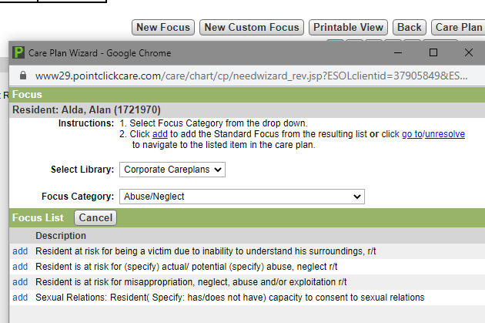
Tip: Care Plan Items that have a require personalization. You will not be able to complete the care plan without updating the required information.

- Click Edit next to each goal and intervention to personalize for the resident, as needed

Resolved/Cancelled Focuses Goals and Interventions:
To Mark Care Plan items as resolved or cancelled
- Clinical > Resident > Care Plan.
Tip:
Resolved Vs Cancelled

Resolved is for a CP item that is deemed no longer pertinent to the resident’s care.

Cancelled is for a CP item that should not have been added to the CP of that particular resident. (an error)

- Click Edit next to the focus, goal, or intervention to be resolved or cancelled.
- Select Resolved or Cancelled.
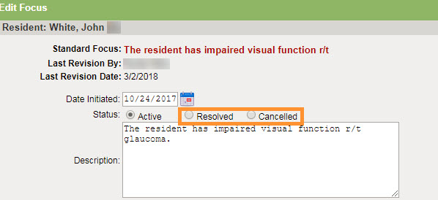
- Click Save

If you are trying to add a goal or intervention, but you see no check box: You must activate a resolved or cancelled item.
- Close window and select.
- Click Edit next to the goal or intervention.
- Select Status of Active, make changes as needed, and click Save.

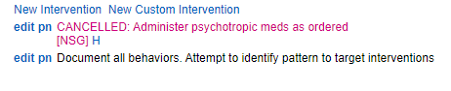

Custom Focus, Goals, & Interventions: A special note
Please, submit your frequently used custom focus, goals,
Warning: Custom care plan items can be used, but use them sparingly, as custom items are not easily tracked or pulled in reports.

and interventions to the EHR team so that they may be
reviewed by the Clinical team and possibly added
to our corporate library. If approved you no longer have to
manually enter the custom items each time.

Closing the Care Plan: Resident’s that are discharged without anticipated return will have their care plans closed automatically by the completion of the MDS Discharge Return not anticipated.

Care Plan Reviews:
Schedule based on MDS schedule and created by MDS coordinator. The care plan review is completed by the IDT by sections assigned to each department. Review all Triggered ITEMS during this review as described above. The care plan must be reviewed for completeness. All focuses must have goals and interventions that are still applicable for the resident’s care. The care plan has been customized for patient centered care with resident preferences and special needs. Make sure to write progress notes for items that have been changed so that if goals were not met or interventions were not effective, they were reviewed and updated with notes describing your reasoning for the changes made.

Progress Notes within Care Plan: Use the PN link in order to write notes related to care plan changes to provide documented justification why focuses goals or interventions were resolved or as a result of your IDT meetings following Accidents/Incidents, Psychotropics and other team meetings.

Tasks:
Tasks vs. Interventions
A task is an activity that is required to help achieve the goal of an intervention and typically has follow up questions and a schedule attached so that documentation can be completed by unlicensed personnel. A task is always on the Kardex.

An intervention is a plan to help achieve the goal of an intervention. An intervention may be on a Kardex but it is not required.

For example: An intervention for a fall would be to provide floor mats to a resident to help prevent injury. The task equivalent of this would be the staff placing that floor mat next to the resident’s bed and then signing that they completed the task.

Adding Tasks: Triggers vs manually:
Tasks can be scheduled automatically from the system from events like Admission, or triggered by assessments, or manually added. Triggered Tasks work just like care plan tasks. You have to decide which triggers to remove and which to add to the care plan/POC.
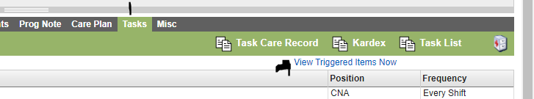

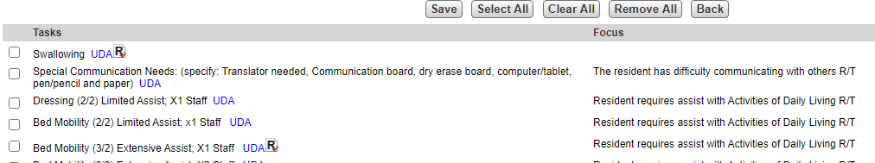

Warning: You must manually resolve duplicate tasks that may be created as residents change condition.
For example, if a resident used to require 3/2 assist with transfers and now requires 2/2 assist you must manually deactivate the 3/2 assist transfers when adding the new task for 2/2 otherwise both will be active on the task list.

Resolve/Cancel Tasks: Tasks can be resolved or cancelled from the task Tab of the resident chart or directly from the care plan in the same way that goals and interventions are resolved or cancelled.

Resident Chart Task Tab
- Clinical > Resident > Tasks.
- Next to the task, click edit.
- Select Resolved or Cancelled.
- Click Save.
- In the task list, select Show Resolved/Cancelled to see resolved and cancelled tasks.
- To reactivate a previously resolved or cancelled task, select Show Resolved/Cancelled > next to the task, click edit > select Active > change the other fields as required > click Save.

Kardex:
Viewing the Kardex:
You can view the Kardex from 3 different areas.
- POC: Resident chart
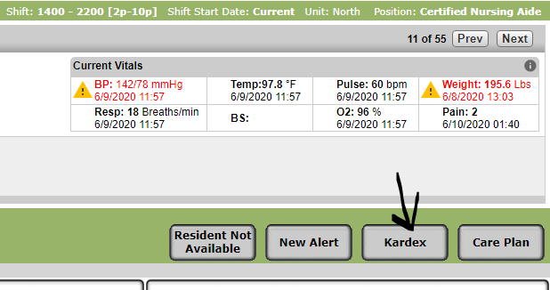
- Reports- Kardex report
- Resident Chart
  - Task tab 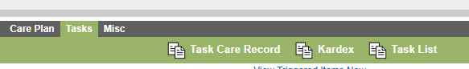
  - Care Plan Tab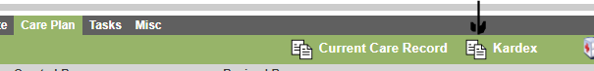

Example of a Kardex
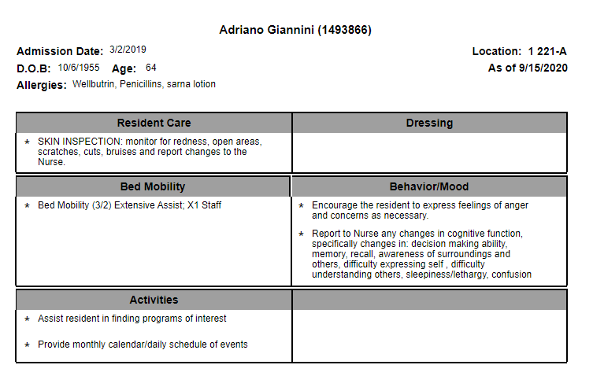

Kardex Creation: Automatic & Adding Manual entries
Certain interventions are automatically generated to the Kardex. These interventions are clearly labeled with the K icon .
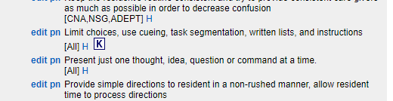

Manually add interventions to the Kardex
At times other details of care may need to be added to the Kardex that are not automatically assigned. These items may be manually assigned.
- Edit the intervention you want to add to the Kardex or if Custom add new Custom Intervention.
- Choose the Kardex Category you want this to appear under.
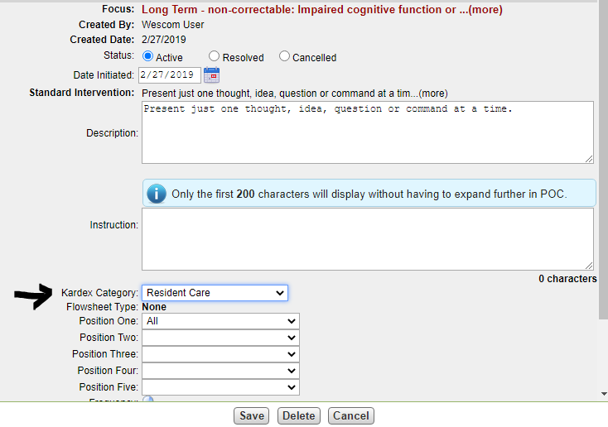
- Save the changes. The intervention will appear on the Kardex.
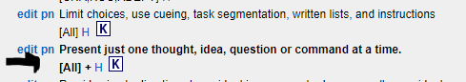

Warning: Remember that the Kardex is supposed to be the most simplified version of the care the resident needs. Adding too many items to the Kardex will cause the staff to miss the higher priority items as they get lost in between all the lower priority items. If the Kardex is too long the staff will not be able to provide care.

Saving the Kardex prior to Resident Discharge
You must save an electronic version of the Kardex and upload this document into the miscellaneous tab prior to discharging a resident. This document only exists for Active Residents meaning once they discharge the document will no longer be available.

