Option 1 Resident Chart Orders Tab
Click on the orders tab under the resident chart that needs refills
Click the plus button next to the medication that needs to be ordered
Click on the actions tab now shown below the supply
Click on reorder
Click on reorder in new window that pops up
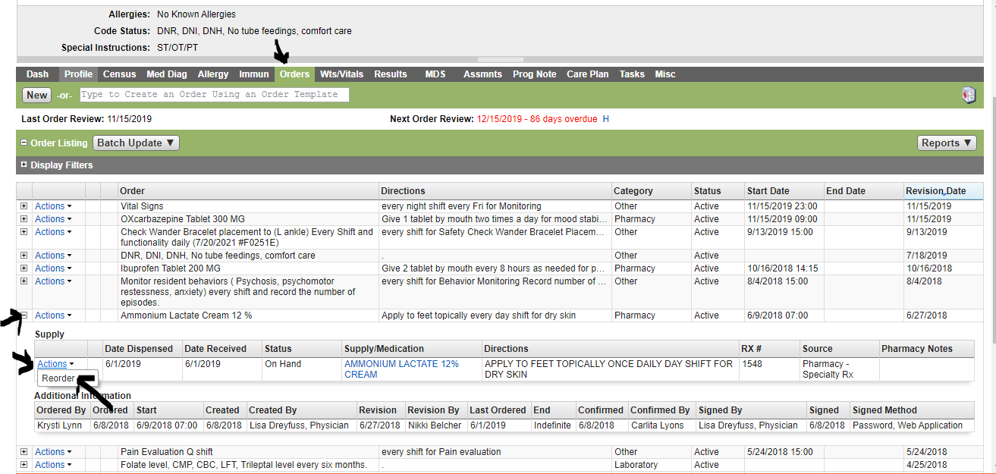
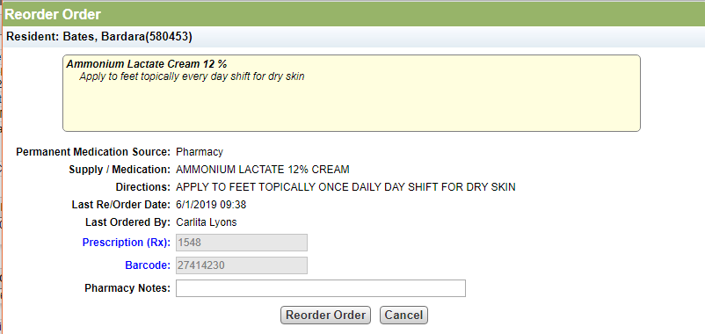

Option 2 EMAR Summary Tab during medication administration
Directly from the summary tab of the medication being administered
Click on the medication that you are administering. If you need to reorder because you see that it is getting low you can
Navigate to the summary tab on the administration screen and chose order under the supply heading. A second window will open that looks just like if ordering from the resident chart orders tab.
Click reorder order.

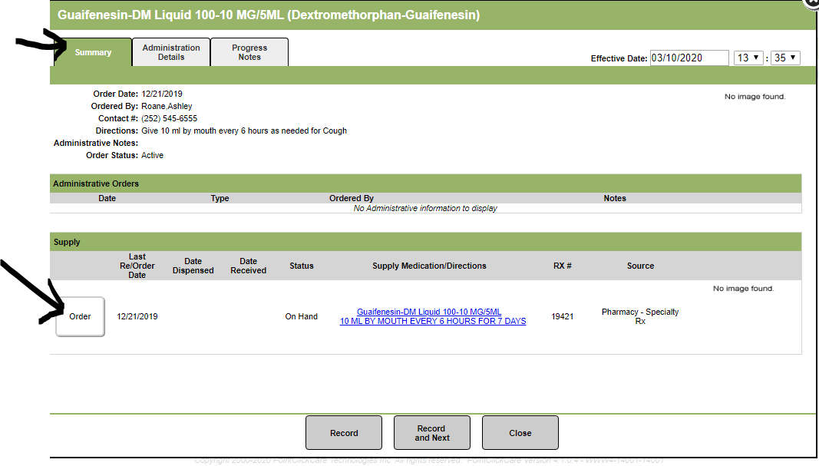
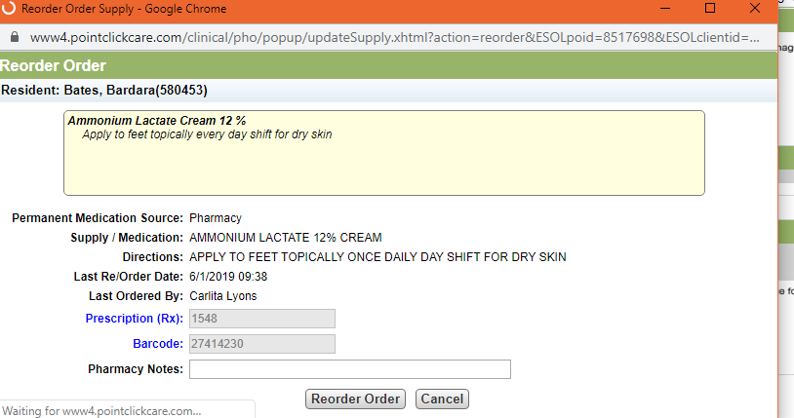

Option 3 EMAR other actions
Order multiple supplies at one time for same resident.
Navigate to resident that needs medications refilled
Click on other actions
Then on reorder order supplies
A new window will open
Click on the reorder button next to the medication.
Button is only available on items that have the source of pharmacy and have not been ordered recently
Once all selections have been made click on reorder supplies at the bottom.
