Navigating the Reports Tab Quick Reference Guide
This quick reference guide contains items required to navigate the Reports tab.
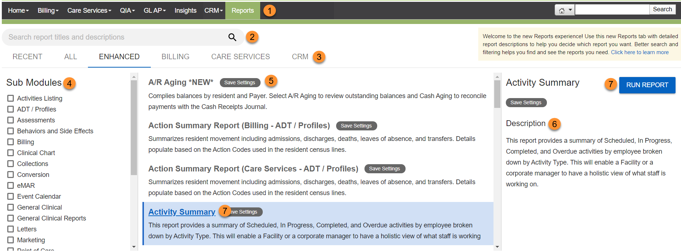

Item Number | Item Name | Description
1. | Reports | Opens the Reports tab.
2. | Search | Locates reports by searching all report names, modules, sub modules, keywords, and report descriptions.
3. | Module | Lists all reports available for a specific module. Click Recent to access reports you ran in the last 60 days.
4. | Sub Modules | Filters the list of reports based on report type.
5. | Report List | Shows an alphabetical list of reports based on search criteria. Includes a short description of the report.
6. | Description | Provides a detailed explanation of the report including hints, tips, and definitions.
7. | Run Report | Click Run Report or click the report name to specify the options and parameters for the selected report.

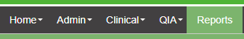
You can search for a specific report by typing in the search bar.
If you accessed reports previously from the Admin tab click on Admin. Based on security the reports that you have access to will be listed. Click on the name of the report and then click on RUN REPORT.
If you accessed reports previously from the Clinical tab click on Clinical. Based on security the reports that you have access to will be listed. Click on the name of the report and then click on RUN REPORT.

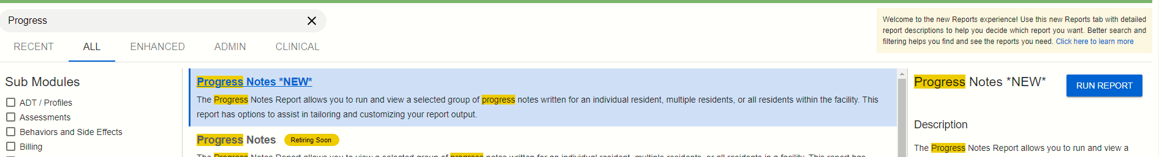

RUN REPORT will bring up the report page and allow you to select the criteria.
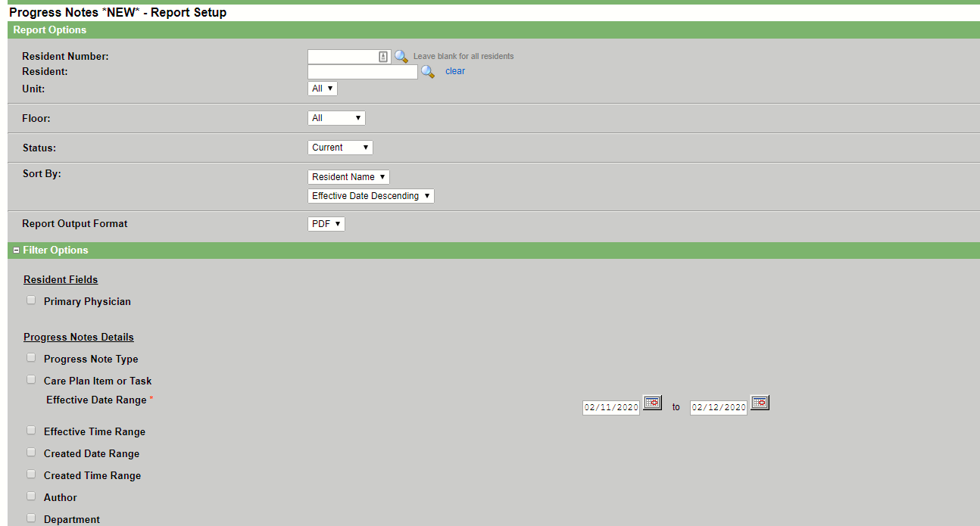

Some reports i.e. Action Summary will allow you to save report setting so that the report can be run over again. The reports that allow Save Settings are denoted by the 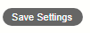button. You can save more that one report option settings to save.
Over time PCC will be adding more reports that allow you to Save Settings.

