CVX Code Clearing for Immunization Tab

On February 19, 2018 a new feature was turned on for the immunization tab in Point Click Care. This new feature is called a CVX Code, which codes immunizations by type of vaccine. This is a requirement as part of our integration.

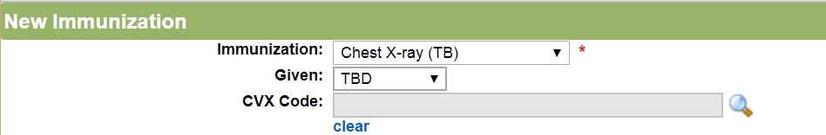
This new feature has caused some confusion, because it is a required field. However, the options in the default setting are not appropriate for the tests in the immunization tab. The popup also has a phrase advising against using inactive vaccine codes.

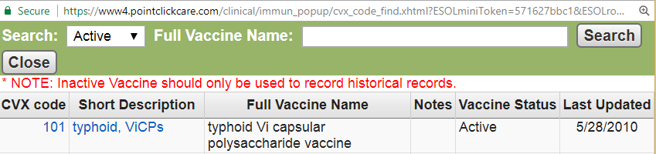

For tests, such as Chest X-Ray, TB One Step and TB Two Step, it is appropriate to use the inactive options by changing the search feature to “Inactive”. This will give the user a list of options for the TB tests. At the present time, PCC has advised to use the test option for Chest X-Ray as well, until a resolution is found.
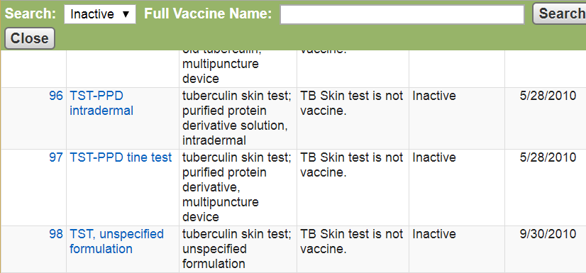

Any staff having a question may call the PCC Support line for Centers at 917-633-4854 during business hours.

