HOW TO PRINT……..
MARS/TARS
Go to Clinical tab
Other
Reports
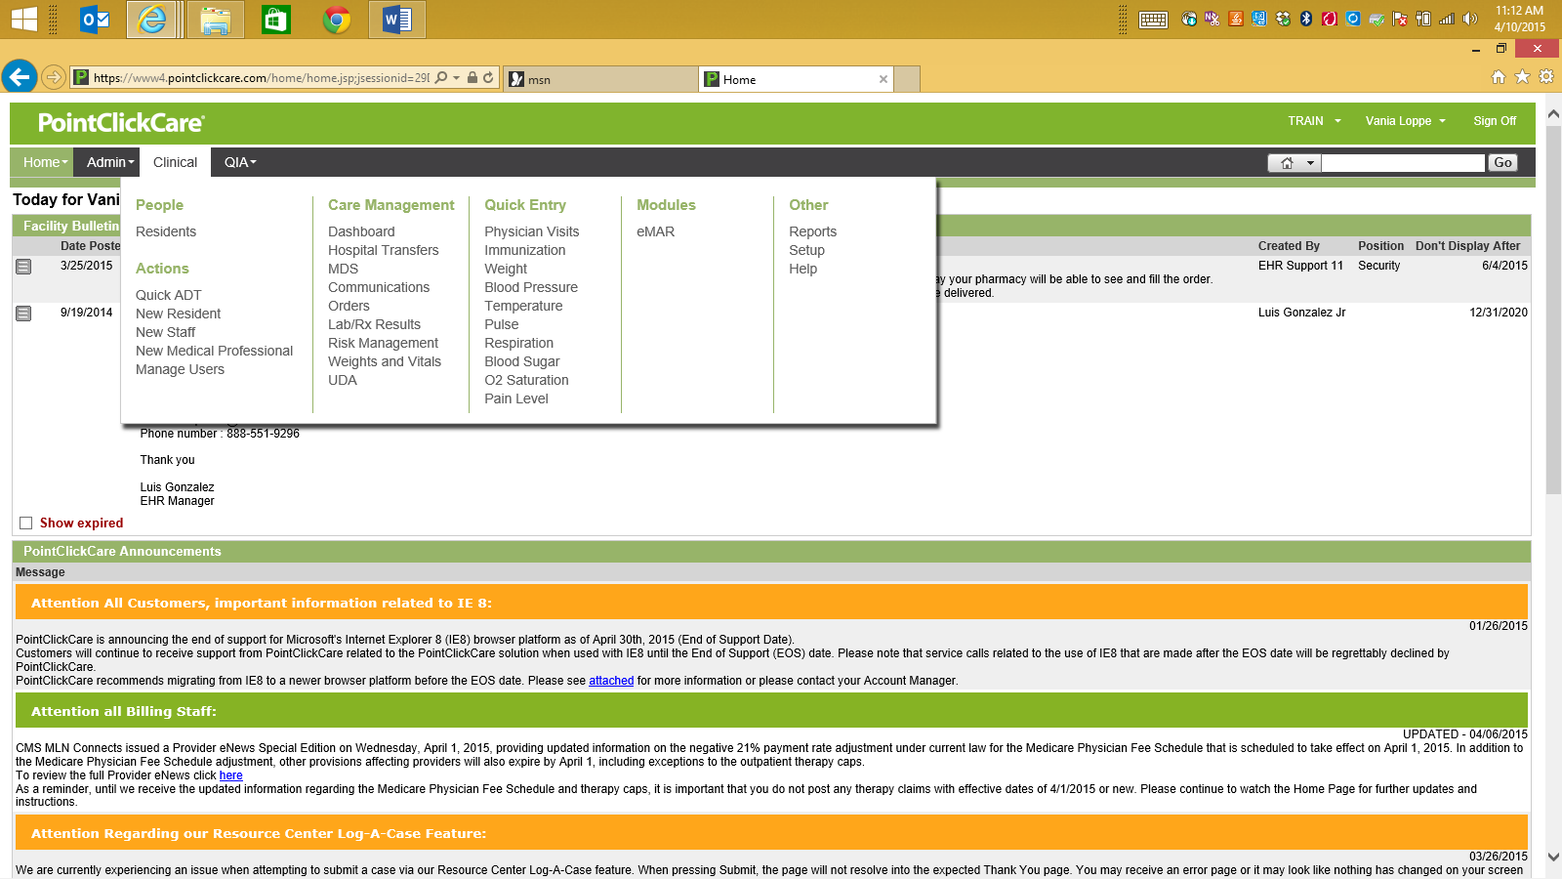
Once in Reports , scroll down and click on Administration Record.

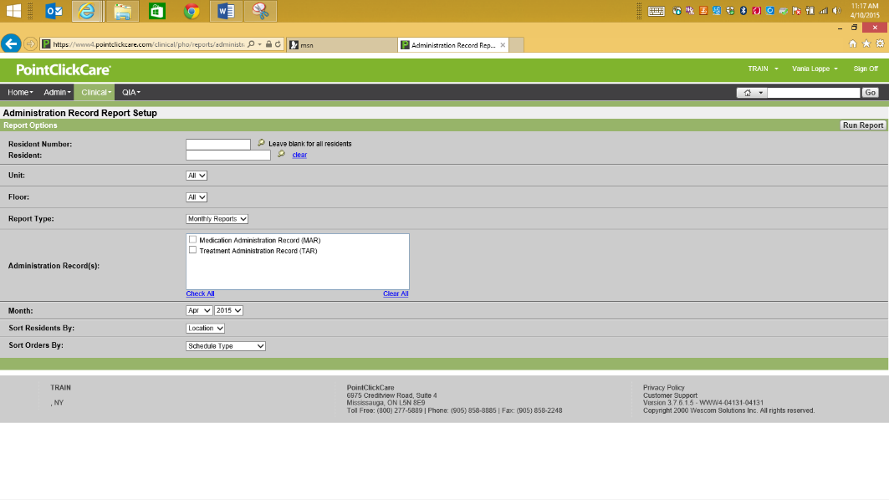
Once you are in the Administration Record Report Setup you will be able to customize the report by picking the resident, unit, floor, report type, choose MAR or TAR or both, month. You will be able to choose how the resident report will be displayed. Once chosen, click Run Report.
Example of a printed MAR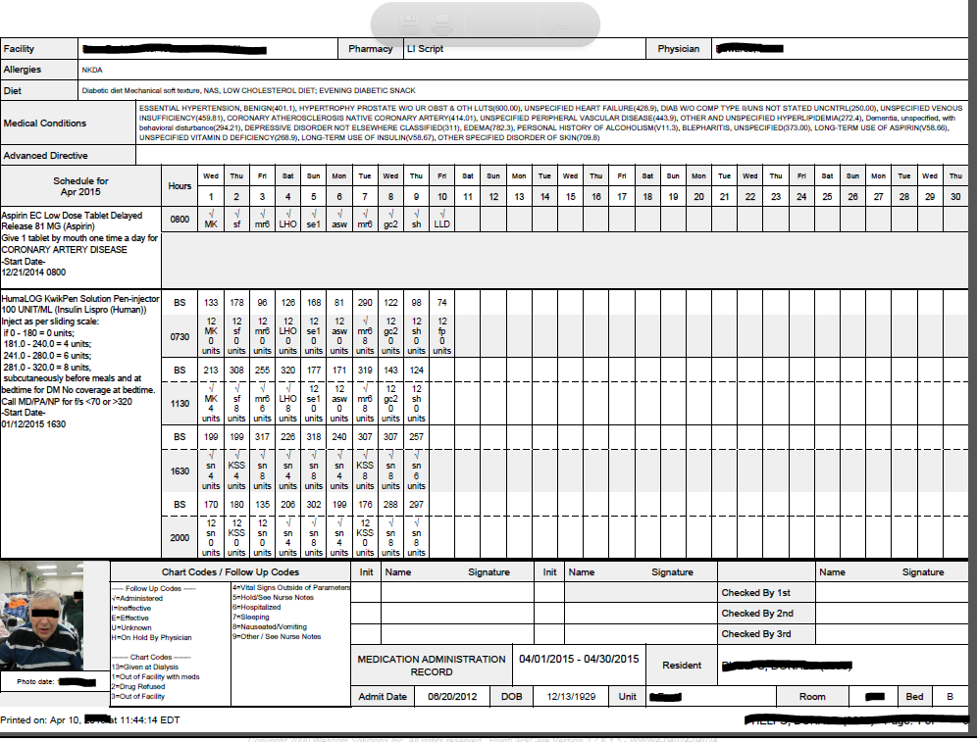
A printed MAR will show the nurses initials, the chart code and response to supplementary documentation if applicable.

Method 2:
You can print a MAR or TAR right from the eMAR window. To print a report go to Other Actions, click on Administration Report.

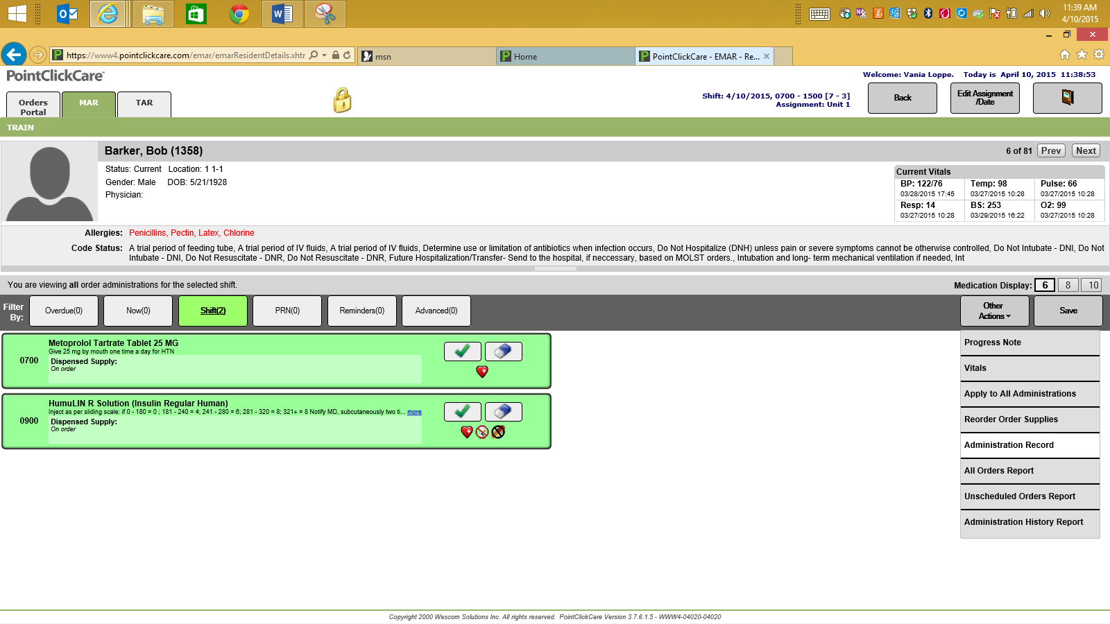

TASKS- You can print reports for tasks assigned to the resident by clicking on the Task Flow Sheet, Kardex and Task List located on the upper right hand corner of the task tab.

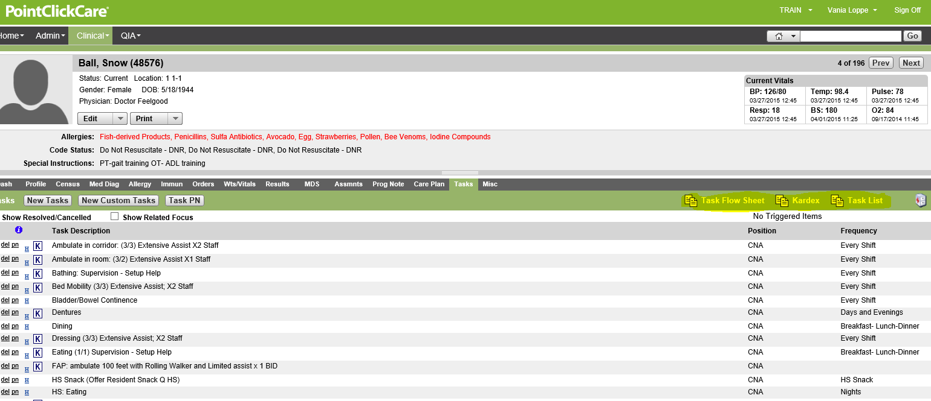
Example of Task Flow Sheet Report
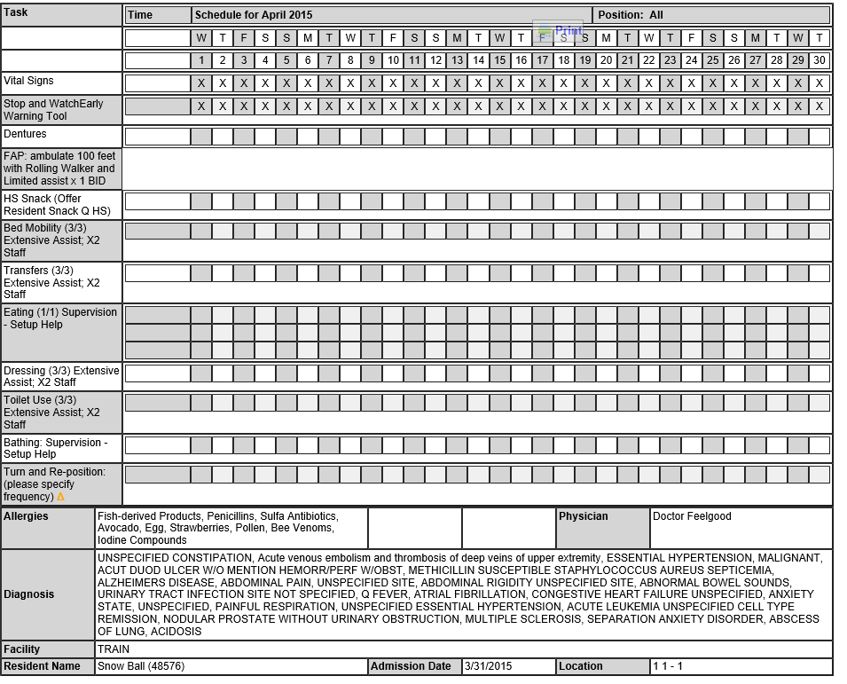

Example of the Kardex
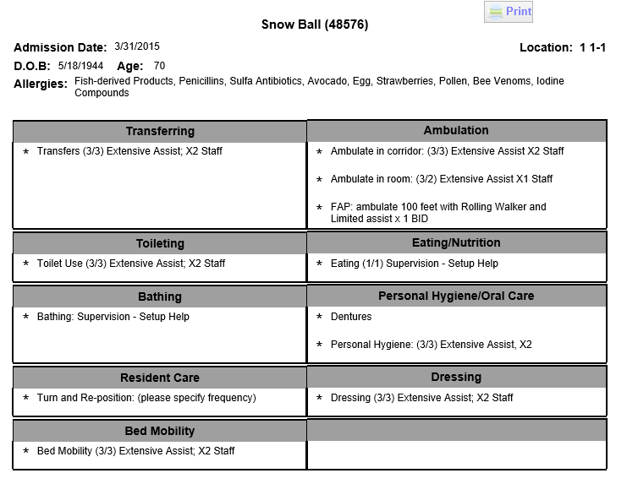
Example of the Task List Report
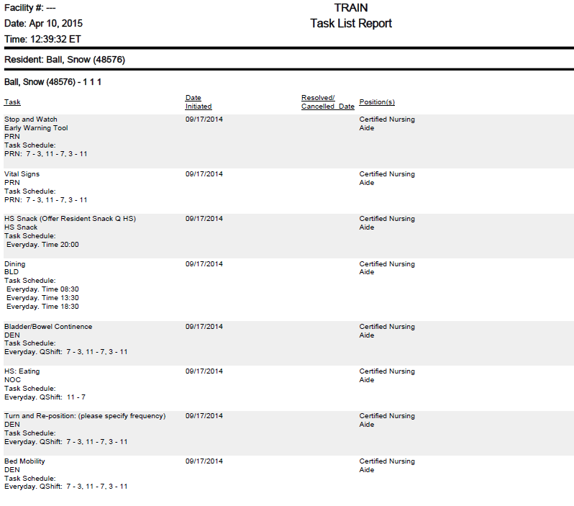
Other Reports available for POC /Tasks/Certified Nurses Aide

In Clinical tab, select Reports, scroll down to Point of Care category. Here you will be able to print out a variety of reports regarding the C.N.A. documentation.
Example of the Look Back Report: Choose the Unit, Floor, the type of report( ADLs, Alarm and Wanderguards, Bathing, BM Report, Late loss ADLS, Meal Intakes, Nourshiments, Skin and Toileting)
Choose the Look Back Period from a specific date. You can choose to look back 3 days, 7 days, 14 days or 16 days)
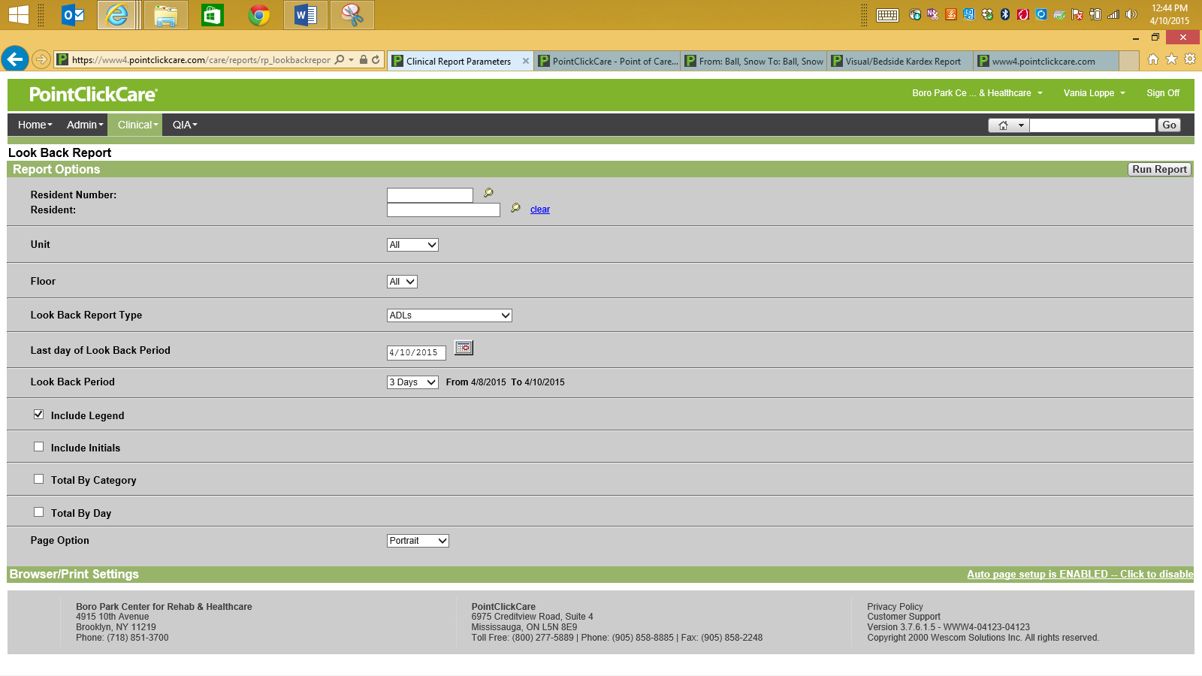

Example of: ADL Look Back Report 3 days
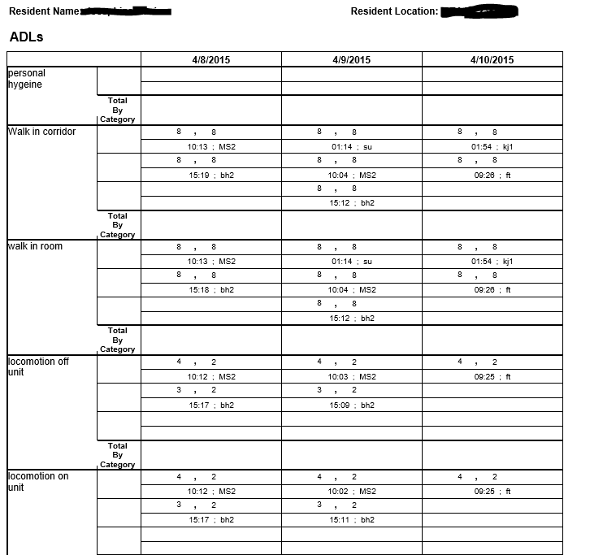

Time of documentation/Initials

ADL Score

Printing Careplans/Tasks: You can print careplans by going to Clinical Tab choosing Reports and scrolling down to the CarePlans/Tasks.

Example: Care Plan Report Setup: You can modify what appears on the printed report by checking filter options.
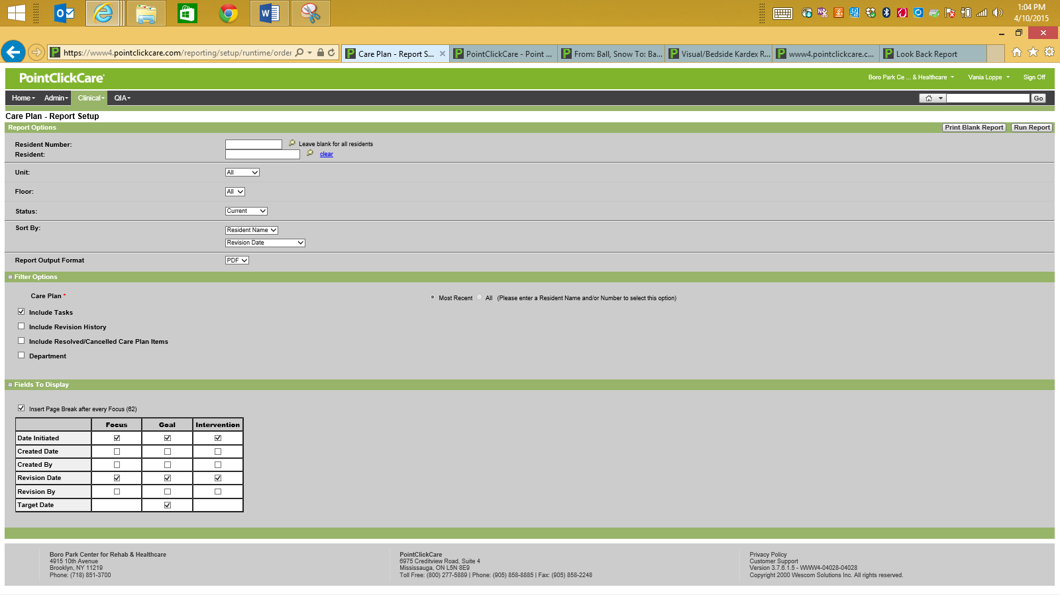
Example of a printed careplan:
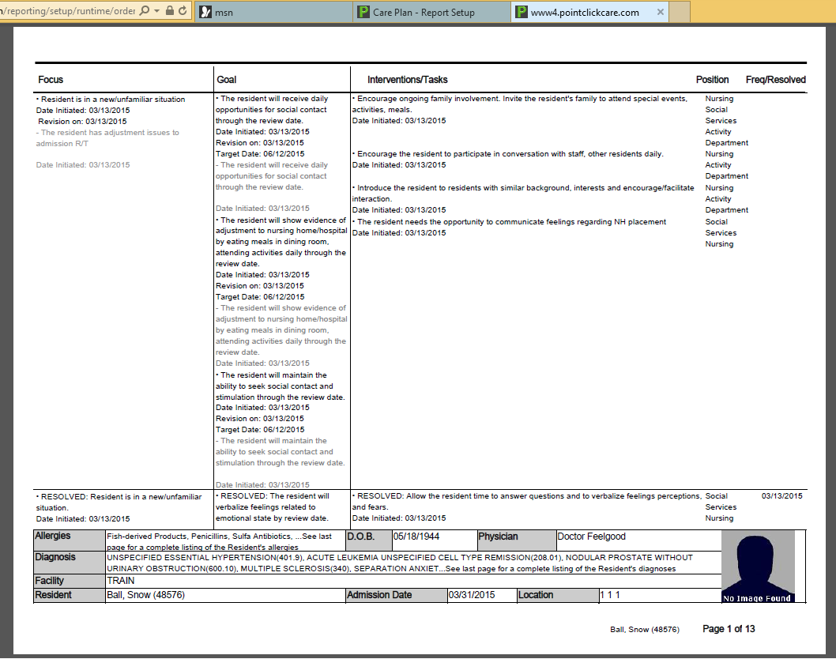

Printing Assessments

From the Clinical Tab, Click on reports, scroll down to Assessments. Here you will be able print reports related to UDAs.

Example of Assessment Report-Report Setup
Choose the assessment type and other features based on the filters available.
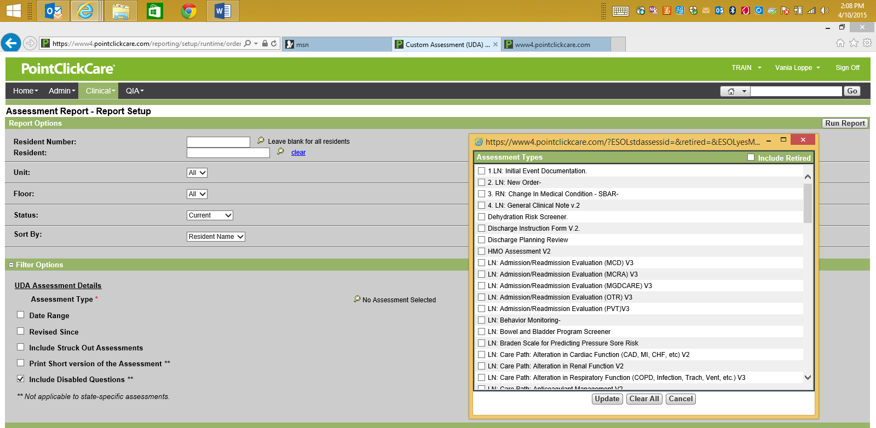

Example of printed assessment report:

Progress Note: printing reports choose from the list under report section marked Progress note.

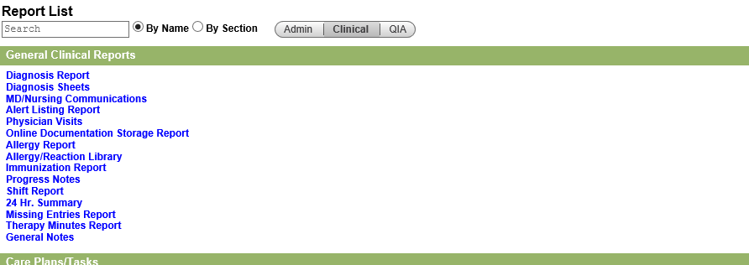

Progress Notes report- setup
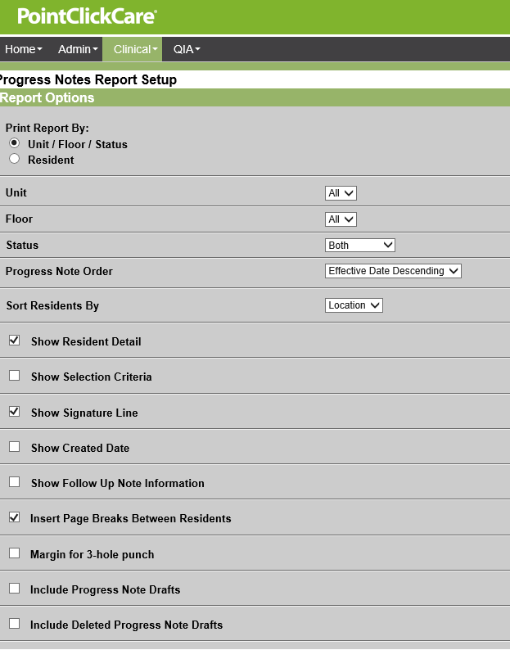

Printing a progress note from the resident chart , click on progress notes. Next to the progress note you will be able to print. Clicking on print.

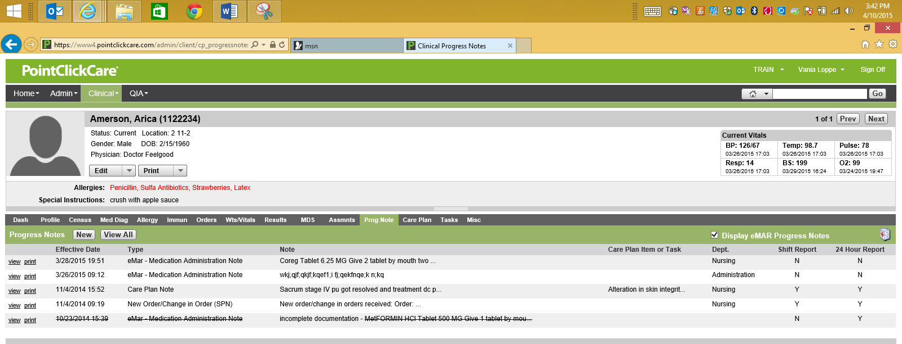

Check View All -To print a group of notes, by date range or discipline.

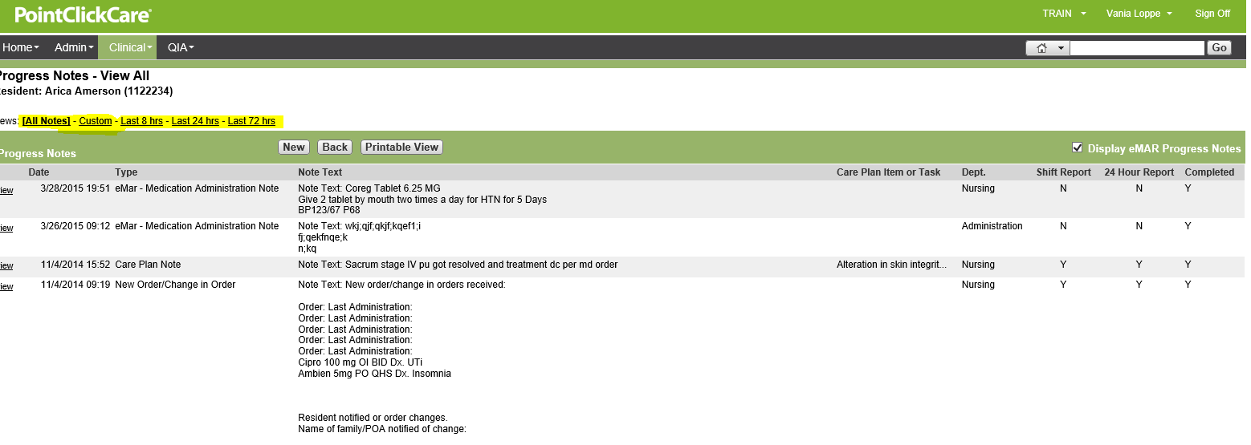

Printing an MDS

Once in a residents chart you will be able to print out a completed MDS. Click on the MDS tab. Choose the MDS you are looking for and click on print to the left of the MDS book.

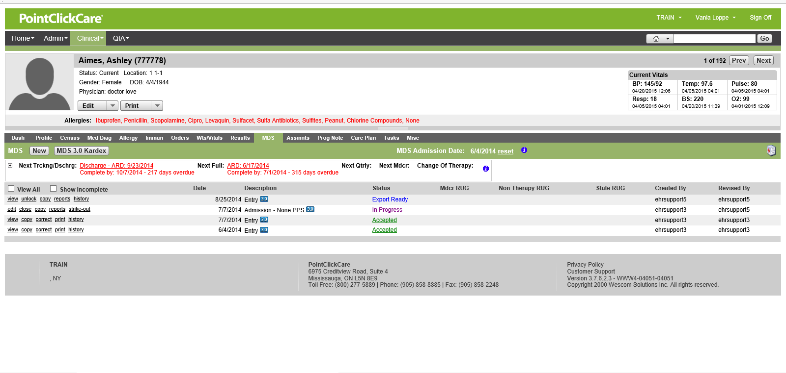

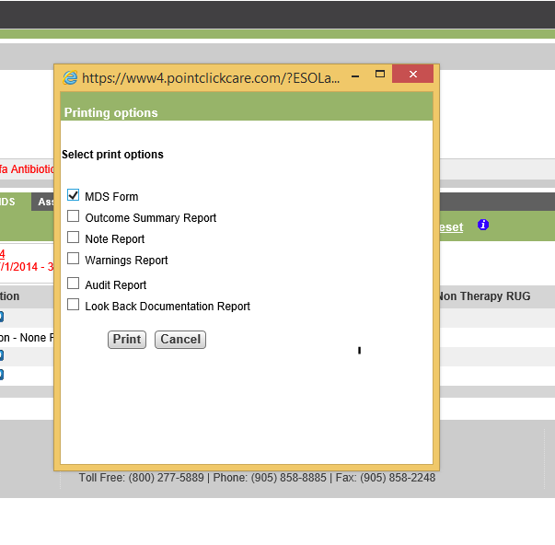

From this pop up window you can choose to print the:
MDS form
Outcome Summary Report
Note Report
Warnings Report
Audit Report
Look Back Documentation Report

Then click Print.

Printing the Census and Conditions/ Roster /Sample Matrix

From the clinical tab, click on MDS. You will be able to print MDS from a submission set. Click on view. From this view window you will be able to choose the resident and print the MDS.
To Print out the Census and Condition, click on the blue hyperlink of the same name to the right of the screen
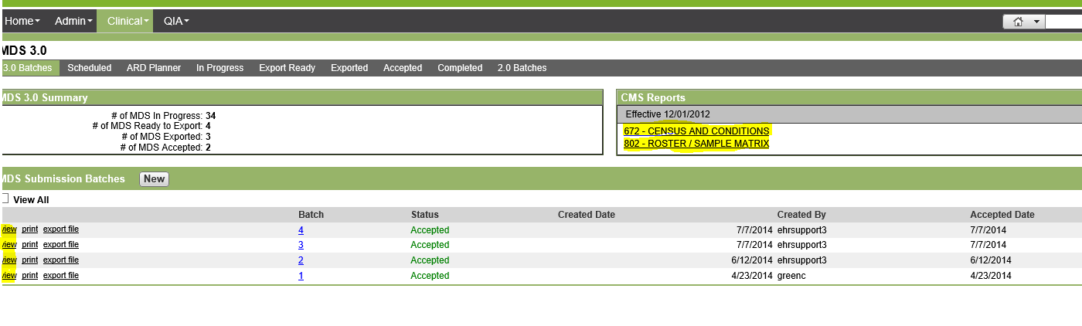

From this page below you can print out a copy by clicking on “Printable View”. You can also modify the information on this report to reflect information that is more recent than the last MDS. Clicking on the blue hyperlink numbers next to the section will give you the names of the residents that make up the total listed. Use this information to ensure all corresponding documentation matches in the residents chart.
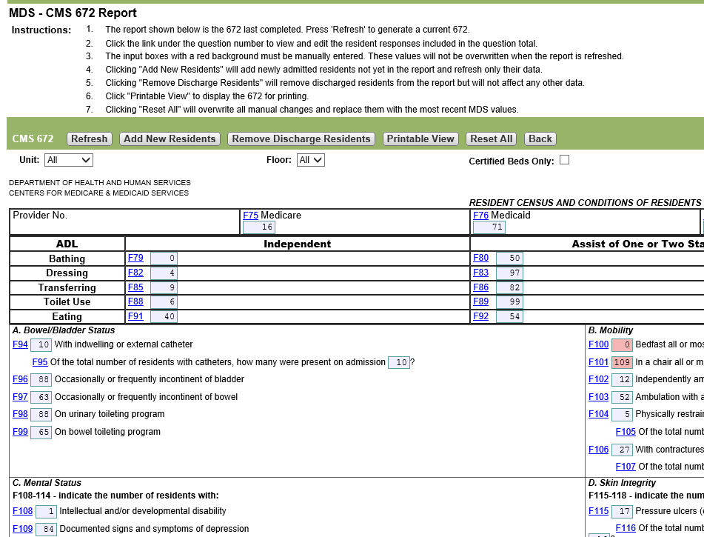

Roster/Sample Matrix- Modifications can also be made to reflect current information by clicking on the edit and checking and unchecking triggered indicators.

