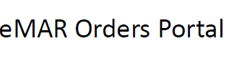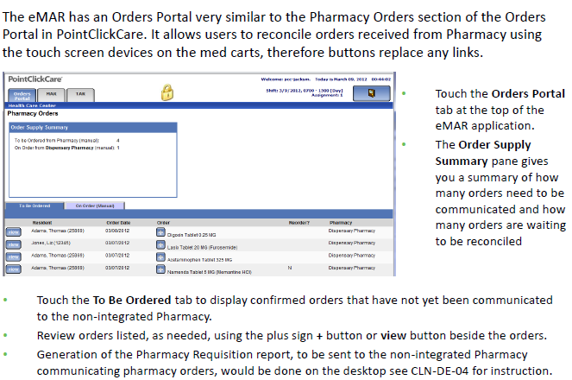
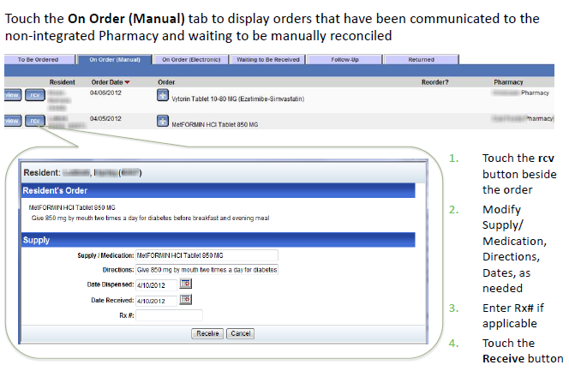
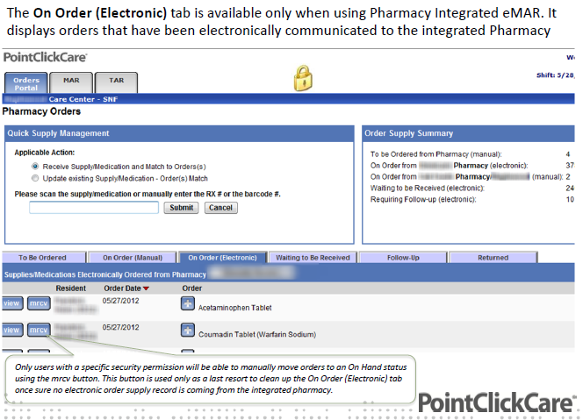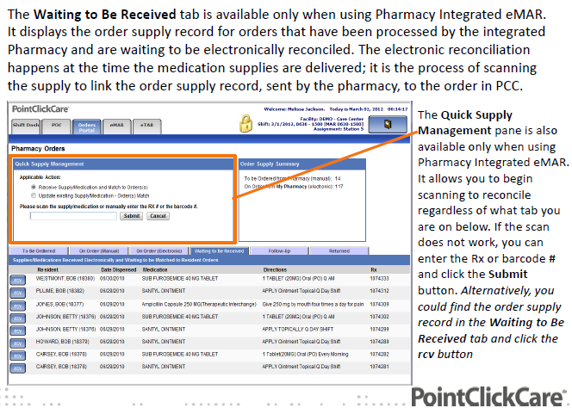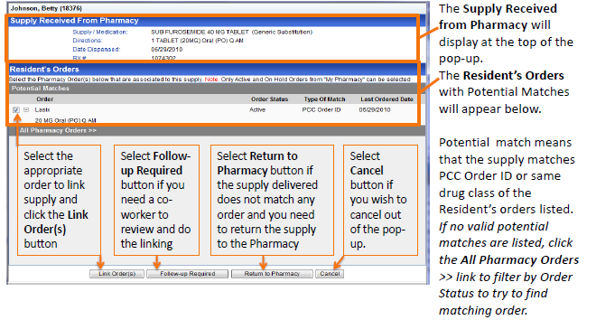
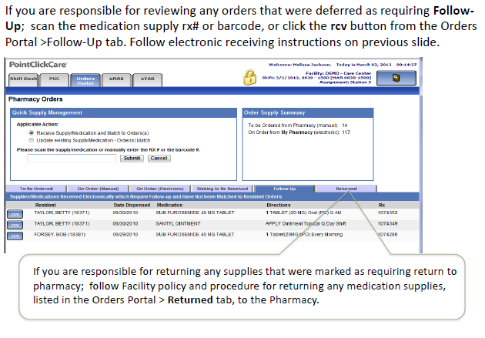
While in the eMAR you can receive supplies by clicking on the red “ # Supplies Waiting to be Received” button. It will open a window for you to indicate the supplies received to date for that particular resident. ( SEE PICTURE NEXT PAGE) 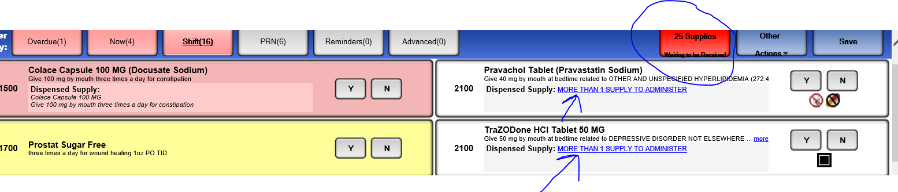

COMMON ERRORS AT START OF INTERGRATION:
In the first few weeks after the integration, the eMar may show medications with the message “ more than 1 supply to administer”. When the nurse opens the medication to administer it, the nurse will have to acknowledge which supply she is using for the medpass.
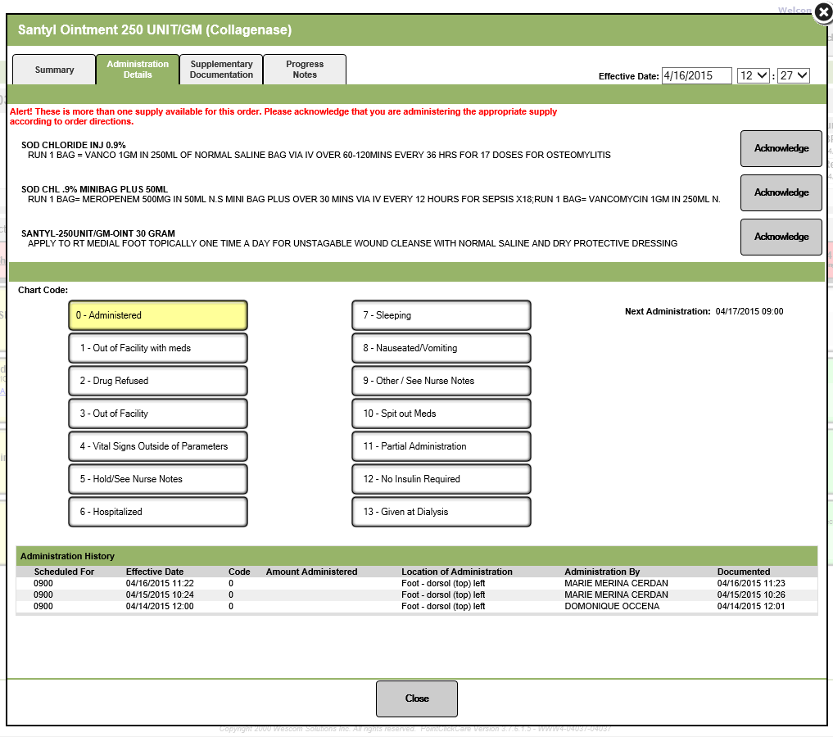
REASON #1
THIS IS AN ERROR CAUSED BY THE WRONG SUPPLY OR MULTIPLE SUPPLIES LINKED TO AN ORDER DURING THE PROCESS OF RECEIVING THE MED FROM PHARMACY. IF NOT CORRECTED THE NURSE MAY DOCUMENT SHE GAVE THE WRONG MEDICATION. This is potential for medication errors!!

THE FIX:
GO TO THE RESIDENTS CHART, GO TO ORDERS TAB IN THE RESIDENTS CHART, CLICK ON THE + SIGN NEXT TO THE MEDICATION WITH THE ERROR. IT WILL OPEN UP A WINDOW THAT SHOWS YOU THE LIST OF ALL THE SUPPLIES LINKED TO THE ORDER. CLICK ON THE SUPPLY MEDICATION (SEE ARROWS).
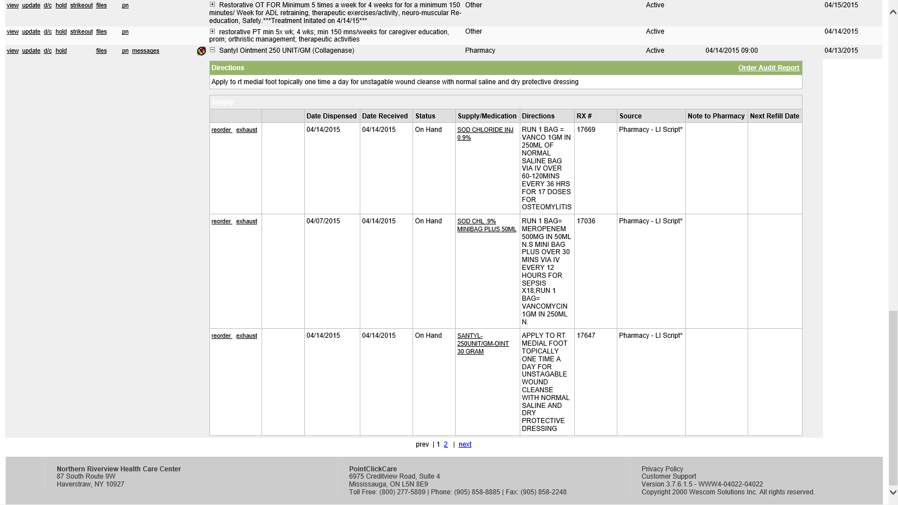
THE NEXT WINDOW WILL SHOW YOU THE ORDERS THAT ARE LINKED TO THE SUPPLY, UNCHECK TO ORDERS THAT ARE WRONGLY LINKED THEN CLICK AT THE BOTTOM, “UPDATE LINKED ORDERS” 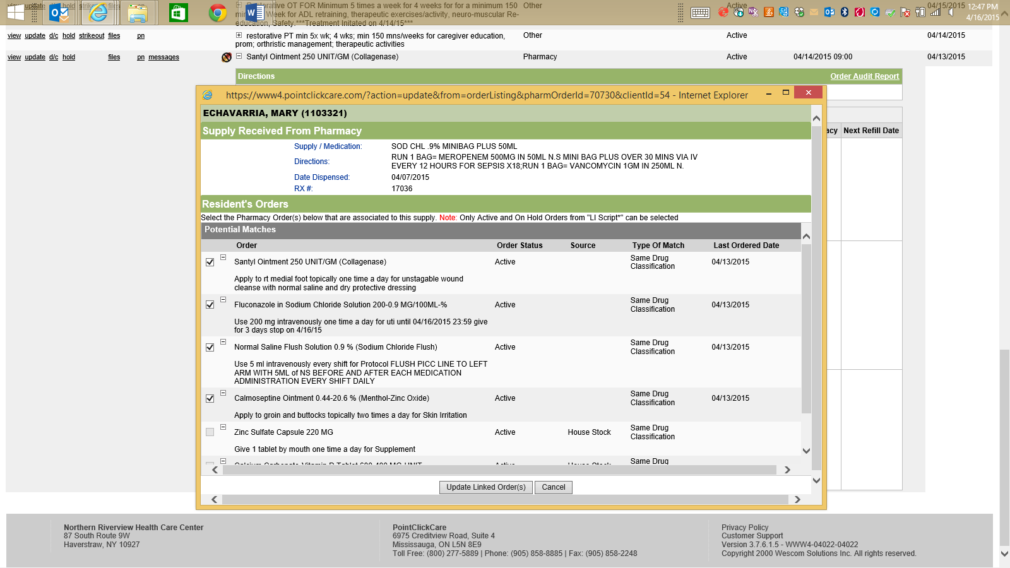
UNCHECK WRONGLY LINKED ORDERES

REASON #2
AT THE BEGINNING OF IMPLEMENTATION WITH A PHARMACY ALL EXISTING PHARMACY ORDERS PRIOR TO INTERGRATION WILL HAVE TO BE EXHAUSTED.
You must go back to the residents charts, go to the orders tab and click on the + sign next the medication that shows that message. A window will open up, the nurse must “exhaust” the older supply without a rx #.
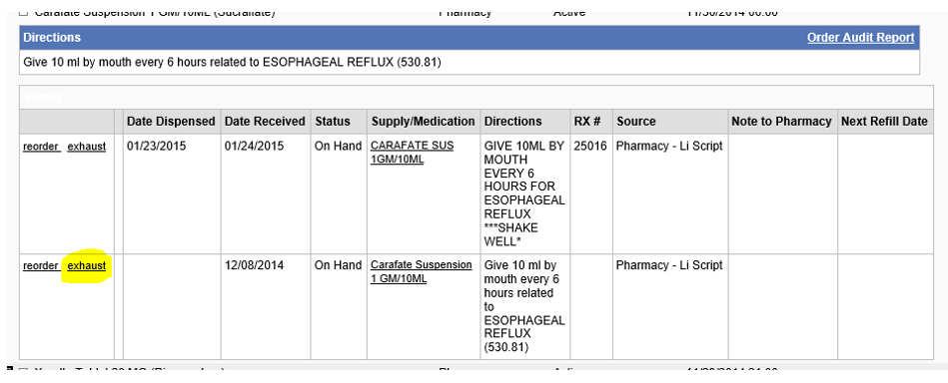
After a few weeks this will resolve itself as the older supplies are replaced with a supply with a rx #.
WHEN RECEIVING A MEDICATION SUPPLY AND THE POTENTIAL MATCHES DO NOT MATCH UP WITH THE ORDER AT ALL CLICK ON “ ALL PHARMACY ORDES” TO SEE ALL THE ORDERS FOR THAT RESIDENT.
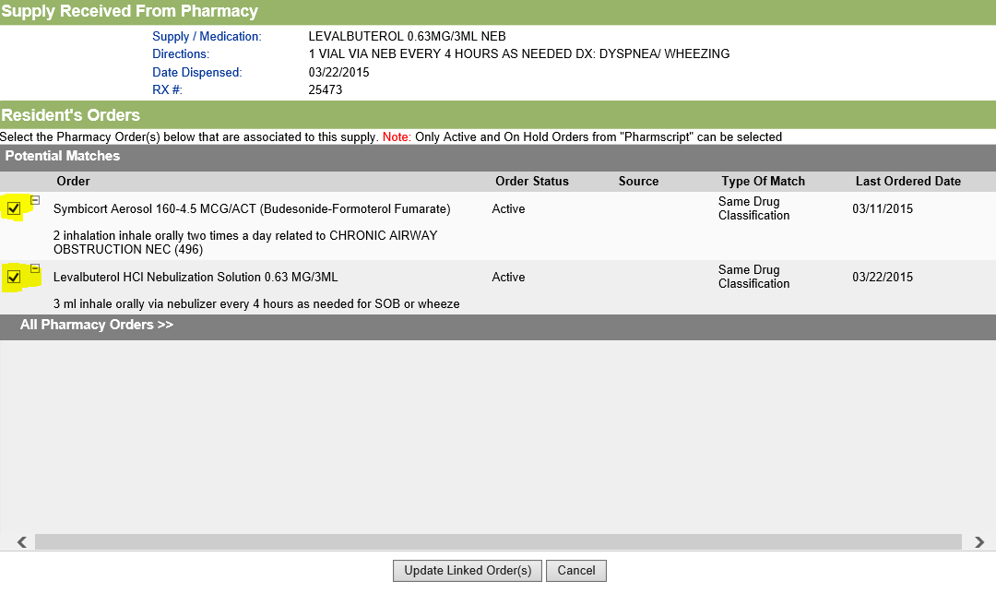

IMPORTANT:
Once Integration is enabled, the facility will be live with the pharmacy from that point forward. This means that all new orders, reorders and discontinuations of medications will need to be entered into PCC and sent electronically to the pharmacy.
Faxing is no longer acceptable other than typically these scenarios, and only after the order has been entered into PCC:
- All orders for Narcotics/Controlled Substances (Cll, Clll, ClV and CV) and Reorders of CII
- All orders of Compounds
- IVs
- Any orders entered (new or updates) where the Directions field exceed the 140 character limit

