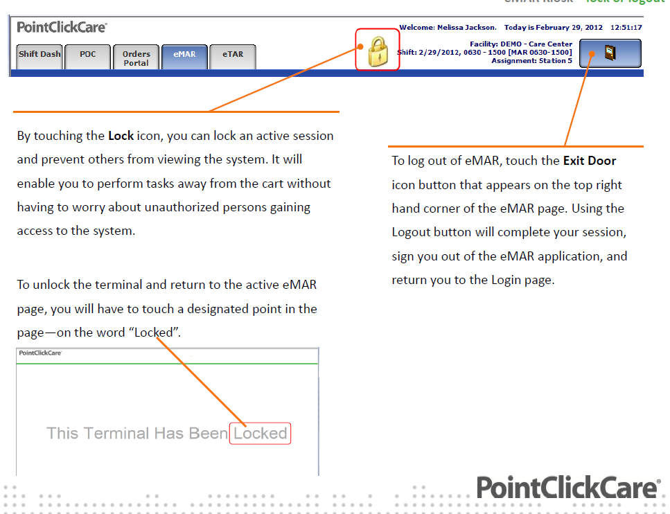

MAR tab is selected by default. The page displays the list of resident requiring documentation of administration, based on the last assignment, current shift and date. You will see tabs for the TAR and ORDERS PORTAL.
Edit/Assignment/Date Button- You can change the date, the assignment and shift by clicking this button. A calendar icon will appear with drop down boxes. Select a different shift or assignment by using the drop down boxes and clicking the OK button. On the calendar you can use the arrows to select the desired month and click on the date. You can also click on the TODAY button to return to the current date. You will only be allowed to go back 30 days from the present date. You can go in the future but you will receive an error message if you try to document.

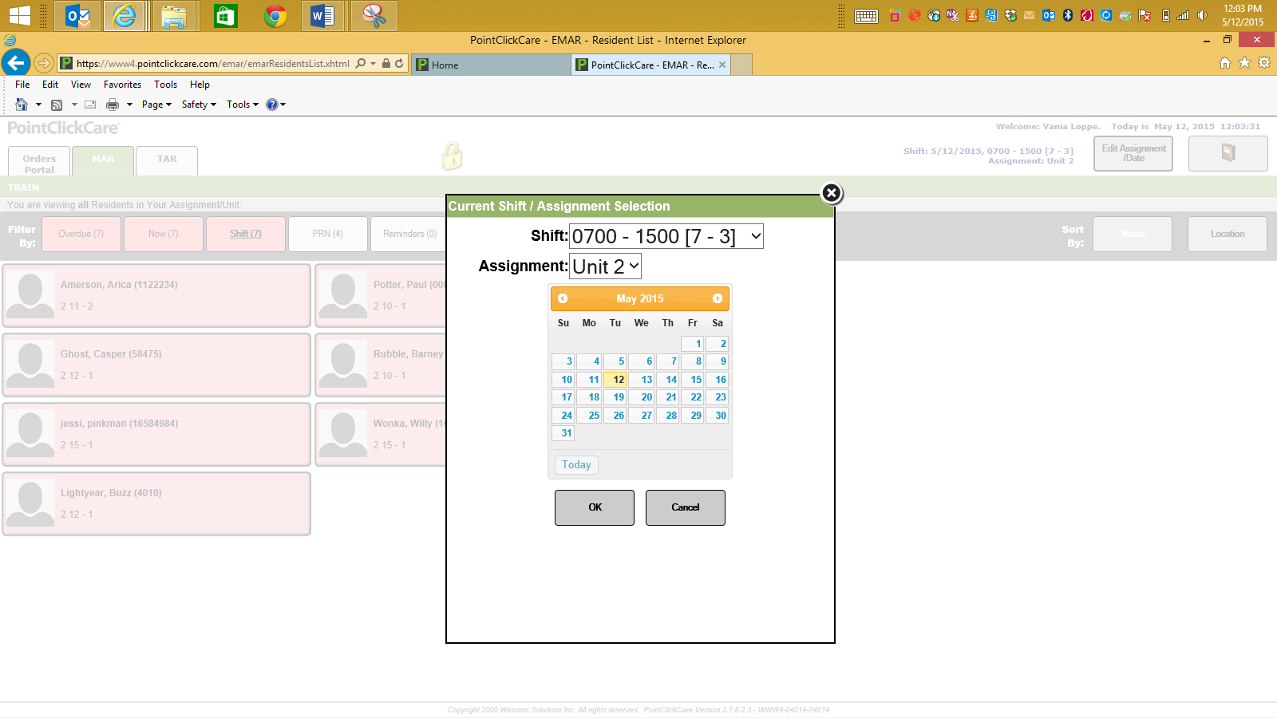

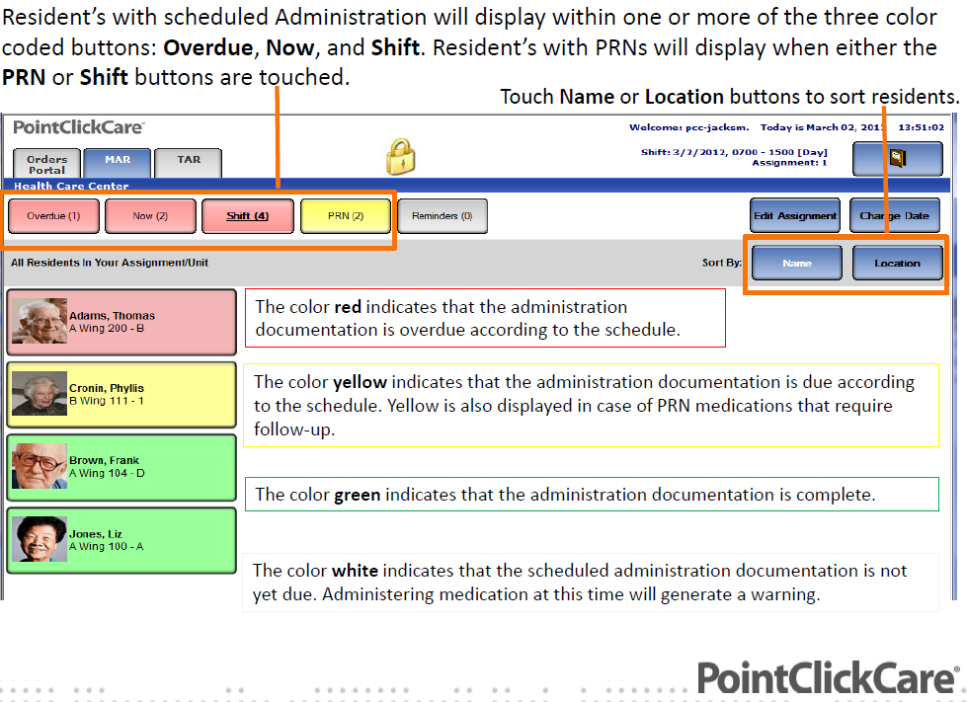

ICONS
◦Heart - Indicates that vitals, lab or other supplementary documentation is required prior to administration.
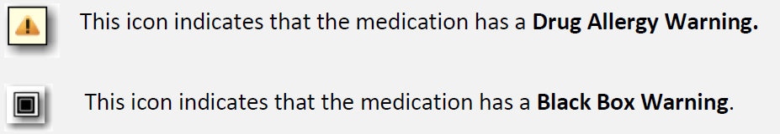
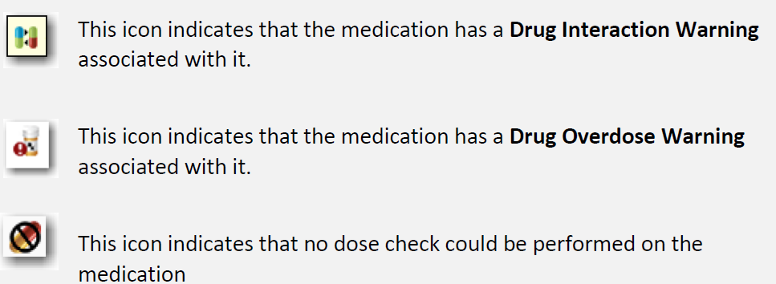
◦Page - Indicates that there are pass time specific administration notes.
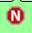
◦ - Indicates that the medication is a Narcotic.

◦The more link indicates that there is more information available than what is displayed. If you hover over the link the full description, directions and pass time administration notes will display. If you click on the more link the Summary tab pop-up will display.

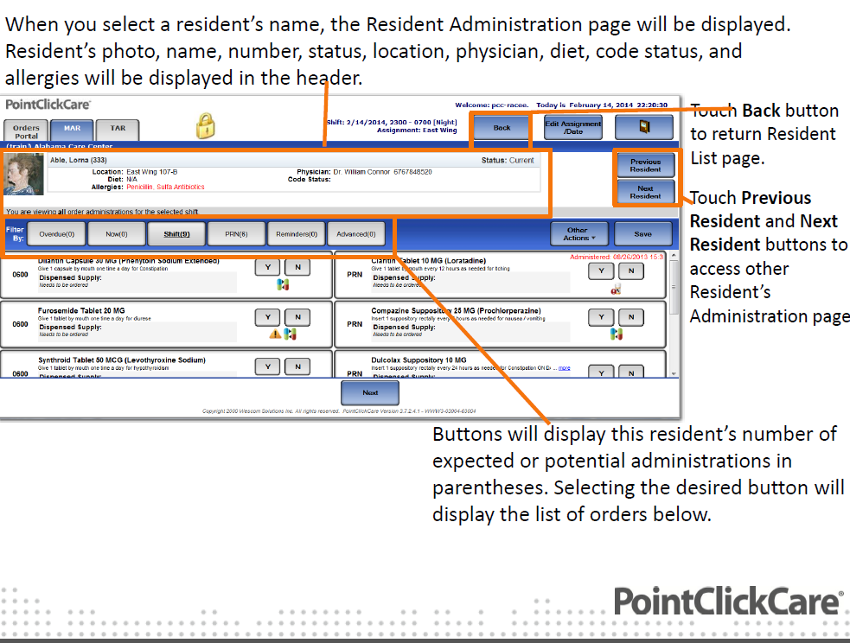

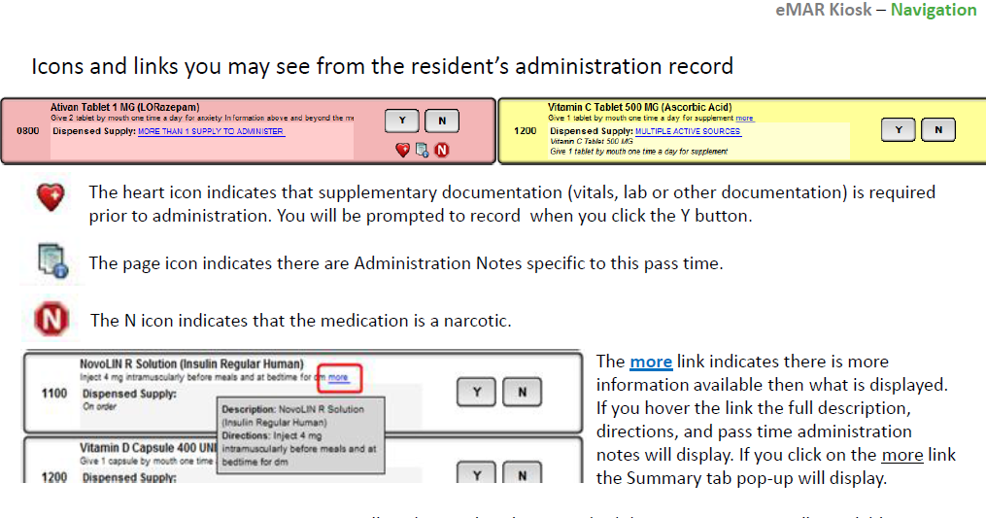
MORE THAN 1 SUPPLY TO ADMINISTER- Indicates that there is more than one supply in the system linked to the order. This can occur if the wrong medication is linked during the receiving process or after initial integration with a pharmacy previous supplies without a rx # still exist in the system. To rectify this for the example of a wrong medication linked, in the residents chart under the orders tab, click on the + next to the medication with the error. Click on the name of the medication incorrectly linked. In the next window that appears uncheck the incorrectly linked medication and save your changes. If this error is a result of post integration with a pharmacy go to the residents chart under the orders tab, click on the + sign next to the medication with the error and exhaust the older medication supply without an rx number by clicking on the word exhaust.
MULTIPLE ACTIVE SOURCES- Indicates that the order has been updated with multiple different sources that both have a status of “on Hand” i.e. family supplied and pharmacy. In this example, once the family supplied is completed it should be exhausted than the pharmacy supply will display as the Dispensed supply in eMAR.

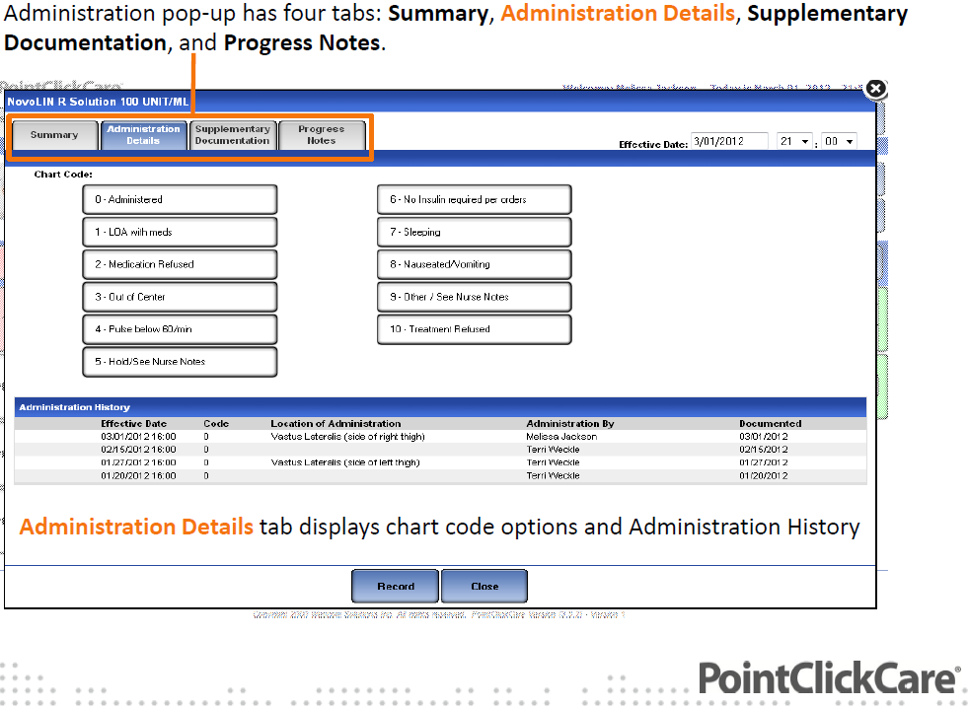

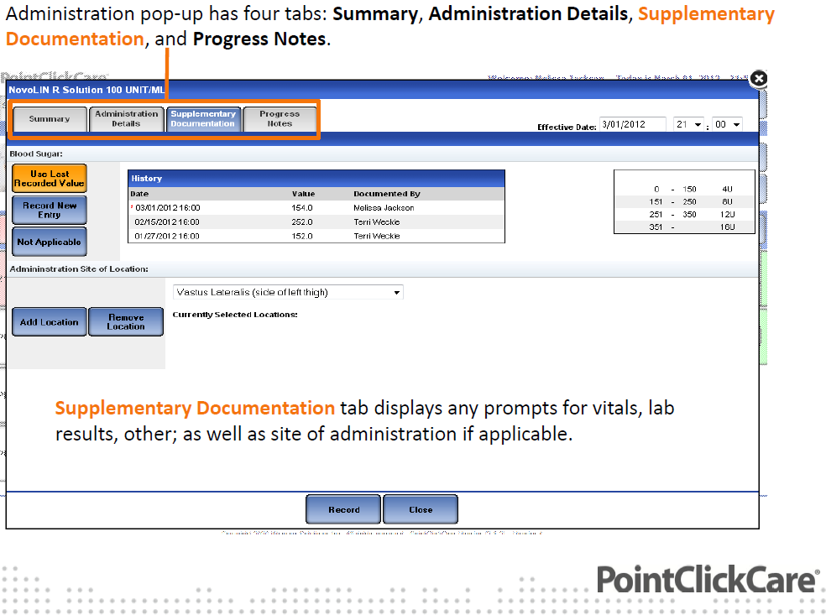

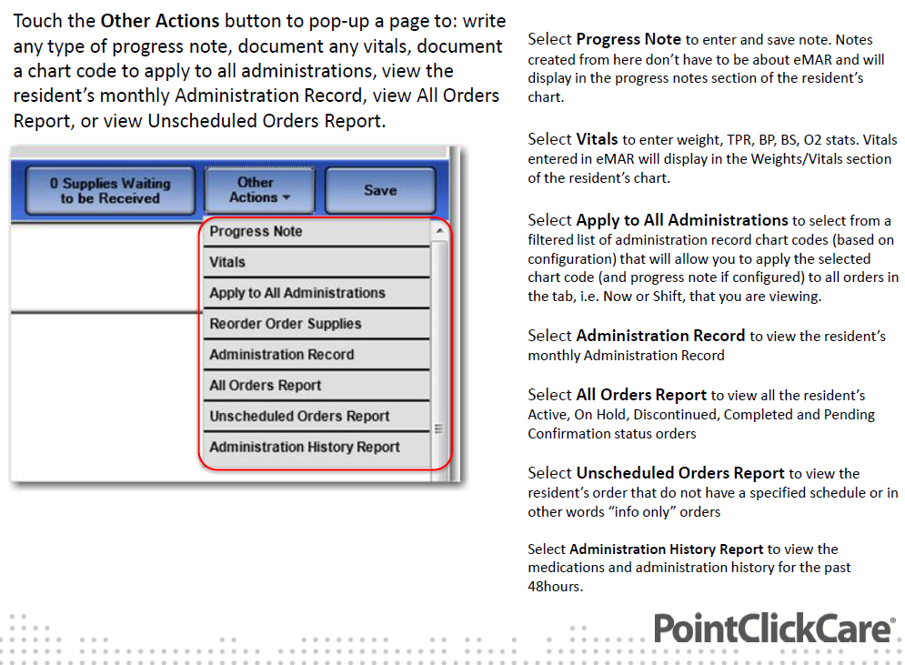

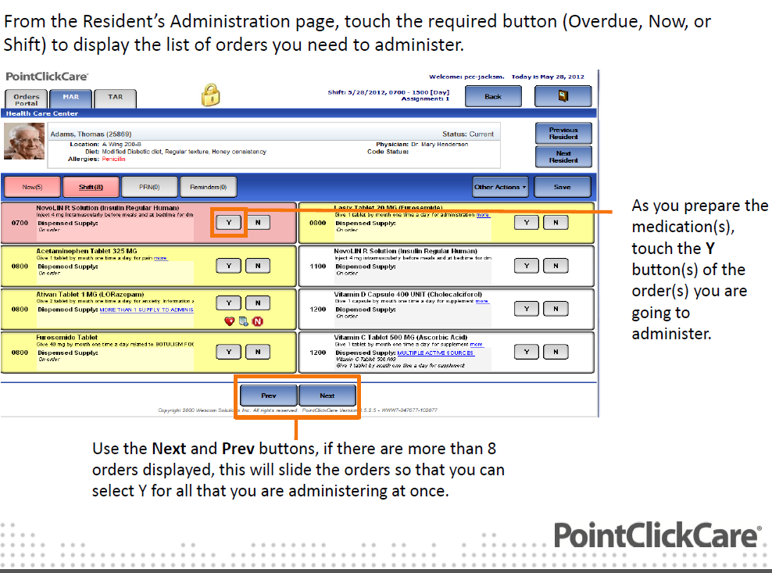

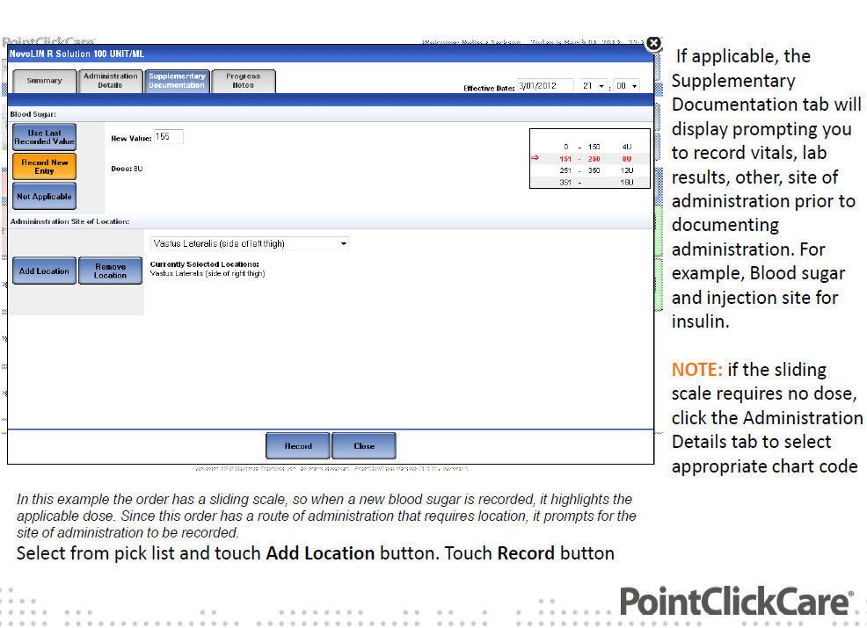

The Y button (s) and SAVE button will display orange. Be sure to lock your screen before leaving the cart. When you return from administering to the resident, unlock the screen and click the orange SAVE button, Alternatively touch the N button which will display Administration details tab, to change the chart code i.e. resident refused.
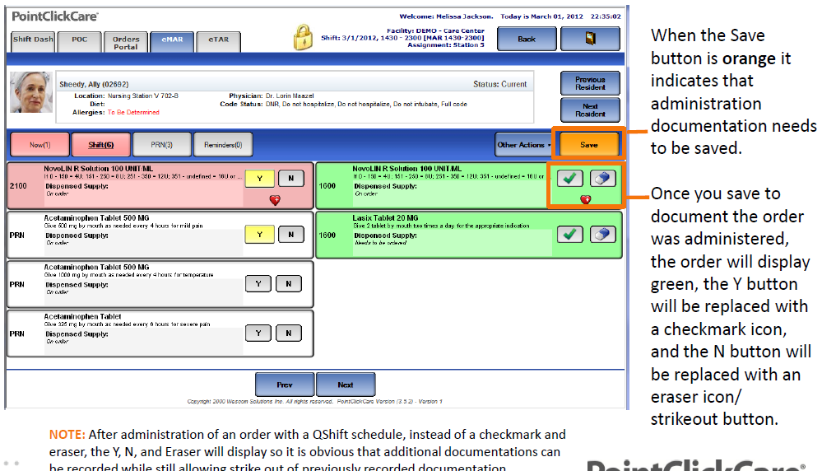

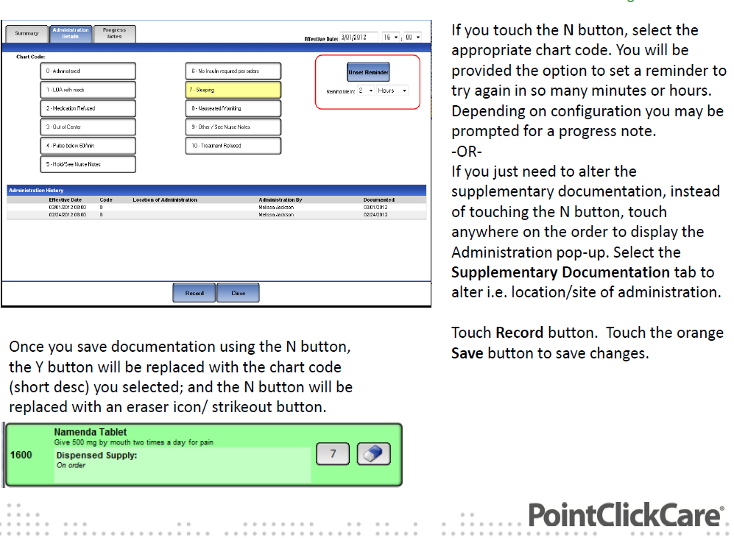

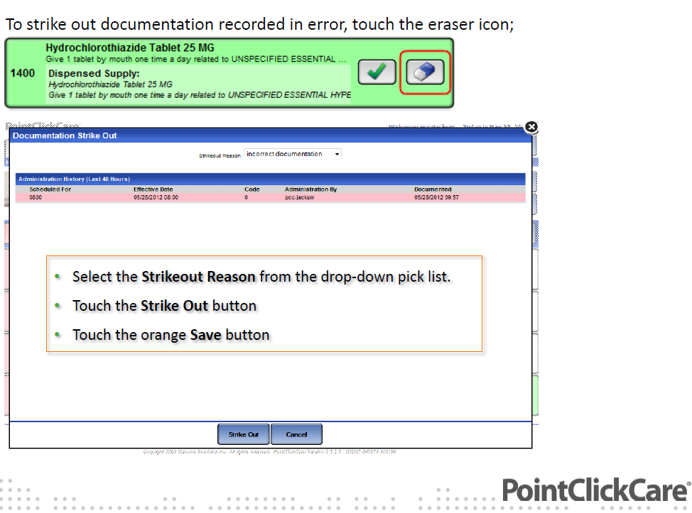

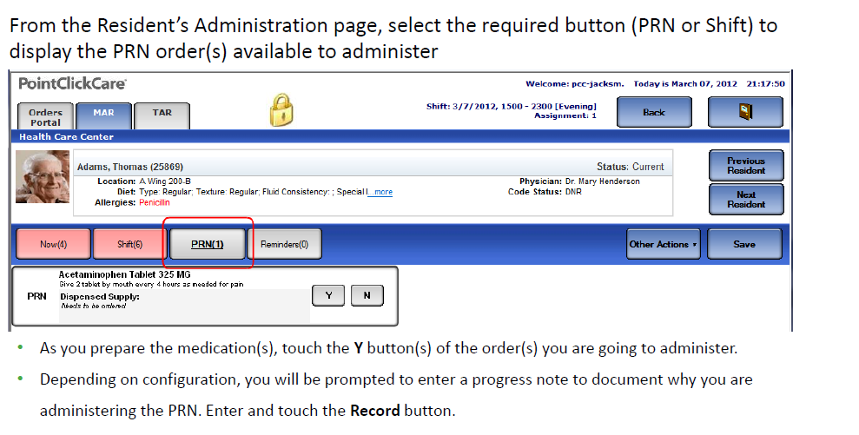
- The Y button (s) and SAVE button will display orange. Be sure to lock your screen before leaving the cart. When you return from administering to the resident, unlock the screen and click the orange SAVE button.
- Once saved the Y button will be replaced with a follow up button and the N button will be replaced with an eraser/strikeout button.

