By Question and Unit:
- Navigate to Reports>CNA Assignments>Documentation CSV
- Change date range to desired time period
  - (1 week of data for 1 unit gave me a spreadsheet with 5000+ rows of data and took aproximately 2-3 minutes for sigma to have available for download)
- Select Unit (report needs to be run for each unit individually. You can not select the entire facility at once)

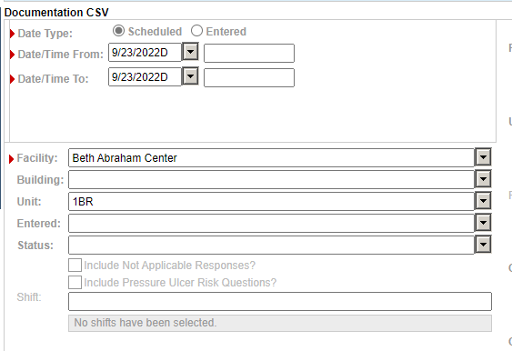
- Check the box to include discharged residents
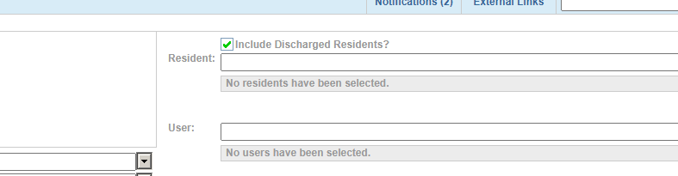

Report will look like the following
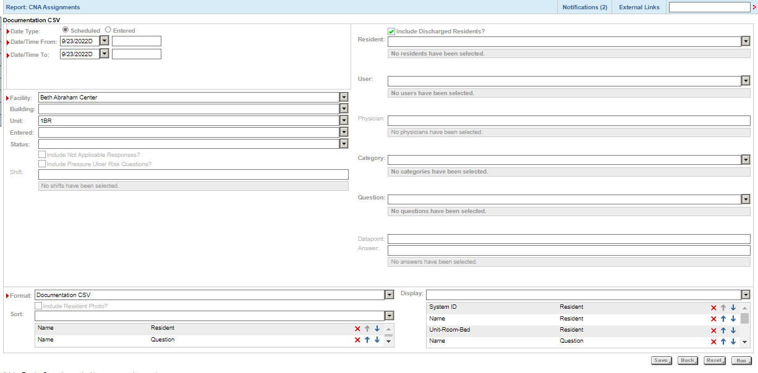
- Click on run to start the report
- The document will download as .csv file when completed.

